### DEPARTMENT OF COMPUTER APPLICATION TKM COLLEGE OF ENGINEERING

**KOLLAM – 691005**



**20MCA136 - NETWORKING & SYSTEM ADMINISTRATION LAB**

PRACTICAL RECORD BOOK

Second Semester MCA 2020-2021

**Submitted by:**

NAME : ANILAMOL CHACKO ROLL NO : TKM20MCA-2009

NETWORKING AND ADMINISTRATION LAB

**DEPARTMENT OF COMPUTER APPLICATION TKM COLLEGE OF ENGINEERING**

**KOLLAM – 691005**



##### Certificate

This is a bonafide record of the work done by ANILAMOL CHACKO in the Second Semester in NETWORKING & SYSTEM ADMINISTRATION LAB Course (20MCA136)

towards the partial fulfillment of the degree of Master of Computer Applications during the academic year 2020-2021.

Staff Member in-charge Examiner

……………………….. ………………………..

1

|  |  |  |  |
| --- | --- | --- | --- |
| Cycle 1 |  | Page no | Date |
| Exp 1 | Familiarisation to computer hardware | 3 | 30-04-2021 |
| Exp 2 | Specification of desktop and server computers | 10 | 30-04-2021 |
| Exp 3 | Installation of linux on virtual box in windows 10 | 11 | 30-04-2021 |
| Exp 4 | Installation of windows on virtual box in ubuntu | 23 | 28-05-2021 |
| Exp 5 | Installation of windows operating system on a bare machine | 25 | 05-05-2021 |
| Exp 6 | Installation of linux over windows operating system | 29 | 02-06-2021 |
| Exp 7 | Installation of server system | 31 | 07-06-2021 |
|  |  |  |  |
| Cycle 2 |  |  |  |
| Exp 8 | Study on command line text editors | 34 | 02-07-2021 |
| Exp 9 | Basic Linux Commands | 36 | 04-07-2021 |
| Exp 10 | Familiarisation with Vi Editor | 52 | 08-07-2021 |
| Exp 11 | Familiarisation with EMACS editor | 55 | 11-07-2021 |
| Exp 12 | Linux File System | 60 | 16-07-2021 |
|  |  |  |  |
| Cycle 3 |  |  |  |
| Exp 13 | Familiarisation to linux shell and shell scripting | 75 | 18-07-2021 |
| Exp 14 | Linux shell scripting problems | 93 | 06-08-2021 |
|  |  |  |  |
| Cycle 4 |  |  |  |
| Exp 15 | Installation of LAMP | 102 | 13-08-2021 |
| Exp 16 | Installation of Laravel | 108 | 19-08-2021 |
|  |  |  |  |
| Cycle 5 |  |  |  |
| Exp 17 | Familiarisation to command Line tool for networking | 113 | 03-09-2021 |
| Exp 18 | Familiarisation of Static and Dynamic IP | 124 | 03-09-2021 |
| Exp 19 | Concept of subnets and CIDR address scheme | 130 | 05-09-2021 |
| Exp 20 | Concept of subnet mask | 133 | 05-09-2021 |
| Exp 21 | Setting up of firewall on LAN | 135 | 07-09-2021 |
| Exp 22 | Wireshark and TCP Dump | 137 | 08-09-2021 |
| Exp 23 | Analyse Packets using wireshark | 147 | 08-09-2021 |
|  |  |  |  |
| Cycle 6 |  |  |  |
| Exp 24 | Familiarisation to hypervisors and Virtual machines | 151 | 15-09-2021 |
| Exp 25 | Familiarisation to Xen or KVM | 153 | 15-09-2021 |
| Exp 26 | Installation of software from source code | 158 | 19-09-2021 |
| Exp 27 | Deploy Linux virtual machine using Ansible Playbook | 162 | 19-09-2021 |

Date:30-04-2021

### CYCLE 1

**EXPERIMENT-1**

### FAMILIARISATION TO COMPUTER HARDWARE

The term hardware refers to the mechanical device that makes up a computer. Computer hardware consists of interconnected electronic devices that we can use to control a computer's operation, input and output. Examples of hardware are CPU, keyboard, mouse, hard disk, etc.

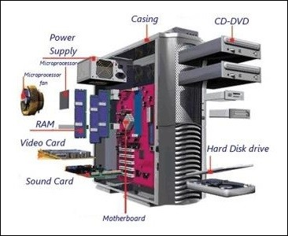

Computer hardware is a collection of several components working together. Some parts are essential and others are added advantages. Computer hardware is made up of CPU and peripherals

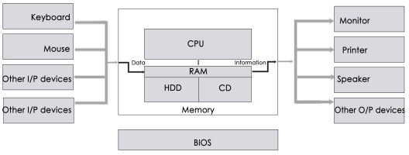

### MAJOR COMPONENTS OF COMPUTER SYSTEM

1. MOTHERBOARD

The motherboard serves as a single platform to connect all of the parts of a computer together. It connects the CPU, memory, hard drives, optical drives, video card, sound card, and other ports and expansion cards directly or via cables. It can be considered as the backbone of a computer.

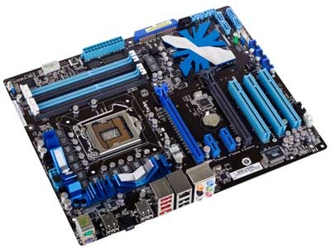

Features of Motherboard

A motherboard comes with following features −

* + Motherboard varies greatly in supporting various types of components.
  + Motherboard supports a single type of CPU and few types of memories.
  + Video cards, hard disks, sound cards have to be compatible with the motherboard to function properly.
  + Motherboards, cases, and power supplies must be compatible to work properly together.

1. RAM

RAM (Random Access Memory) is the internal memory of the CPU for storing data, program, and program results. It is a read/write memory which stores data until the machine is working. As soon as the machine is switched off, data is erased. RAM is significantly faster than a hard disk — twenty to a hundred times faster, depending on the specific hardware type and task. Because of its speed, RAM is used to process information immediately. When you want to accomplish a specific task, computer operating systems load data from the hard disk into RAM to process it, such as to sort a spreadsheet or to display it on screen.

RAM is volatile, i.e. data stored in it is lost when we switch off the computer or if there is a power failure. Hence, a backup Uninterruptible Power System (UPS) is often used with computers. RAM is small, both in terms of its physical size and in the amount of data it can hold.

RAM is of two types −

* + Static RAM (SRAM)
  + Dynamic RAM (DRAM)

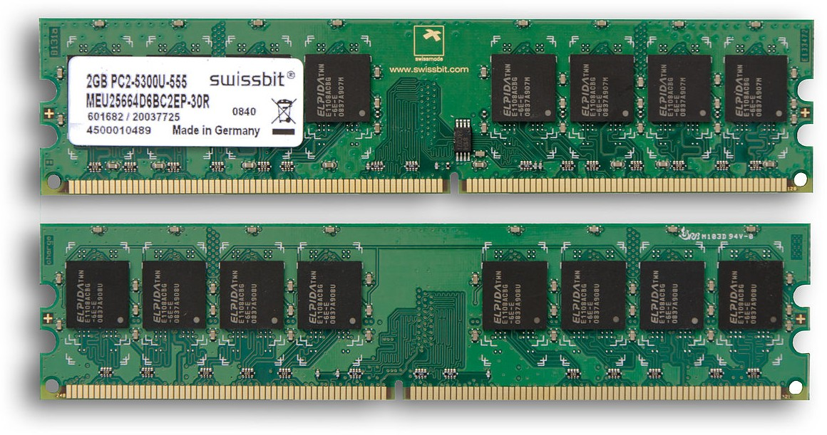

1. DAUGHTER CARDS

A daughterboard (or *daughter board* , *daughter card* , or *daughtercard* ) is a circuit board that plugs into and extends the circuitry of another circuit board. The other circuit board may be the computer's main board (its motherboard ) or it may be another board or card that is already in the computer, often a sound card.

Expansion cards allow the capacities and interfaces of a computer system to be adjusted to the tasks it will perform. For example, a high-speed multi-channel data acquisition system would be of no use to a personal computer used for bookkeeping, but might be a key part of a system used for industrial process control.Expansion cards can often be installed or removed in the field, allowing a degree of user customization for particular purposes. Some expansion cards take the form of "daughterboards" that plug into connectors on a supporting system board.

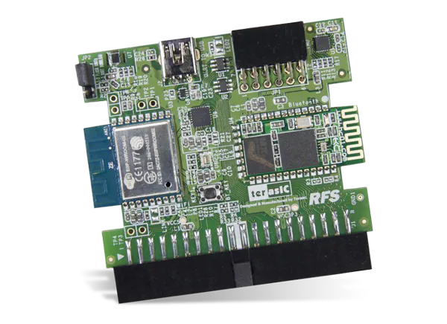

1. BUS SLOTS

Alternatively known as a **bus slot** or **expansion** port, an **expansion slot** is a connection or port inside a computer on the **motherboard** or riser card. It provides an installation point for a hardware **expansion** card to be connected.For example, if you wanted to install a new video card in the computer, you'd purchase a video expansion card and install that card into the compatible expansion slot. Some of the expansion sort found in computer are:

* + AGP
  + AMR
  + CNR
  + EISA
  + ISA
  + PCI
  + PCI Express
  + VESA

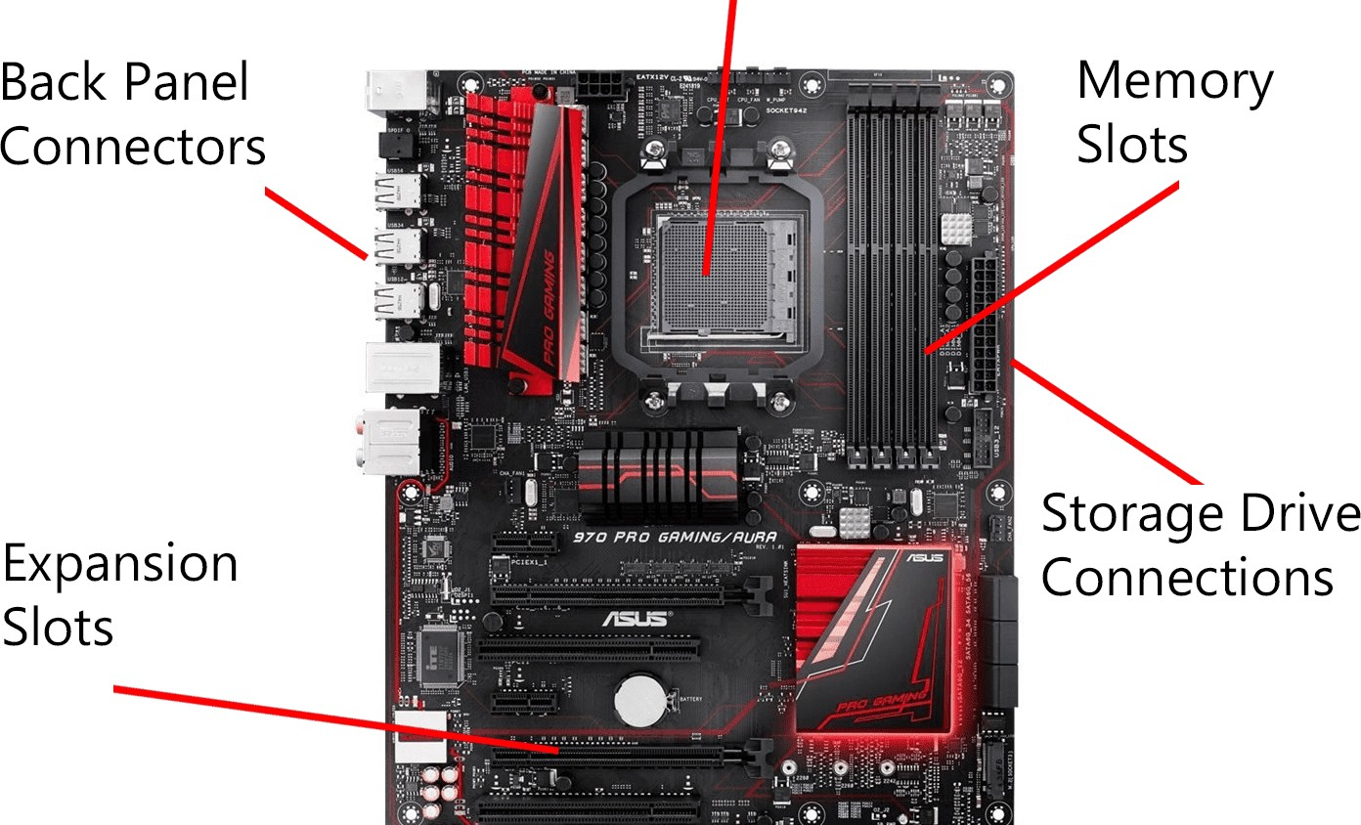

1. SMPS

**SMPS** is the Switched Mode Power Supply circuit which is designed for obtaining the regulated DC output voltage from an unregulated DC or AC voltage.

Switch mode power supplies, **SMPS** provide improved efficiency & space saving over traditional linear supplies, but care has to be taken to ensure noise on the output is low. Switch mode power supplies are widely **used** because of the advantages they offer in terms of size, weight, cost, efficiency and overall performance.

There are four main types of SMPS such as

* + DC to DC Converter
  + AC to DC Converter
  + Fly back Converter
  + Forward Converter

The AC to DC conversion part in the input section makes the difference between AC to DC converter and DC to DC converter. The Fly back converter is used for Low power applications. Also there are Buck Converter and Boost converters in the SMPS types which decrease or increase the output voltage depending upon the requirements.

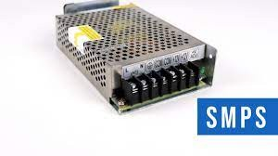

1. PORTS AND INTERFACE

The Motherboard of a computer has many I/O sockets that are connected to the ports and interfaces found on the rear side of a computer(fig 3.14) . The external devices can be connected to the ports and interfaces. The various types of ports are given below:

**Serial Port:** To connect the external devices, found in old computers.

**Parallel Port:** To connect the printers, found in old computers.

**USB Ports:** To connect external devices like cameras, scanners, mobile phones, external hard disks and printers to the computer.

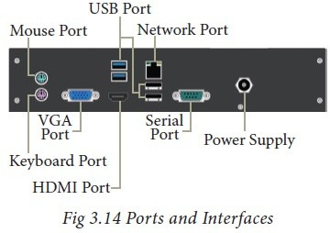

1. EXPANSION SLOT

Alternatively known as a bus slot or expansion port, an expansion slot is a connection or port inside a [computer](https://www.computerhope.com/jargon/c/computer.htm) on the [motherboard](https://www.computerhope.com/jargon/m/mothboar.htm) or [riser card](https://www.computerhope.com/jargon/r/risecard.htm). It provides an installation point for a hardware expansion card to be connected. For example, if you wanted to install a new video card in the computer, you'd purchase a video expansion card and install that card into the compatible expansion slot.

Date: 30-04-21

**EXPERIMENT- 2**

**SPECIFICATION OF DESKTOP AND SERVER COMPUTERS**

To be used efficiently, all computer software needs certain hardware components or other software resources to be present on a computer.[1] These prerequisites are known as (computer) system requirements and are often used as a guideline as opposed to an absolute rule. Most software defines two sets of system requirements: minimum and recommended. With increasing demand for higher processing power and resources in newer versions of software, system requirements tend to increase over time.

8 things you should keep in mind before buying yourself a system.

1.BUDGET

Everyone has the purchasing power but how much can you really spend on buying a laptop is what you should ask yourself before purchasing one.

2.PROCESSOR

The CPU is the main part of a laptop which defines the speed of processing any task. In short, if you want to multi-task on your laptop you should buy one which has a powerful processor.

1. HARD DISK DRIVE

The hard disk drive basically keeps all your data including videos, documents, photos and other system files.

1. SCREEN SIZE

The screen size and type totally depends on what you use your laptop for.

5.DESIGN

Everyone wants to buy a laptop that is lightweight, slim, sleek and good to look at. 6.GRAPHIC PROCESSOR

7.BATTERY

A good battery life is important if you work or play on your laptop almost all the time.

8.BRAND

The brand makes a huge difference.

Date: 30-04-21

##### EXPERIMENT NO- 3

**INSTALLATION OF LINUX ON VIRTUAL BOX IN WINDOWS 10**

VirtualBox is a general-purpose full virtualizer for x86 hardware, targeted at server, desktop and embedded use.VirtualBox is being actively developed with frequent releases and has an ever growing list of features, supported guest operating systems and platforms it runs on.

* This is a popular method to install a Linux operating system.
* The virtual installation offers you the freedom of running Linux on an existing OS already installed on your computer.
* This means if you have Windows running, then you can just run Linux with a click of a button.
* Virtual machine software like Oracle VM can install Linux on Windows in easy steps.

STEP 1 - DOWNLOAD AND INSTALL VIRTUALBOX

* Go to the website of Oracle VirtualBox and get the latest stable version from here: <https://www.virtualbox.org/wiki/Downloads>
* Just double-click on the downloaded .exe file and follow the instructions on the screen.
* It is like installing any regular software on Windows.

CREATING A VIRTUALBOX VM

In this section, steps are shown how to create a VirtualBox VM for installing Ubuntu

20.04 LTS.

* Open VirtualBox.
* Then, click on Machine > New…
* Now, type in a name for the VM, select Linux from the Type dropdown menu, and Ubuntu (64-bit) from the Version dropdown menu. Then, click on Next.

STEP 2 - DOWNLOAD THE LINUX ISO

* Next, you need to download the ISO file of the Linux distribution.
* You can get this image from the official website of the Linux distribution you are trying to use.
* I am using Ubuntu in this example, and you can download ISO images for Ubuntu from the link below:

<https://ubuntu.com/download>

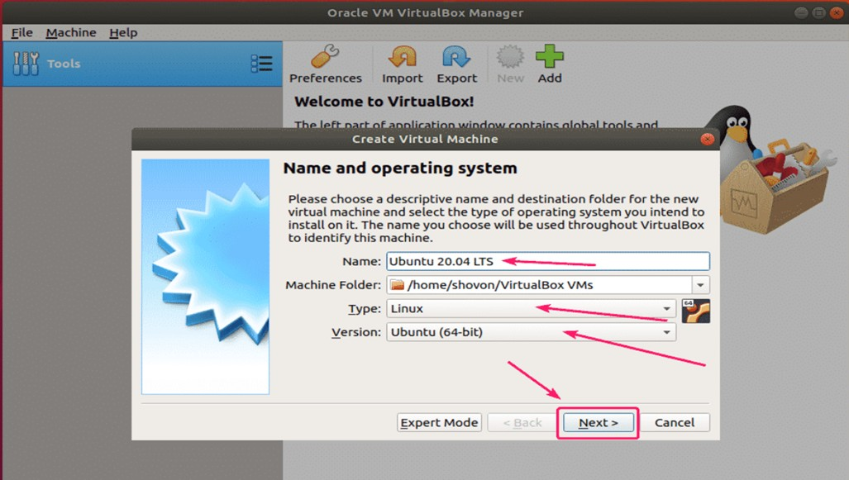

* Now, you have to set the memory size for the VM.
* For Ubuntu Desktop 20.04 LTS, it should be at least 2048 MB (2 GB).
* For Ubuntu Server 20.04 LTS, it should be at least 512 MB.
* Once you’re done, click on **Next >**.

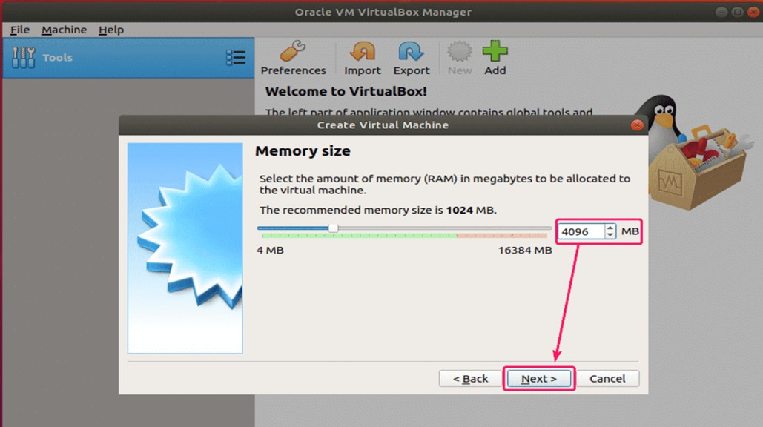

* Now, select **Create a virtual hard disk now** and click on **Create** . This serves as the hard disk of the virtual Linux system.
* It is where the virtual system will store its files.

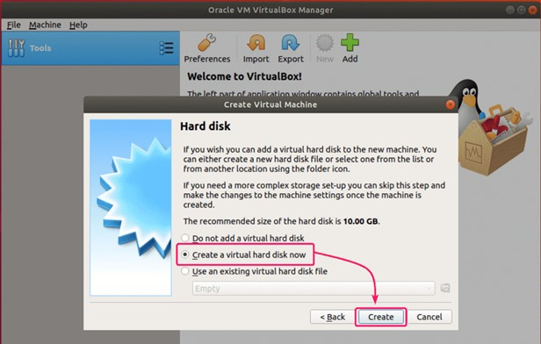

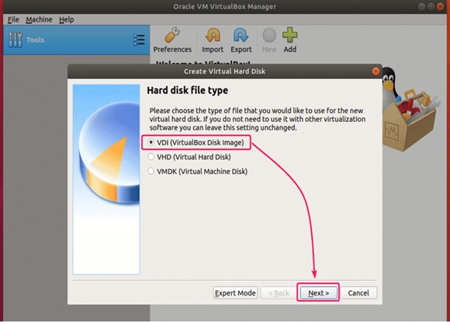

* Select **Dynamically allocated** and click on **Next >**.
* You can choose either the “Dynamically allocated” or the “Fixed size” option for creating the virtual hard disk.

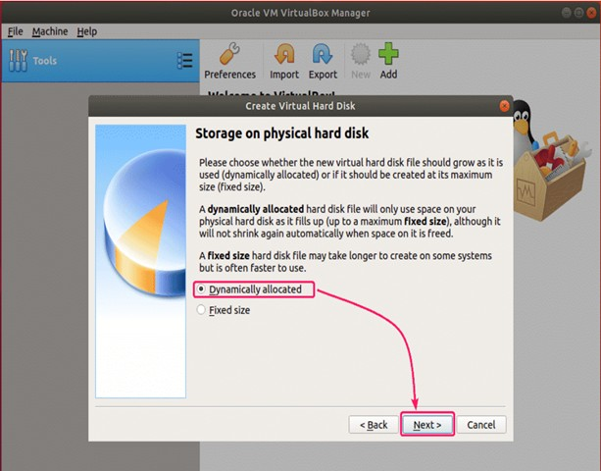

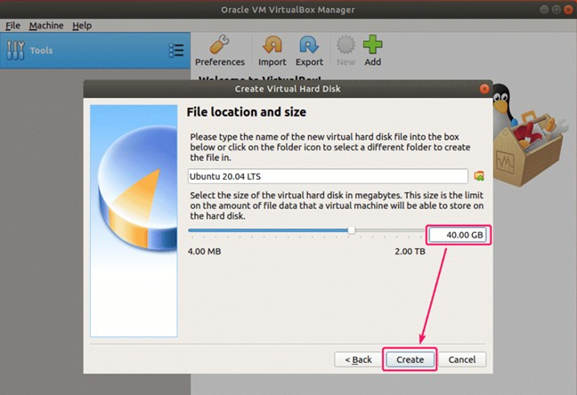

* Set the virtual hard disk size for the VM.
* It should be at least 20.0 GB.
* Once you’re done, click on **Create.**

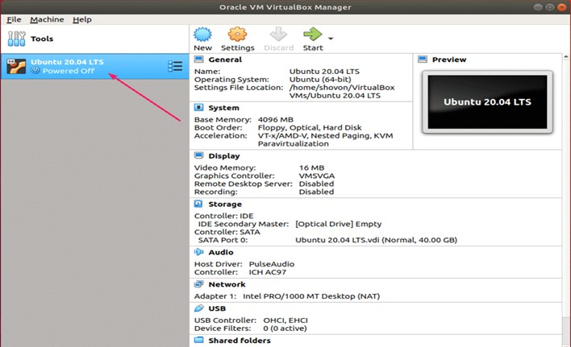

**STARTING THE VM:** Now, select the VM and click on Start.

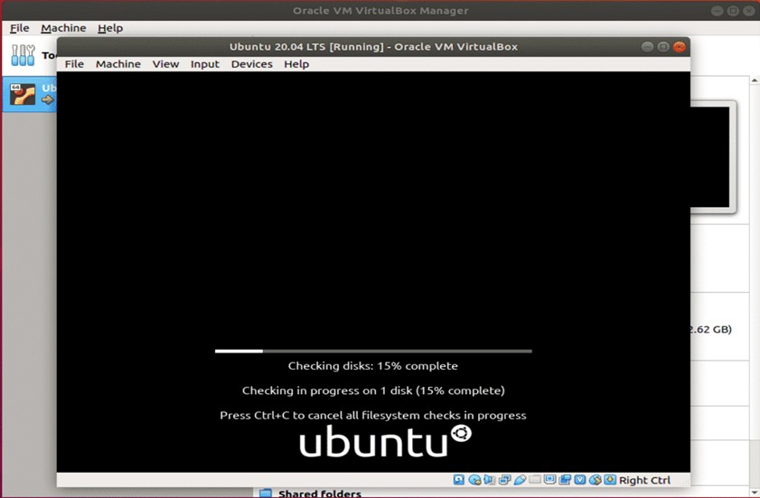

The VM should start and boot from the Ubuntu 20.04 LTS ISO image.

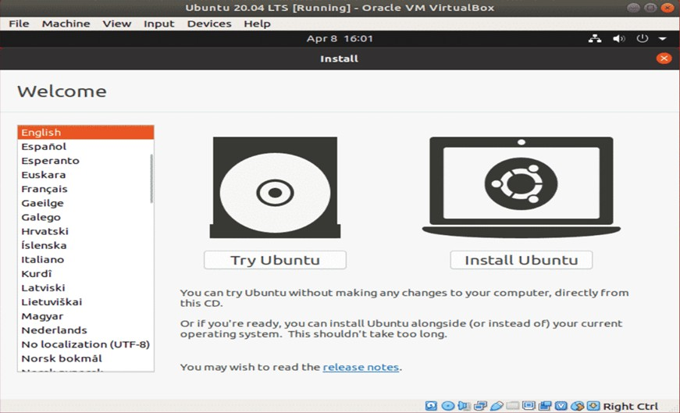

* From here, you can do a **Normal installation** or **Minimal installation**.
* **Normal installation** comes with all the apps as usual.
* **Minimal installation** comes with a limited number of apps. It saves a lot of disk spaces.
* If you have an internet connection on your computer, you can check **Download updates while installing Ubuntu** to download all the necessary updates while installing Ubuntu on your computer.
* Once you’re done, click on **Continue**.

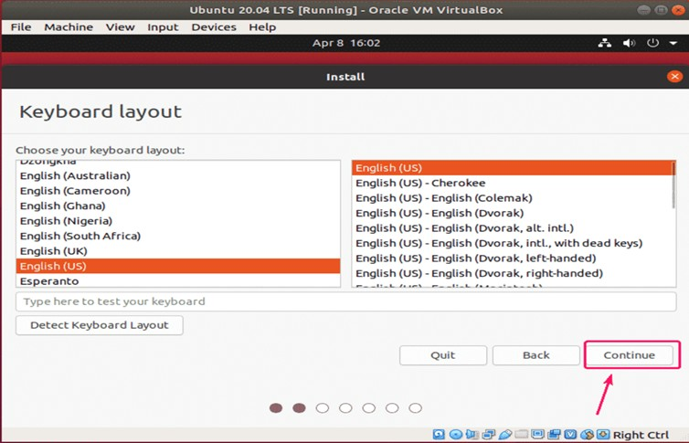

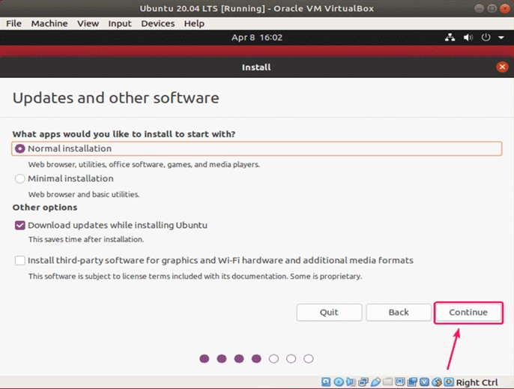

* As this is a VM, I won’t go through the trouble of manually partitioning the hard drive.
* Just select **Erase disk and install Ubuntu** and click on **Install Now**.
* The Ubuntu installer will automatically create all the necessary partitions in your virtual hard drive.

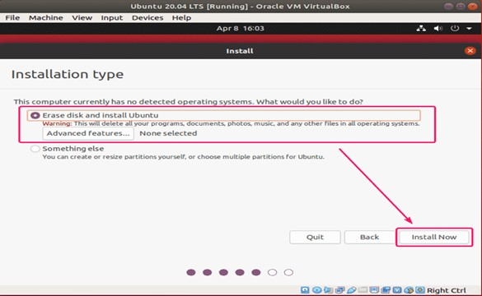

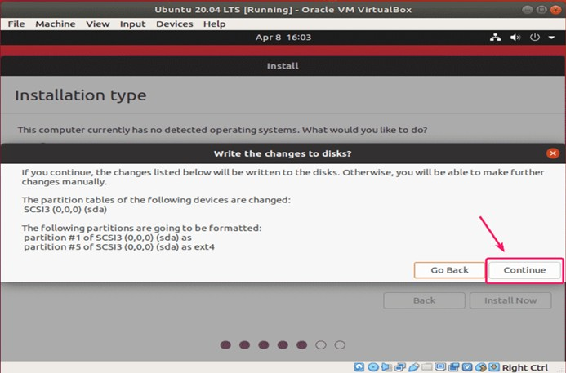

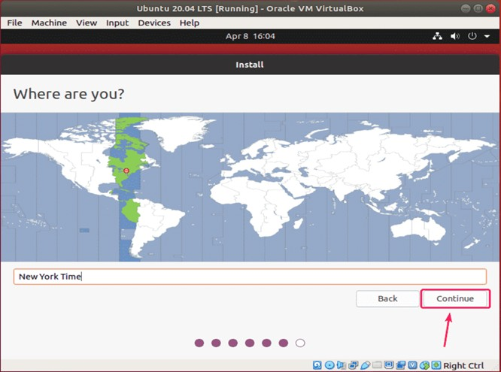

* Try to choose a password that you can remember.
* You can also reset the password in Ubuntu if you forget it.

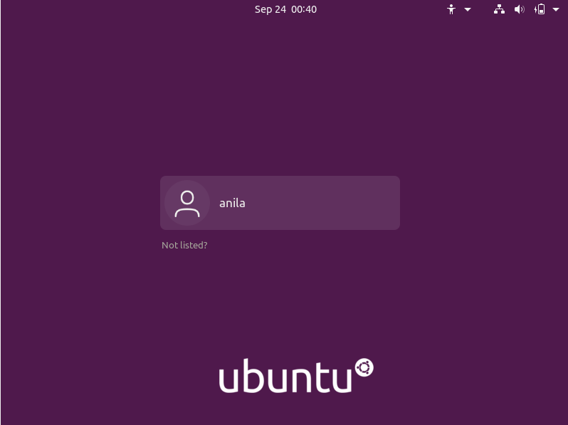

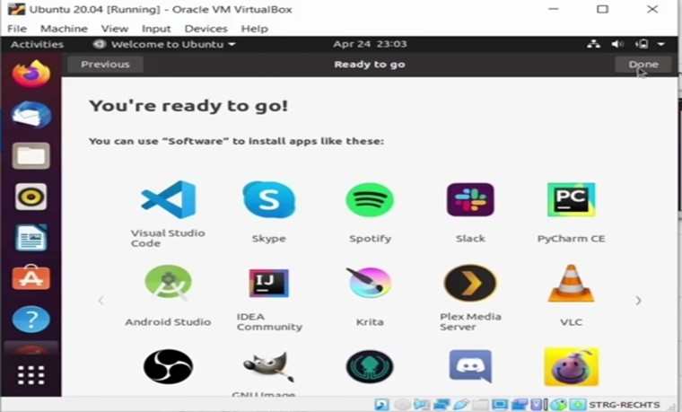

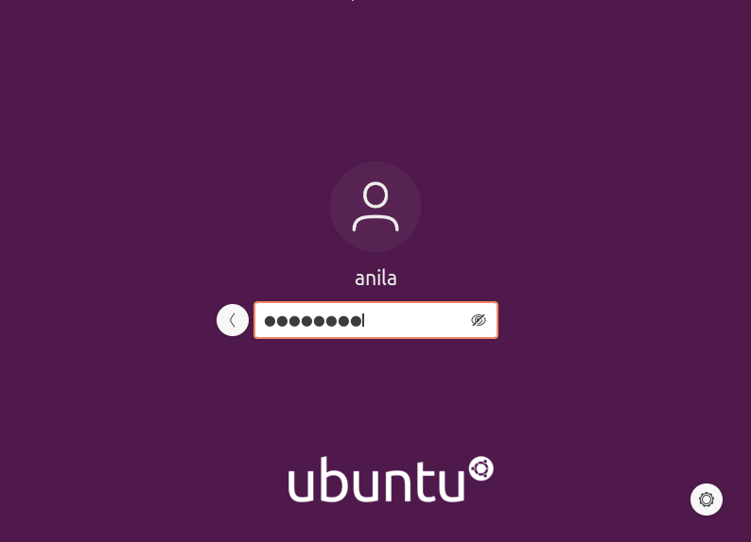



This is how we can install the Ubuntu version of Linux using Virtual Machine.

Date: 28-05-2021

##### EXPERIMENT-4

**INSTALLATION OF WINDOWS ON VIRTUAL BOX IN UBUNTU**

Step 1: Download Windows 10 ISO

First and foremost, you need to download a Windows 10 ISO. You can download Windows 10 32-bit or 64-bit, depending on your system.

Step 2: Install VirtualBox on Ubuntu

Install VirtualBox on Ubuntu using the command sudo apt install virtualbox

Step 3: Install Windows 10 in VirtualBox

Start VirtualBox. You should see a screen like the one below.

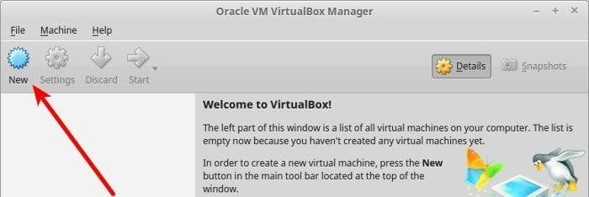

Click on new and name the VM anything you like. Also select the operating system and version. In this case I’ve chosen Windows 10 and 64-bit.

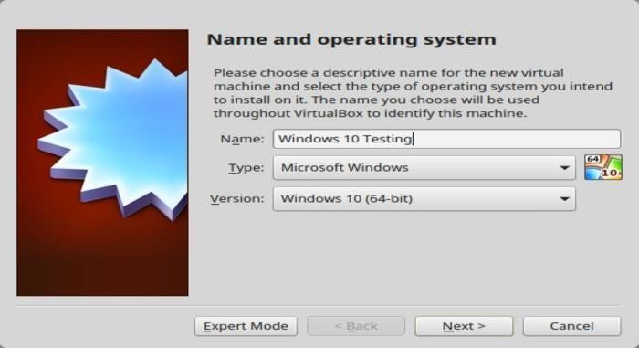

Choose the RAM size. The recommended RAM size for 64-bit Windows 10 is 2 GB, while for 32- bit Windows 10 it’s 1 GB. But I suggest you have a little more than that for a smoother experience

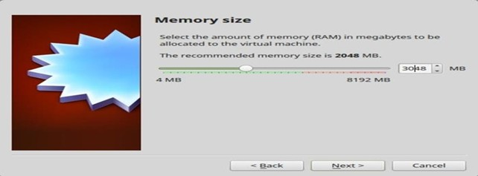

Next is the size for the virtual machine. If you’re crunched on space choose the recommended size, otherwise make it a little more than the recommended size.

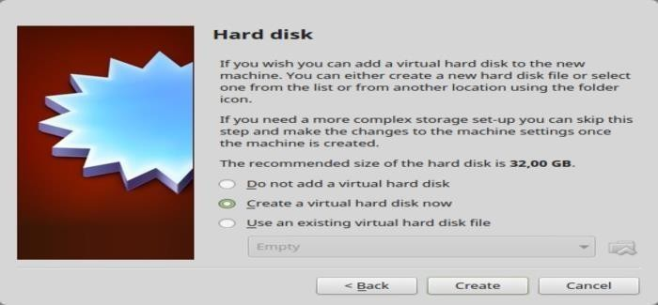

Select Create a virtual disk now, for the format, go ahead with the VDI format.

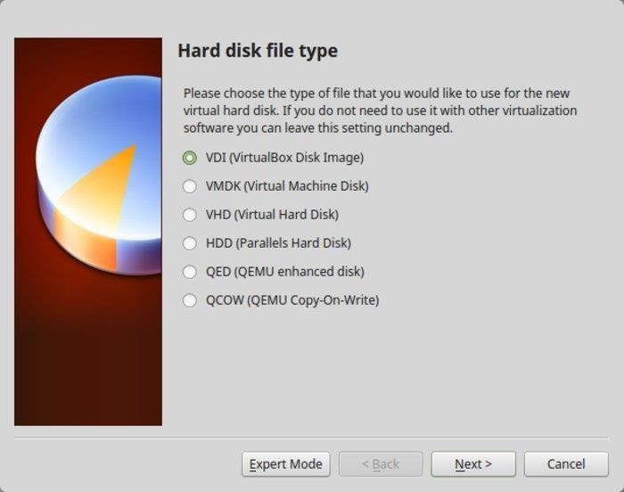

Date: 5-05-21

##### EXPERIMENT-5

**INSTALLATION OF WINDOWS OPERATING SYSTEM ON A**

##### BARE MACHINE

INTRODUCTION

Our Objective is to install Windows 10 Operating system to our PC/Machine via a bootable medium. We will be installing the OS from scratch assuming that we want to update/format/fix the OS in our system by making a fresh installation.

Requirements :

1. PC/Machine with at least 4GB RAM
2. An 8GB DVD or USB Flash drive.
3. Rufus software (https://rufus.ie/en_US/).
4. Required Windows 10 OS/OEM.
5. Strong stable internet connection.

STEP 1 : ACQUIRING REQUIRED OS/OEM

Before installing Windows 10, we must decide which OS version image we should install in our computer. Most users have the option to choose between the official Windows image from Microsoft or the official OEM Image from their Machine manufacturer like. HP, Dell, Asus and so on.

Acquiring Official Windows 10 OS from Microsoft :

1. Go to the Windows 10 official page and select the latest build of the os in dropdown menu and press

‘confirm’.([https://www.microsoft.com/en-us/software](http://www.microsoft.com/en-us/software) download/windows10ISO).

1. A new dropdown menu appears which allows us to choose the preferred language

for our OS. Please choose the required language from the same and press ‘confirm’.

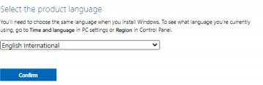

1. Next we see a menu to download the 32-bit & 64-bit architecture versions of the OS for download. Please verify your hardware and download the required version.

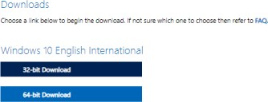

1. The download takes time as the image file is usually 5-6 GB in size. Once the download is complete, we will have file with extension (.iso).

STEP 2: PREPARING BOOTBALE MEDIUM

To install the OS onto a machine, we need a bootable medium containing the installation files. The two common media are bootable Flash drive & bootable DVD. We must prepare either one of them in order to install the OS.

Preparing Bootable DVD:

In order to create a bootable medium, we must burn the downloaded disk image of the OS (.iso) onto an empty DVD. Use either built-in functionality or 3rd-party software for the same.

Preparing Bootable Pen Drive:

1. Download the Rufus software from the official website. (https://rufus.ie/en_US/)&(https://github.com/pbatard/rufus/r eleases/download/v3.14/rufus-3.14.exe)
2. Open the Rufus software and the below UI opens.
3. Insert an empty flash drive with at least 8GB space into your computer and it will appear in the Rufus UI. Now, click the ‘Select’ button and choose the downloaded Windows OS Image (.iso) and click ‘start’ to initiate the process. Remember the flash drive will be formatted on conversion to bootable medium.
4. After the process finishes, the software will notify us the same and our flash drive is now successfully converted into a bootable medium.

STEP 3 : SYSTEM BOOTING & INSTALLATION

Once the bootable medium is ready, we can use it to boot the machine/PC and install the OS to the hard-disk.

1. Insert the bootable DVD or flash drive into the computer and restart it.
2. Usually the BIOS will automatically boot using the bootable medium, otherwise manually bot it up on the boot menu.
3. Choose the required language and layout settings in the initial installation window and press next and install button.
4. Now the installer will prompt you to input a valid License Key. If you do not have one, you can purchase and input it later.
5. Next choose the version of Windows 10 you like to install. Make sure you purchase or have a matching License Key.
6. Accept the software license terms by ticking the checkbox and click next.
7. If you want to upgrade an existing version of Windows, select upgrade option, else select Custom Install for a fresh installation.
8. Next, inside the disk partition screen, you can create disk partitions and select the drive to install windows which will become the C:\ Drive.
9. On clicking next, the installer starts to install the Windows OS to the Hard Disk, please wait as it will take a few minutes to complete the same.
10. On complete installation, the PC will restart and move to a initial screen to configure your region, keyboard layout, time zone settings. Once they are setup, you will be introduced to the Windows 10 Desktop Screen.
11. Now, make sure you update the windows system immediately download and install updates to install necessary drivers and software patches to the system. In case of some proprietary hardware, the user may have to install the drivers manually.
12. Monitor your system performance on Task manager, if everything is working normally, your installation is complete and your system is ready for use.

Date:02-06-2021

**EXPERIMENT-6**

**INSTALLATION OF LINUX OVER WINDOWS OPERATING SYSTEM**

##### Requirements

* PC with at least 2GB RAM.
* 8GB Flash drive
* Rufus
* Linux ISO file

**Steps involved**

* Partition a Hard Drive in Windows 10
* Make a Linux Bootable USB
* Install linux from USB

**Step1: Partition a Hard Drive in Windows 10**

* open cmd
* Type the command “diskmgmt.msc” and hit enter.

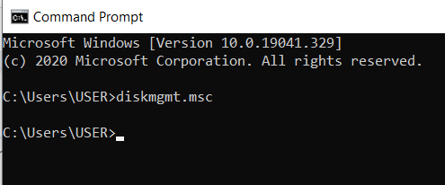

* Right-click on your main hard drive and select Shrink Volume.
* choose how much you want to shrink your drive.

**Step2: Make a Linux Bootable USB**

* Download a Linux distro in ISO format. https://ubuntu.com/
* Insert the USB drive into your computer.
* Download Rufus https://rufus.ie/en_US/
* Open Rufus and select your USB drive from the Device list.
* Under Boot Selection, click the Select button and choose the ISO file you downloaded.

**Step 3:Install linux from USB**

* Place the USB stick,reboot the machine and instruct the UEFI to boot-up from the USB by pressing a special function key (usually F12, F10 or F2 depending on the vendor specifications).
* Choose the language you wish to perform the installation and click on the Continue
* choose the first option “Normal Installation” and hit on the Continue button.
* check the Something else option and hit on the Continue button
* we’ll create our custom partition layout for Ubuntu
* hit the Install Now button in order to apply changes to disk and start the installation process.
* set your machine physical location by selecting a city nearby from the map. When done hit Continue to move ahead.
* Pick up a username and password for your administrative sudo account, enter a descriptive name for your computer and hit Continue to finalize the installation.
* After the installation process reaches its end hit on the Restart Now button in order to complete the installation.
* Ubuntu has successfully installed on your system.

Date: 07-05-2021

##### EXPERIMENT- 7 INSTALLATION OF SERVER SYSTEM

STEP 1: We can download the evaluation ISO of Windows Server 2012 R2 from the following link:

<https://www.microsoft.com/en-us/evalcenter/evaluate-windows-server-2012-r2>

STEP 2: After downloading the ISO of Microsoft, create a boot USB driver which can be created with the Microsoft tool called Windows USB/DVD Download Tool and can be downloaded from the following link:

[https://www.microsoft.com/en-us/download/windows-usb-dvd-download-tool](http://www.microsoft.com/en-us/download/windows-usb-dvd-download-tool)

STEP 3: After completing the above given steps, plug-in the USB to the server and wait for a while till it loads the files.

STEP 4: After the files are loaded, you will see the screen of language settings of installation, keyboard, time and currency format. Generally, all the default ones are also good enough to start with.

Click Next.

STEP 5: Click “Install now”.

STEP 6: Once you have clicked on Install Now, the setup will start and it will load all the files

STEP 7: Wait until the files are loaded . Let’s select Windows Server 2012 DataCenter Evaluation (Server with GUI) and

click Next.

STEP 8: Click “I accept the license terms” and then click on the Next button

STEP 9: A screen will appear in the window. In “Driver Options” you can create a new partition, delete or format the Hard disk. After you have done this process then you can select the partition where the Windows server 2012 R2 will be installed in our case we have one partition. Once all this is done, then click on Next.

STEP 10: Let’s wait until this process finishes during this time and then the server will reboot

STEP 11: Once the reboot is done a screen will appear in the window. Set the password for the server and then click on “Finish”.

STEP 12: It will take some minutes until the setup finishes completely. STEP 13: Once all this is done, you have completed the installation process

##### HOW TO SELECT THE APPROPRIATE OPERATING SYSTEM FOR YOUR SYSTEM

[Stability and Robustness](https://perl.apache.org/docs/general/hardware/hardware.html#toc_Stability_and_Robustness)

Probably the most important features in an OS are stability and robustness. You are in an Internet business. You do not keep normal 9am to 5pm working hours like many conventional businesses you know. You are open 24 hours a day. You cannot afford to be off-line, for your customers will go shop at another service like yours (unless you have a monopoly :). If the OS of your choice crashes every day, first do a little investigation. There might be a simple reason which you can find and fix. There are OSs which won't work unless you reboot them twice a day. You don't want to use the OS of this kind, no matter how good the OS' vendor sales department. Do not follow flushy advertisements, follow developers' advice instead.

[Memory Management](https://perl.apache.org/docs/general/hardware/hardware.html#toc_Memory_Management)

You want an OS with a good memory management, some OSs are well known as memory hogs. The same code can use twice as much memory on one OS compared to another. If the size of the mod_perl process is 10Mb and you have tens of these running, it definitely adds up!

[Memory Leaks](https://perl.apache.org/docs/general/hardware/hardware.html#toc_Memory_Leaks)

Some OSs and/or their libraries (e.g. C runtime libraries) suffer from memory leaks. A leak is when some process requests a chunk of memory for temporary storage, but then does not subsequently release it. The chunk of memory is not then available for any purpose until the process which requested it dies. We cannot afford such leaks. A single mod_perl process sometimes serves thousands of requests before it terminates. So if a leak occurs on every request, the memory demands could become huge. Of course our code can be the cause of the memory leaks as well (check out the Apache::Leak module on CPAN). Certainly, we can reduce the number of requests to be served over the process' life, but that can degrade performance.

[Sharing Memory](https://perl.apache.org/docs/general/hardware/hardware.html#toc_Sharing_Memory)

We want an OS with good memory sharing capabilities. As we have seen, if we preload the modules and scripts at server startup, they are shared between the spawned children (at least for a

part of a process' life - memory pages can become "dirty" and cease to be shared). This feature can reduce memory consumption a lot!

[Cost and Suppor](https://perl.apache.org/docs/general/hardware/hardware.html#toc_Cost_and_Support)t

If we are in a big business we probably do not mind paying another $1000 for some fancy OS with bundled support. But if our resources are low, we will look for cheaper and free OSs. Free does not mean bad, it can be quite the opposite. Free OSs can have the best support we can find. Some do. It is very easy to understand - most of the people are not rich and will try to use a cheaper or free OS first if it does the work for them. Since it really fits their needs, many people keep using it and eventually know it well enough to be able to provide support for others in trouble. Why would they do this for free? One reason is for the spirit of the first days of the Internet, when there was no commercial Internet and people helped each other, because someone helped them in the first place. I was there, I was touched by that spirit and I am keen to keep that spirit alive.

[Discontinued Products](https://perl.apache.org/docs/general/hardware/hardware.html#toc_Discontinued_Products)

The OSs in this hazard group tend to be developed by a single company or organization.

You might find yourself in a position where you have invested a lot of time and money into developing some proprietary software that is bundled with the OS you chose (say writing a mod_perl handler which takes advantage of some proprietary features of the OS and which will not run on any other OS). Things are under control, the performance is great and you sing with happiness on your way to work. Then, one day, the company which supplies your beloved OS goes bankrupt (not unlikely nowadays), or they produce a newer incompatible version and they will not support the old one (happens all the time). You are stuck with their early masterpiece, no support and no source code! What are you going to do? Invest more money into porting the software to another OS.

[OS Releases](https://perl.apache.org/docs/general/hardware/hardware.html#toc_OS_Releases)

Actively developed OSs generally try to keep pace with the latest technology developments, and continually optimize the kernel and other parts of the OS to become better and faster. Nowadays, the Internet and networking in general are the hottest topics for system developers. Sometimes a simple OS upgrade to the latest stable version can save you an expensive hardware upgrade. Also, remember that when you buy new hardware, chances are that the latest software will make the most of it.

Date: 02-06-2021

### CYCLE-2

##### EXPERIMENT- 8

**STUDY ON COMMAND LINE TEXT EDITORS**

LINUX TEXT EDITORS

**Text editors** are programs used to create and edit plain text files. The main purpose of the text editor is to create a file to be used by another program.A text editor plays an important role while coding. So, it is important to select the best text editor. A text editor should not only be simple but also functional and should be good to work with.

A *text editor with IDE features* is considered as a good text editor.

Vi/VIM EDITOR

Vim editor is one of the most used and powerful command-line based editor of the Linux system. By default, it is supported by most Linux distros. It has enhanced functionalities of the old [Unix](https://www.javatpoint.com/vi-editor) [Vi editor](https://www.javatpoint.com/vi-editor). It is a user-friendly editor and provides the same environment for all the Linux distros. It is also termed as **programmer's editor** because most programmers prefer Vi editor.

Vi editor has some special features such as Vi modes and syntax highlighting that makes it powerful than other text editors. Generally, it has two modes:

**Command Mode:** The command mode allows us to perform actions on files. By default, it starts in command mode. In this mode, all types of words are considered as commands. We can execute commands in this mode.

**Insert Mode:** The insert mode allows to insert text on files. To switch from command mode to insert mode, press the **Esc** key to exit from active mode and **'i'** key.

NANO EDITOR

Nano is a straightforward editor. It is designed for both beginners and advanced users. In the nano editor, the useful options are given at the bottom, use the **CTRL+ option** to perform an operation.

Gedit Editor

Gedit editor is the default editor for the GNOME desktop environment. When we open a file, it will open with the Gedit editor. It provides straightforward functionalities like any basic text editor. It is a lightweight editor with a straightforward user interface.

Sublime Text

The sublime text editor is also one of the most popular IDE-based text editors. It is used as a development environment tool more than a text editor.

VSCode Editor

VSCode editor is a modern and widely used text editor. It is built by Microsoft and has support for Linux, Mac and [Windows OS](https://www.javatpoint.com/windows). It is facilitated with many powerful features to support many programming languages and markup languages.

Pico Editor

The Pico editor is a terminal-based Linux text editor. It has built-in support for pine news and email clients. GNU Emacs

GNU Emacs is the oldest and simplest text editor for the Linux system. It is a part of the GNU project. It is still a popular text editor used by thousands of users because of its simplicity. It is written in **C and LISP** programming languages.

1. **pwd**

##### EXPERIMENT- 9 BASIC LINUX COMMANDS

Date: 04-06-2021

Use the **pwd** command to find out the path of the current working directory (folder) you’re in. The command will return an absolute (full) path, which is basically a path of all the directories that starts with a forward slash **(/)**.

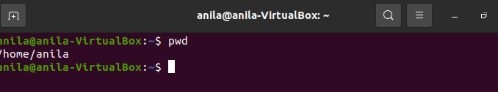

1. cd

To navigate through the Linux files and directories, use the **cd** . It requires either the full path or the name of the directory, depending on the current working directory that you’re in.

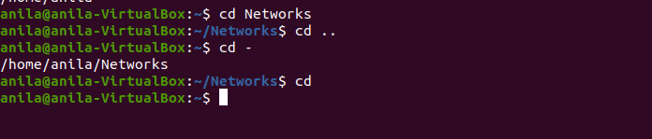

1. ls

The **ls** command is used to view the contents of a directory. By default, this command will display the contents of your current working directory.

* **ls -R** will list all the files in the sub-directories as well
* **ls -a** will show the hidden files
* **ls -al** will list the files and directories with detailed information like the permissions, size, owner, etc.
* ls -t lists files sorted in the order of “last modified”
* -r option will reverse the natural sorting order. Usually used in combination with other switches such as ls -tr. This will reverse the time-wise listing.

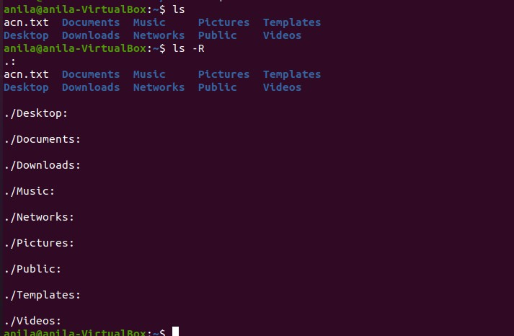

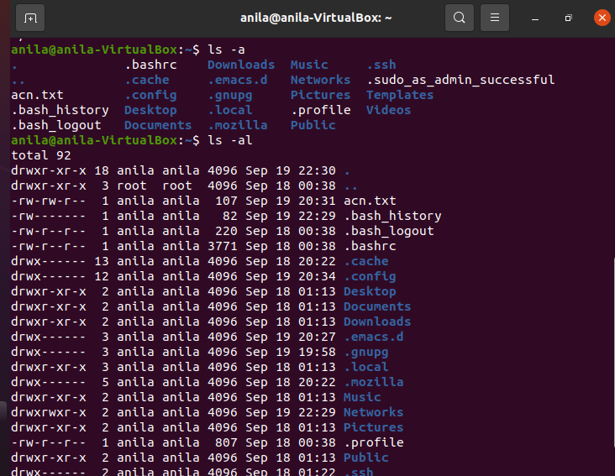

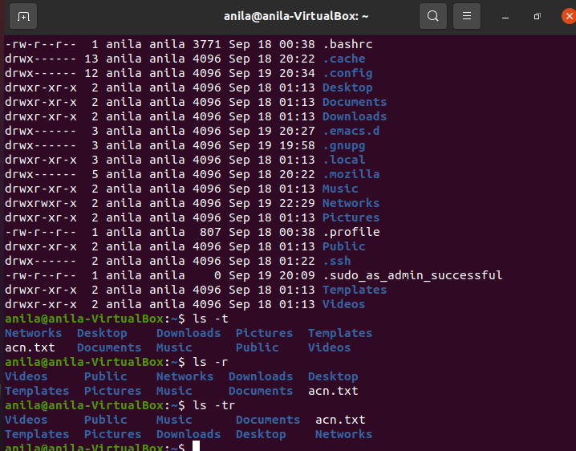

1. cat

**cat** (short for concatenate) is one of the most frequently used commands in Linux. It is used to list the contents of a file on the standard output stdout . To run this command, type **cat** followed by the file’s name and its extension.

* **cat > filename** creates a new file
* **cat filename1 filename2>filename3** joins two files (1 and 2) and stores the output of them in a new file (3)
* to convert a file to upper or lower case use, **cat filename | tr a-z A-Z >output.txt**

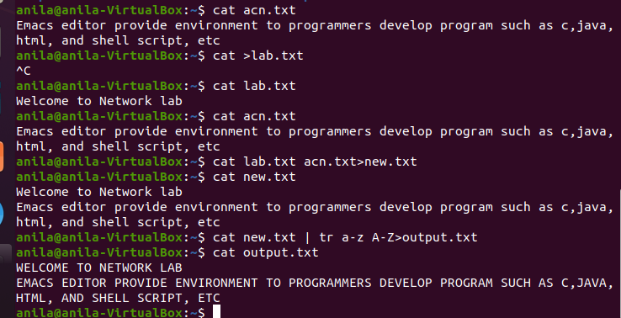

1. cp

Use the **cp** command to copy files from the current directory to a different directory. For instance, the command **cp scenery.jpg /home/username/Pictures** would create a copy of **scenery.jpg** (from your current directory) into the **Pictures** directory.

* cp -i will ask for user’s consent in case of a potential file overwrite.
* cp -p will preserve source files’ mode, ownership and timestamp.
* cp -r will copy directories recursively.
* cp -u copies files only if the destination file is not existing or the source file is newer than the destination file

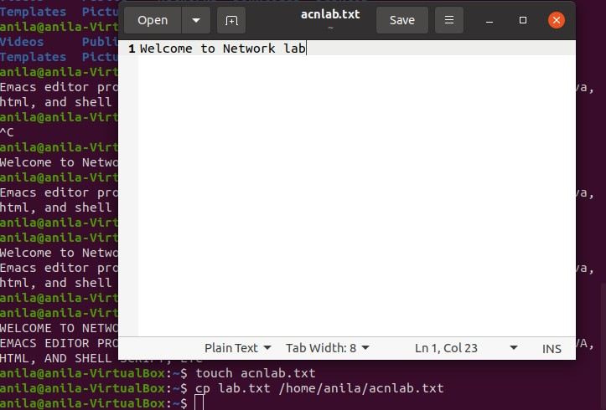.

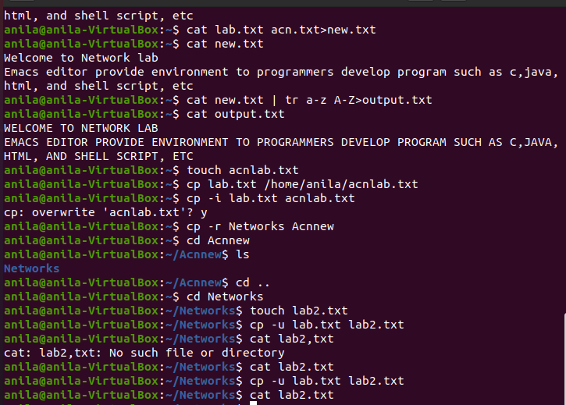

1. mv

The primary use of the **mv** command is to move files, although it can also be used to rename files. The arguments in mv are similar to the cp command.

To rename files, the Linux is **mv oldname.ext newname.ext**

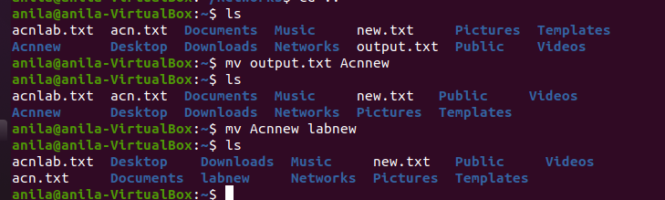

1. mkdir

Use **mkdir** command to make a new directory

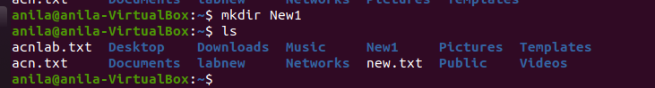

1. rmdir

If you need to delete a directory, use the **rmdir** command. However, rmdir only allows you to delete empty directories.

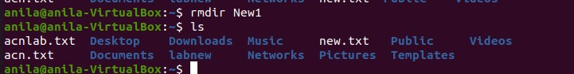

1. rm

The **rm** command is used to delete directories and the contents within them. If you only want to delete the directory — as an alternative to rmdir — use **rm -r**.

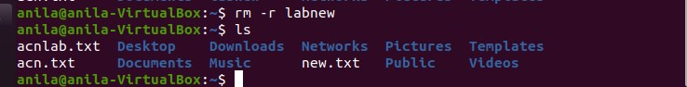

1. touch

The **touch** command allows you to create a blank new file through the Linux command line. As an example, enter touch **/home/username/Documents/Web.html** to create an HTML file entitled **Web** under the **Documents** directory.

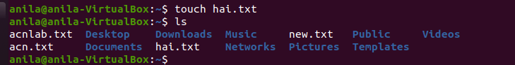

1. locate

You can use this command to **locate** a file, just like the search command in Windows. What’s more, using the **-i** argument along with this command will make it case-insensitive, so you can search for a file even if you don’t remember its exact name.

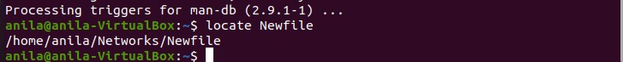

1. find

Similar to the **locate** command, using **find** also searches for files and directories. The difference is, you use the **find** command to locate files within a given directory.

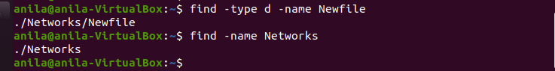

1. grep

Another basic Linux command that is undoubtedly helpful for everyday use is **grep**. It lets you search through all the text in a given file.

To illustrate, **grep blue notepad.txt** will search for the word blue in the notepad file. Lines that contain the searched word will be displayed fully.



1. sudo

Short for “**SuperUser Do**”, this command enables you to perform tasks that require administrative or root permissions. You must have sufficient permissions to use this command.

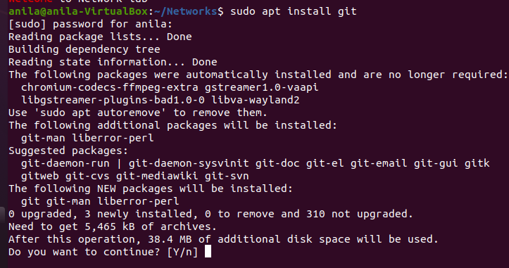

1. df

Use **df** command to get a report on the system’s disk space usage, shown in percentage and KBs. If you want to see the report in megabytes, type **df -m**.

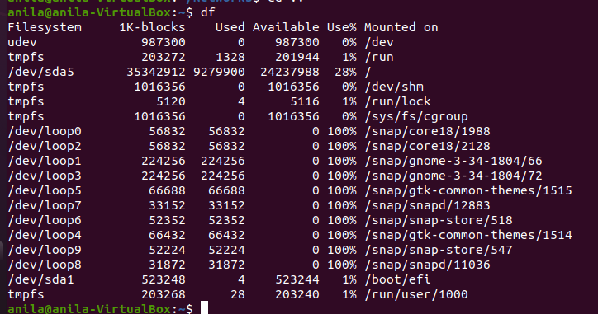

1. du

If you want to check how much space a file or a directory takes, the **du** (Disk Usage) command is the answer. However, the disk usage summary will show disk block numbers instead of the usual size format. If you want to see it in bytes, kilobytes, and megabytes, add the **-h** argument to the

command line.

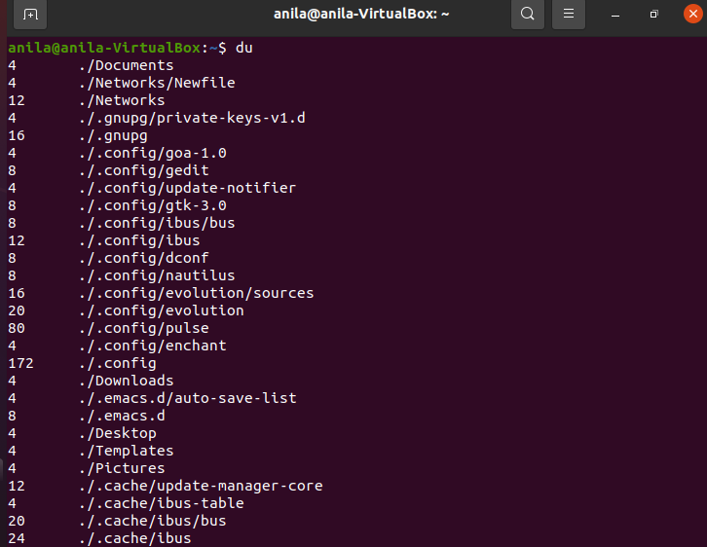

1. head

The **head** command is used to view the first lines of any text file. By default, it will show the first ten lines, but you can change this number to your liking.show the first five lines, type **head -n 5**

1. tail

This one has a similar function to the head command, but instead of showing the first lines, the **tail**

command will display the last ten lines of a text file. For example, **tail -n filename.ext.**

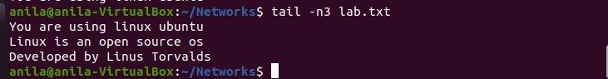

1. diff

Short for difference, the **diff** command compares the contents of two files line by line. After analyzing

the files, it will output the lines that do not match. Programmers often use this command when they need to make program alterations instead of rewriting the entire source code.

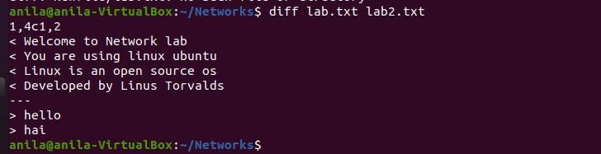

1. tar

The **tar** command is the most used command to archive multiple files into a **tarball** — a common Linux file format that is similar to zip format, with compression being optional.

This command is quite complex with a long list of functions such as adding new files into an existing archive, listing the content of an archive, extracting the content from an archive, and many more.

1. chmod

**chmod** is another Linux command, used to change the read, write, and execute permissions of files and directories. Read about permissions and how to manipulate them .

1. chown

In Linux, all files are owned by a specific user. The **chown** command enables you to change or transfer the ownership of a file to the specified username. For instance, **chown linuxuser2 file.ext** will make **linuxuser2** as the owner of the **file.ext**.

1. ps

**Ps** command will display all current processes along with their process ids (PID) . Read manuals for various options.

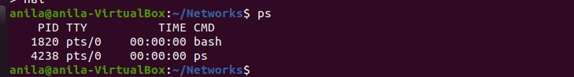

1. Kill

If you have an unresponsive program, you can terminate it manually by using the **kill** command. It will send a certain signal to the misbehaving app and instructs the app to terminate itself.

There is a total of sixty-four signals that you can use, but people usually only use two signals:

* **SIGTERM (15)** — requests a program to stop running and gives it some time to save all of its progress. If you don’t specify the signal when entering the kill command, this signal will be used.
* **SIGKILL (9)** — forces programs to stop immediately. Unsaved progress will be lost.

Besides knowing the signals, you also need to know the process identification number (PID) of the program you want to **kill**. If you don’t know the PID, simply run the command **ps ux**.

**kill [signal option] PID**. You can issue kill -9 PID

1. ping

Use the **ping** command to check your connectivity status to a server. For example, by simply entering **ping google.com**, the command will check whether you’re able to connect to Google and also measure the response time.

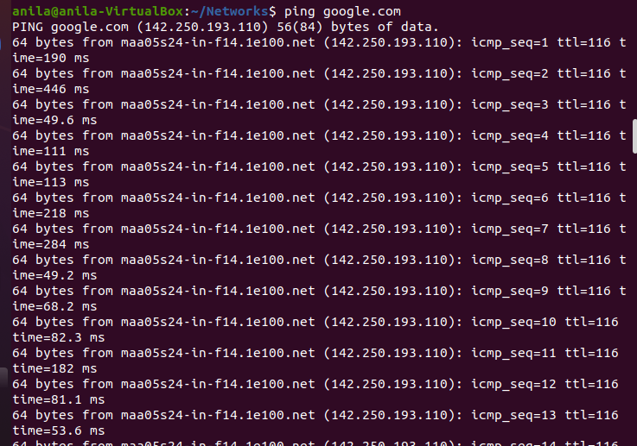

1. wget

The Linux command line is super useful — you can even download files from the internet with the help of the **wget** command. To do so, simply type **wget** followed by the download link.

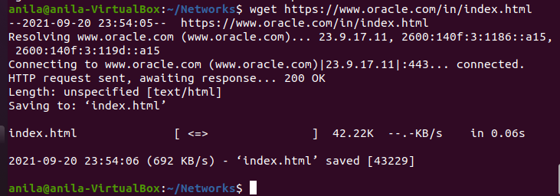

1. uname

The **uname** command, short for Unix Name, will print detailed information about your Linux system like the machine name, operating system, kernel, and so on.



1. top

As a terminal equivalent to Task Manager in Windows, the **top** command will display a list of running processes and how much CPU each process uses. It’s very useful to monitor system resource usage, especially knowing which process needs to be terminated because it consumes too many resources.

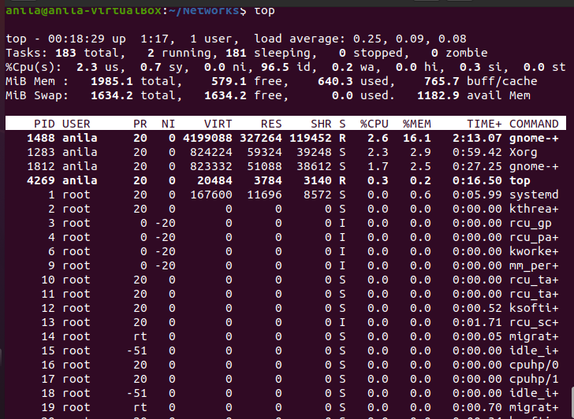

1. history

When you’ve been using Linux for a certain period of time, you’ll quickly notice that you can run hundreds of commands every day. As such, running **history** command is particularly useful if you want to review the s you’ve entered before.

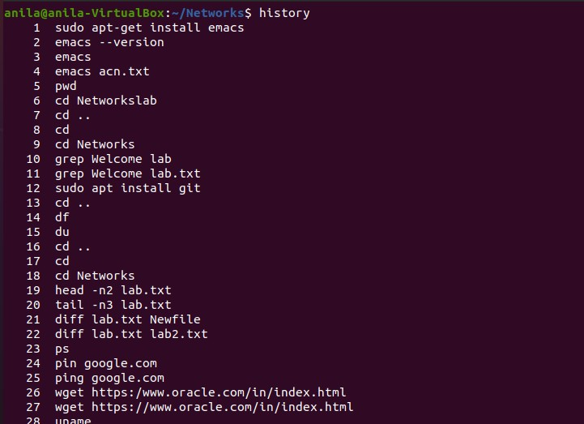

1. man

Confused about the function of certain Linux commands? Don’t worry, you can easily learn how to use them right from Linux’s shell by using the **man** command. For instance, entering **man tail** will show the manual instruction of the tail command.

Use the command: man man to start learning about man utility.

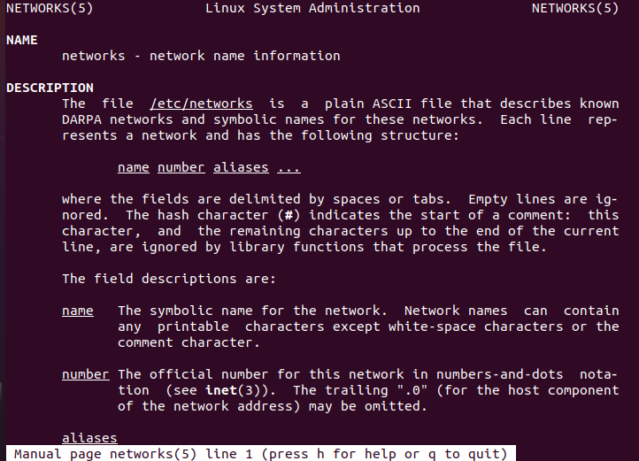

1. echo

This command is used to move some data into a file. For example, if you want to add the text, “Hello, my name is John” into a file called name.txt, you would type **echo Hello, my name is John >> name.txt**



1. zip, unzip

Use the **zip** command to compress your files into a zip archive, and use the **unzip** command to extract the zipped files from a zip archive. ( This program should be installed , some distributions may not have them.

1. hostname

If you want to know the name of your host/network simply type **hostname**. Adding a **-I** to the end will display the IP address of your network.



1. useradd, userdel

This is available only to system admins.Since Linux is a multi-user system, this means more than one person can interact with the same system at the same time. **useradd** is used to create a new user, while **passwd** is adding a password to that user’s account. To add a new person named John type, **useradd John** and then to add his password type, **passwd 123456789.**

To remove a user is very similar to adding a new user. To delete the users account type, **userdel UserName**

Date:08-06-21

##### EXPERIMENT- 10

**FAMILIARISATION WITH VI EDITOR**

The VI editor is the most popular and classic text editor in the Linux family. Below, are some reasons which make it a widely used editor –

1. It is available in almost all Linux Distributions
2. It works the same across different platforms and Distributions
3. It is user-friendly. Hence, millions of Linux use it for their editing needs

Nowadays, there are advanced versions of the vi editor available, and the most popular one is

**VIM** which is **V**i **Im**proved. Some of the other ones are Elvis, Nvi, Nano, and Vile.

* 1. **VI OPERATIONAL MODES**
     + Vi Command Mode:

❏ The vi editor opens in this mode, and it only understands commands.

❏ In this mode, you can perform administrative tasks such as move the cursor and cut, copy, paste the text.

❏ This mode also saves the changes you have made to the file.

❏ Commands are case sensitive. The right letter case should be used.

* + - Vi Insert Mode:

❏ This mode is for inserting text in the file.

❏ You can switch to the Insert mode from the command mode **by pressing 'i' on the keyboard**

❏ Once you are in Insert mode, any key would be taken as an input for the file on which you are currently working.

❏ To return to the command mode and save the changes you have made you need to press the Esc key

* 1. **STARTING VI**

To open a file with vi, type: vi ‘filename’.txt0

1. If the file does not exist, a screen will appear with just a cursor at the top followed by tildes (~) in the first column.
2. If the file does exist, the first few lines of the file will appear.
3. The status line at the bottom of the screen shows error messages and provides information and feedback, including the name of the file.
   1. **Vi EDITING COMMANDS**

★ i - Insert at cursor (goes into insert mode)

★ a - Write after cursor (goes into insert mode)

★ A - Write at the end of line (goes into insert mode)

★ ESC - Terminate insert mode

★ u - Undo last change

★ U - Undo all changes to the entire line

★ o - Open a new line (goes into insert mode)

★ dd - Delete line

★ 3dd - Delete 3 lines.

★ D - Delete contents of line after the cursor

★ C - Delete contents of a line after the cursor and insert new text. Press ESC key to end insertion.

★ dw - Delete word

★ 4dw - Delete 4 words

★ cw - Change word

★ x - Delete character at the cursor

★ r - Replace character

★ R - Overwrite characters from cursor onward

★ s - Substitute one character under cursor continue to insert

★ S - Substitute entire line and begin to insert at the beginning of the line

★ ~ - Change case of individual character

**Note**: You should be in the "**command mode" to execute these commands**. VI editor is

**case-sensitive** so make sure you type the commands in the right letter-case.

Make sure you press the right command otherwise you will end up making undesirable changes to the file. You can also enter the insert mode by pressing a, A, o, as required.

**Moving within a file**

★ k - Move cursor up

★ j - Move cursor down

★ h - Move cursor left

★ l - Move cursor right

You need to be in the command mode to move within a file. The default keys for navigation are mentioned below else; You can **also use the arrow keys on the keyboard**.

**Saving and Closing the file**

★ Shift+zz - Save the file and quit

★ :w - Save the file but keep it open

★ :q - Quit without saving

★ :wq - Save the file and quit

You should be in the **command mode to exit the editor and save changes** to the file.

WORKING WITH Vi EDITOR

**i-**Use this command to insert text before the current cursor location

**o-**Use this command to create a new line for text below the current cursor location

**yy-**Use this command to copy the current line

**P-**Use this command to paste the copied text after the cursor

1. Use this command to delete the character under the current location

Date: 11-06-2021

##### EXPERIMENT- 11

**FAMILIARISATION WITH EMACS EDITOR**

* + Very popular editor.
  + most complex and flexible text editor than other text editors.
  + freedom to the users to editing text files
  + The emacs program can be run either in a terminal or in a GUI.
  + There are two major “brands” of emacs :GNU Emacs and Xemacs, and they have very similar functions.
  + GNU Emacs –most popular version of Emacs which was created by Richard Stallman for the GNU Project.
  + Xemacs is a variant that branched from GNU Emacs In 1991.

Some Features:

* + Faster
  + Powerful
  + Simple

According to Vi editor ,the emacs editor does not use an insert mode

Commands in emacs are either control characters(hold down the <Ctrl> Key while typing another character)

##### Some Important commands

* + CTRL-X + CTRL-C - To exit emac
  + CTRL-H - To access help documentation
  + CTRL-X + CTRL-S - To save the current file
  + CTRL-X + CTRL-W - To save as new file
  + CTRL-X + CTRL-U - To undo the last edit
  + CTRL-G - To cancel the current command
  + CTRL-D - To delete(Kill) the character at the cursor
  + ESC -D - To delete characters from the cursor to the end of the current line
  + CTRL-K - To delete characters from the cursor to the end of the current line
  + ESC –W - To copy region as kill CTRL-Y To paste into the buffer what had been deleted
  + CTRL-S - To search the string from the current cursor position
  + CTRL-R - To search the string above the current cursor position

##### Some Cursor Movement Command

* + ESC-F - To move cursor forward
  + ESC-B - To move the cursor backward one word at a time
  + CTRL-A - To move the cursor to the beginning of the current line
  + CTRL-E - To move the cursor to the end of the current line
  + ESC-< - To move the cursor beginning of the buffer
  + ESC-> - To move the cursor to the end of the buffer

Programming in emacs:

The emacs editor provides an environment to programmers develop programs such as c, java, HTML and shell script etc.

After writing the program source code, it also compiles, links, debug and executes itself in the terminal window to test it.

**Execution of emacs on Linux: Installing emacs editor on Ubuntu**

**$ sudo apt-get install emacs**

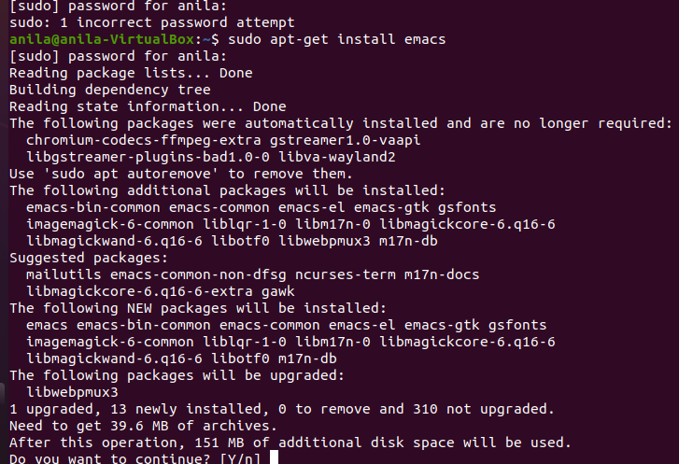

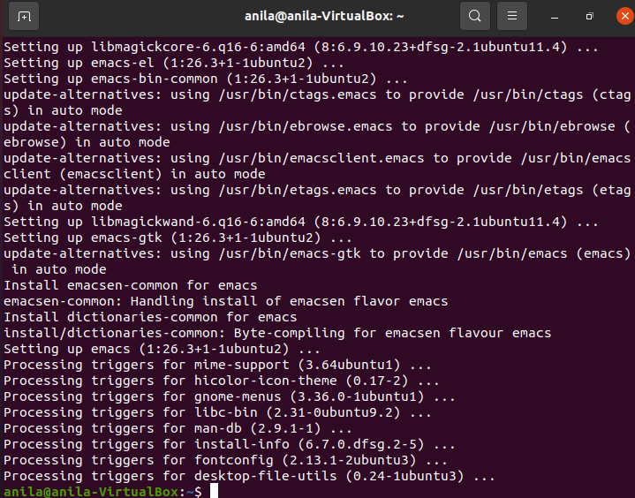

Check version using the command

**$ emacs --version**

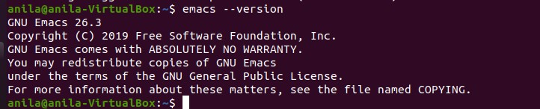

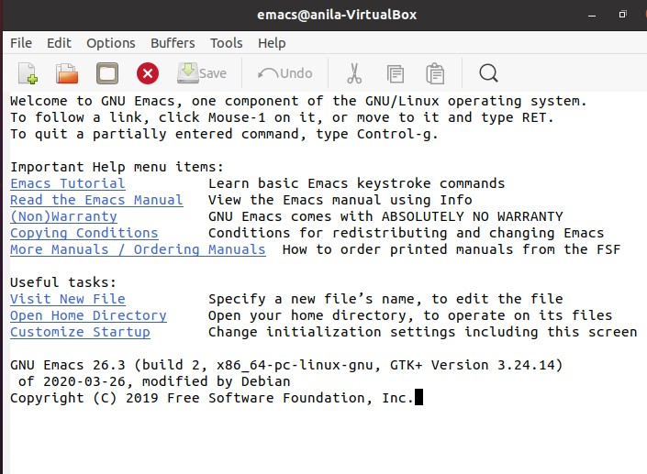

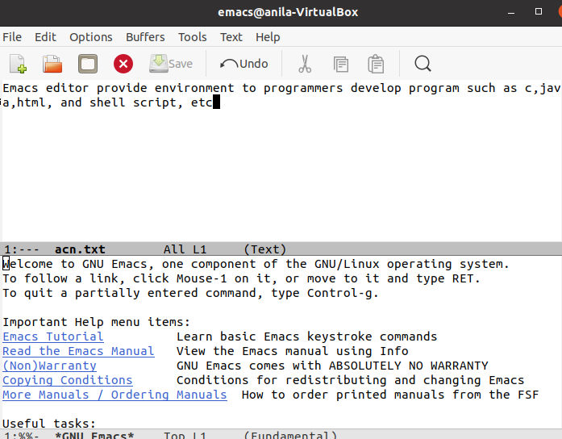

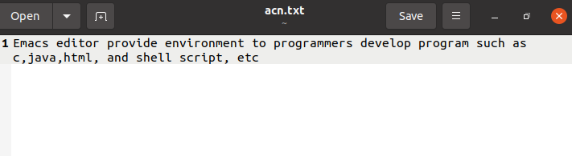

Date: 16-06-2021

##### EXPERIMENT- 12 LINUX FILE SYSTEM

The Linux File Hierarchy Structure or the Filesystem Hierarchy Standard (FHS) defines the directory structure and directory contents in Unix-like operating systems. It is maintained by the Linux Foundation.

Ø In the FHS, all files and directories appear under the root directory /, even if they are stored on different physical or virtual devices.

Ø Some of these directories only exist on a particular system if certain subsystems, such as the X Window System, are installed.

Ø Most of these directories exist in all UNIX operating systems and are generally used in much the same way; however, the descriptions here are those used specifically for the FHS and are not considered authoritative for platforms other than Linux.

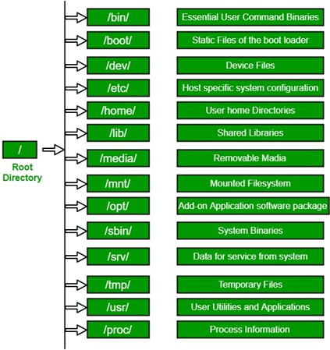

ROOT DIRECTORY

All the directories in the Linux system comes under the root directory which is represented by a forward slash (/).

Everything on your Linux system is located under the / directory, known as the root directory. You can think of the / directory as being similar to the C:\ directory on Windows — but this isn’t strictly true, as Linux doesn’t have drive letters. While another partition would be located at D:\ on Windows, this other partition would appear in another folder under / on Linux.

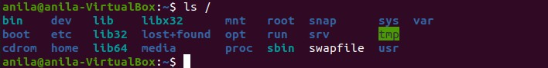

BINARY DIRECTORIES

Binary directory contains following directories:

/bin

/sbin

/lib

/opt

The /bin directory contains the essential user binaries (programs) that must be present when the system is mounted in single-user mode. Applications such as Firefox are stored in /usr/bin, while important system programs and utilities such as the bash shell are located in /bin. The /usr directory may be stored on another partition — placing these files in the /bin directory ensures the system will have these important utilities even if no other file systems are mounted. The /sbin directory is similar — it contains essential system administration binaries.

/bin- The '/bin' directory contains user binaries, executable files, Linux commands that are used in single user model

common commands that are used by all the users, like cat, cp, cd, ls, etc.

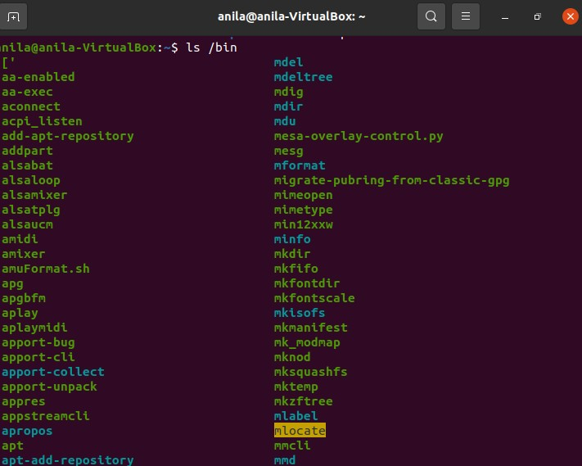

/sbin-'/sbin' directory also contains executable files.

but unlike '/bin' it only contains system binaries which require root privilege to perform certain tasks and are helpful for system maintenance purpose.

e.g. fsck, root, init, ifconfig, etc.

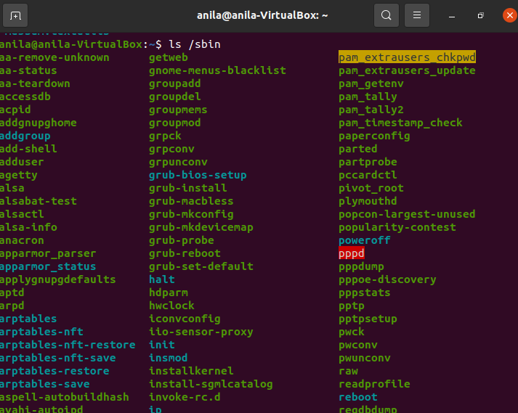

/lib-The '/lib' directory contains shared libraries which are often used by the '/bin' and '/sbin' directories.

It also contains kernel module. These filenames are identable as ld* or lib*.

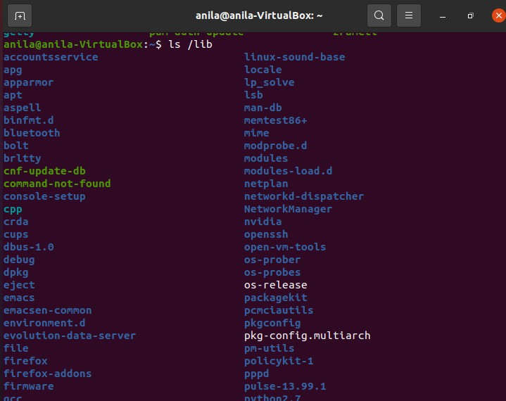

/opt- term 'opt' is short for optional.

Its main purpose is to store optional application software packages.

Add-on applications from individual vendors should be installed in '/opt’.

And so in some systems '/opt' is empty as they may not have any add-on application.

The /opt directory is often where software you compile (that is, you build yourself from source code and do not install from your distribution repositories) sometimes lands. Applications will end up in the /opt/bin directory and libraries in the /opt/lib directory.

A slight digression: another place where applications and libraries end up in is

/usr/local, When software gets installed here, there will also be /usr/local/bin and

/usr/local/lib directories. What determines which software goes where is how the developers have configured the files that control the compilation and installation process.



CONFIGURATION DIRECTORY

The configuration directory contains configured files which configures the parameters and initial settings for some computer programs.

Configuration directory have following sub-diectories:

/boot

/etc

* /boot

The '/boot' directory contains boot loader files which are essential to boot the system.

In other words, they only contain files which are needed for a basic Linux system to get up and going.

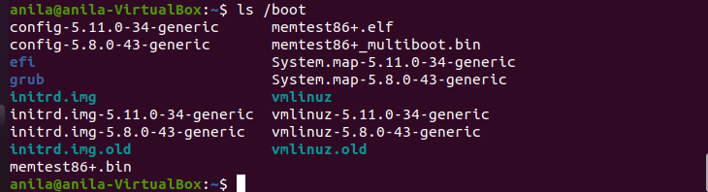

* /etc

All the machine related configurtion files are kept in '/etc'. Almost everything related to the configuration of your system is placed here. It also contain startup and shutdown shell script which is used to start and stop a program. All the files are static and text based and no binary files can be placed in this directory.

The meaning of 'etc' is very controversial. Earlier it was referred to as 'Etcetera' because it could contain all the files that did not belong from anywhere else. But recently its most likely meaning is 'Editable Text Configuration' or 'Extended Tool chest'.

Configuration files will have an extension of .conf.

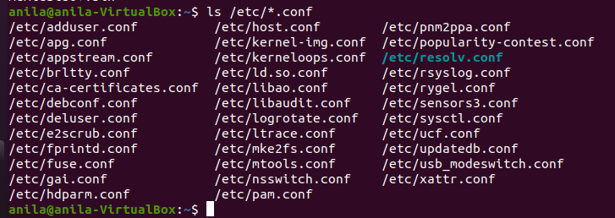

DATA DIRECTORY

Data directory is used to store data of the system. Data directory contains following directories.

/home

/root

/srv

/media

/mnt

/tmp

* /home

The '/home' directory stores users personnel files. After the '/home' there is a directory which is generally named at the user's name like we have '/home/sssit'.

Inside this directory we have our sub-directories like Desktop, Downloads, Documents, pictures, etc.

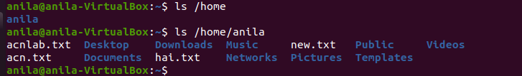

* /root

The '/root' directory is the home directory of the root user. '/root' directory is different from (/) root.

* /srv

The term 'srv' is short for service.

The '/srv' directory contains server specific data for services provided by the system like www, cvs, rysync, ftp, etc.

* /media

The '/media' directory acts as a mount point for removable media devices such as CD-Rom, floppy, USB devices, etc.

This is newly introduced directory and hence a system can run without this directory also.

* /tmp

The term 'tmp' stands for temporary.

Data stored in '/tmp' is temporary and may use either disk space or RAM.

* /dev

/dev contains device files. Many of these are generated at boot time or even on the fly. For example, if you plug in a new webcam or a USB pendrive into your machine, a new device entry will automatically pop up here.

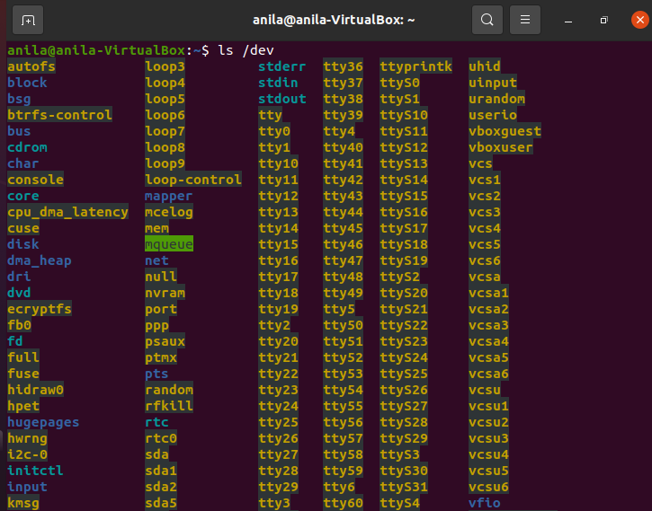

* /mnt

The /mnt directory, however, is a bit of remnant from days gone by. This is where you would manually mount storage devices or partitions. It is not used very often nowadays.

* /proc

/proc, like /dev is a virtual directory. It contains information about your computer, such as information about your CPU and the kernel your Linux system is running. As with /dev, the files and directories are generated when your computer starts, or on the fly, as your system is running and things change.

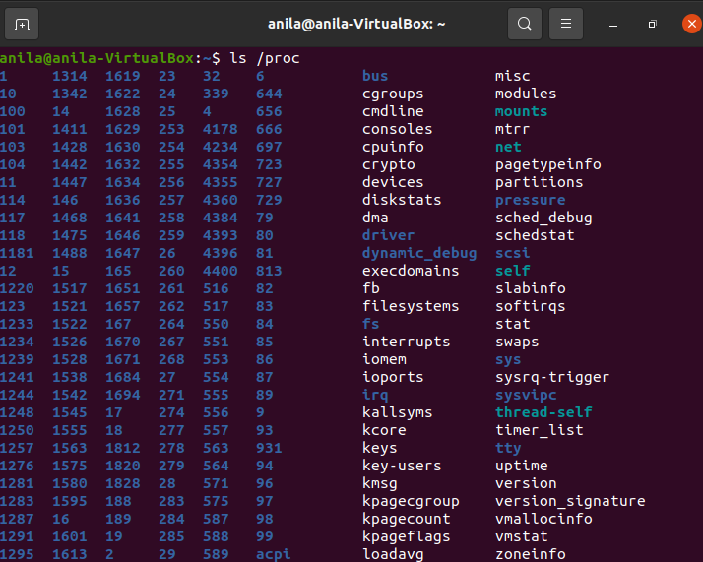

* /run

/run is another new directory. System processes use it to store temporary data for their own nefarious reasons.

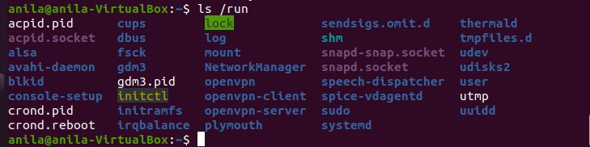

* /usr

The /usr directory was where users’ home directories were originally kept back in the early days of UNIX. However, now /home is where users kept their stuff as we

saw above. These days, /usr contains a mish-mash of directories which in turn contain applications, libraries, documentation,

wallpapers, icons and a long list of other stuff that need to be shared by applications and services.

You will also find bin, sbin and lib directories in /usr. What is the difference with their root-hanging cousins? Not much nowadays. Originally, the /bin directory (hanging off of root) would contain very basic commands, like ls, mv and rm; the kind of commands that would come pre-installed in all UNIX/Linux installations, the bare minimum to run and maintain a system. /usr/bin on the other hand would contain stuff the users would install and run to use the system as a work station, things like word processors, web browsers, and other apps.

But many modern Linux distributions just put everything into /usr/bin and have /bin point to /usr/bin just in case erasing it completely would break something. So, while Debian, Ubuntu and Mint still keep /bin and /usr/bin (and /sbin and /usr/sbin) separate; others, like Arch and its derivatives just have one “real” directory for binaries, /usr/bin, and the rest or *bins are “fake” directories that point to /usr/bin.



* /sys

/sys is another virtual directory like /proc and /dev and also contains information from devices connected to your computer.

In some cases you can also manipulate those devices. I can, for example, change the brightness of the screen of my laptop by modifying the value stored in the

/sys/devices/pci0000:00/0000:00:02.0/drm/card1/card1-eDP-1/intel_backlight/brigh tness file (on

your machine you will probably have a different file). But to do that you have to become a superuser. The reason for that is, as with so many other virtual directories,

messing with the contents and files in /sys can be dangerous and you can trash your system. DO NOT TOUCH until you are sure you know what you are doing.



* /tmp

/tmp contains temporary files, usually placed there by applications that you are running. The files and directories often (not always) contain data that an application doesn’t need right now, but may need later on.

You can also use /tmp to store your own temporary files — /tmp is one of the few directories hanging off / that you can actually interact with without becoming a superuser.

* /var

/var was originally given its name because its contents was deemed variable, in that it changed frequently. Today it is a bit of a misnomer because there are many other directories that also contain data that changes frequently, especially the virtual directories we saw above.

Be that as it may, /var contains things like logs in the /var/log subdirectories. Logs are files that register events that happen on the system. If something fails in the kernel, it will be logged in a file in /var/log; if someone tries to break into your computer from outside, your firewall will also

log the attempt here. It also contains spools for tasks. These “tasks” can be the jobs you send to a shared printer when you have to wait because another user is printing a long document, or mail that is waiting to be delivered to users on the system.

Your system may have some more directories we haven’t mentioned above. In the screenshot, for example, there is a /snap directory. That’s because the shot was captured on an Ubuntu system. Ubuntu has recently incorporated snap packages as

a way of distributing software. The /snap directory contains all the files and the software installed from snaps.

/var/log/syslog contains lot of system related logfiles.



**Installing tree**

Using sudo apt install tree

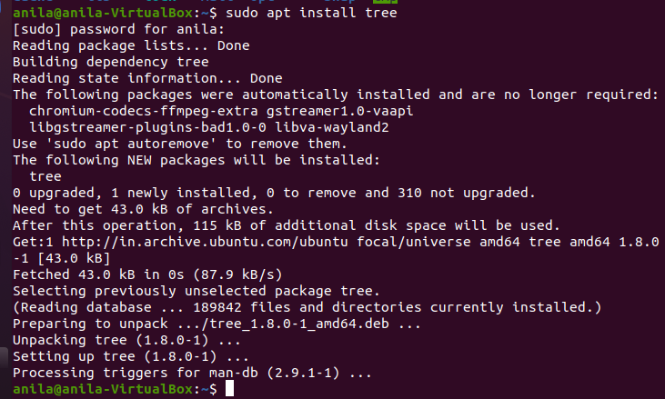

$tree /

The / in the instruction above refers to the root directory. The root directory is the one from which all other directories branch off from. When you run tree and tell it to start with /, you will see the whole directory tree, all directories and all the subdirectories in the whole system, with all their files, fly by.

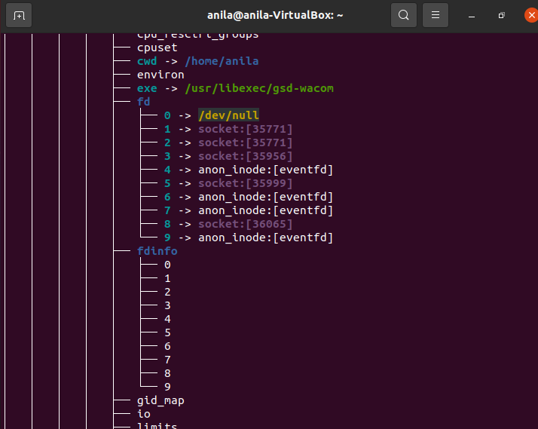

If you have been using your system for some time, this may take a while, because, even if you haven’t generated many files yourself, a Linux system and its apps are always logging, caching, and storing temporary files. The number of entries in the file system can grow quite quickly.

Instead, try this: tree -L 1 /

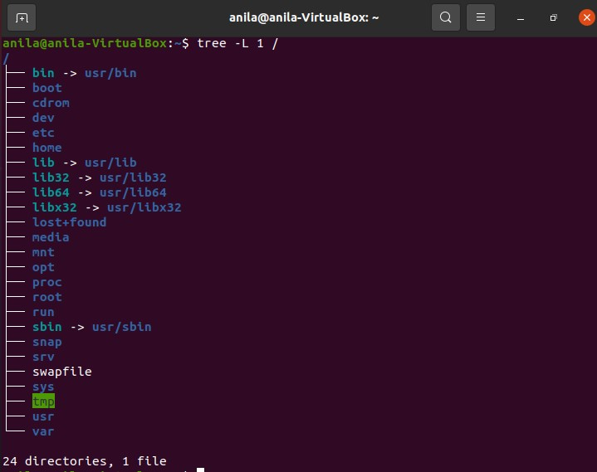

Date: 18-06-2021

### CYCLE- 3

##### EXPERIMENT- 13

**FAMILIARISATION TO LINUX SHELL AND SHELL SCRIPTING**

If you are using any major operating system you are indirectly interacting to **shell**. If you are running Ubuntu, Linux Mint or any other Linux distribution, you are interacting to shell every time you use terminal. In this article I will discuss about linux shells and shell scripting so before understanding shell scripting we have to get familiar with following terminologies –

* + - Kernel
    - Shell
    - Terminal
* **What is Kernel**

The kernel is a computer program that is the core of a computer’s operating system, with complete control over everything in the system. It manages following resources of the Linux system –

* + File management
  + Process management
  + I/O management
  + Memory management
  + Device management etc.
  + It is often mistaken that [**Linus Torvalds**](https://en.wikipedia.org/wiki/Linus_Torvalds) has developed Linux OS, but actually he is only responsible for development of Linux kernel.

Complete Linux system = Kernel + [GNU](https://en.wikipedia.org/wiki/GNU) system utilities and libraries + other management scripts + installation scripts.

★ What is Shell

★ A shell is special user program which provide an interface to user to use operating system services. Shell accept human readable commands from the user and convert them into something which the kernel can understand. It is a command language interpreter that executes commands read from input devices such as keyboards or from files. The shell gets started when the user logs in or starts the terminal.

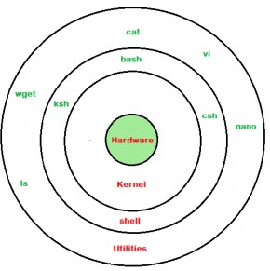

***linux shell***

Shell is broadly classified into two categories –

* Command Line Shell
* Graphical shell

★ Command Line Shell

Shell can be accessed by user using a command line interface. A special program called Terminal in linux/macOS or Command Prompt in Windows OS is provided to type in the human readable commands such as “cat”, “ls” etc. and then it is being execute. The result is then displayed on the terminal to the user. A terminal in Ubuntu 16.4 system looks like this –

” command with “-l” option is executed.

It will list all the files in current working directory in long listing format.

Working with command line shell is bit difficult for the beginners because it’s hard to memorize so many commands. It is very powerful, it allows user to store commands in a file and execute them together. This way any repetitive task can be easily automated. These files are usually called batch files in Windows and Shell Scripts in Linux/macOS systems.

Graphical Shells

Graphical shells provide means for manipulating programs based on graphical user interface (GUI), by allowing for operations such as opening, closing, moving and resizing windows, as well as switching focus between windows. Window OS or Ubuntu OS can be considered as good example which provide GUI to user for interacting with program. User do not need to type in command for every actions.A typical GUI in Ubuntu system –

There are several shells are available for Linux systems like –

* [**BASH (Bourne Again SHell)**](https://en.wikipedia.org/wiki/Bash_(Unix_shell)) **–** It is most widely used shell in Linux systems. It is used as default login shell in Linux systems and in macOS. It can also be installed on Windows OS.
* [**CSH (C SHell)**](https://en.wikipedia.org/wiki/C_shell) **–** The C shell’s syntax and usage are very similar to the C programming language.
* [**KSH (Korn SHell)**](https://en.wikipedia.org/wiki/Korn_shell) **–** The Korn Shell also was the base for the POSIX Shell standard specifications etc.

★ Each shell does the same job but understand different commands and provide different built in functions.

**Shell Scripting**

Usually shells are interactive, that means, they accept commands as input from

users and execute them. However, we want to execute a bunch of commands routinely, so we have to type in all commands each time in the terminal.

As shell can also take commands as input from file we can write these commands in a file and can execute them in shell to avoid this repetitive work. These files are called Shell Scripts or Shell Programs. Shell scripts are similar to the [batch file](https://en.wikipedia.org/wiki/Batch_file) in MS-DOS. Each shell script is saved with .sh file extension eg. myscript.sh

A shell script has syntax just like any other programming language. If you have any prior experience with any programming language like Python, C/C++ etc. it would be very easy to get started with it.

A shell script comprises following elements –

* Shell Keywords – if, else, break etc.
* Shell commands – cd, ls, echo, pwd, touch etc.
* Functions
* Control flow – if..then..else, case and shell loops etc.

★ Why do we need shell scripts

There are many reasons to write shell scripts –

* To avoid repetitive work and automation
* System admins use shell scripting for routine backups
* System monitoring
* Adding new functionality to the shell etc.

**BASH**

Bash is a command language interpreter.

It is widely available on various operating systems and is a default command interpreter on most GNU/Linux systems.

The name is an acronym for the ‘**B**ourne-**A**gain **SH**ell’. Bash (Bourne Again Shell) is a shell program.

It was written by Brian Fox as an enhanced version of the Bourne Shell program 'sh'.

It is an open-source GNU project. It provides functional improvements over Bourne Shell for both programming and interactive use.

Creating a shell script

1. Creating a file using any text editor
2. Start the script with #!/bins/sh
3. Write some code
4. Save the script file as **filename.sh**
5. For executing the script type **bash filename.sh**

Shell Variables

A shell variable is a variable that is available only to the current shell. In contrast, an environment variable is available system wide and can be used by other applications on the system.

Variables store data in the form of character and number. In Linux (Shell), there are two types of variables:

* + System variables - Created and maintained by Linux itself. This type of variable defined in CAPITAL LETTERS.
  + User defined variables (UDV) - Created and maintained by user. This type of variable defined in lower letters

Variables are defined as follows:

variable_name=variable_value eg: NAME="Anushree"

To access the value stored in a variable, prefix its name with the dollar sign ($).

**echo $NAME**

|  |  |
| --- | --- |
| **S.No.** | **Variable & Description** |
| 1 | $0  The filename of the current script. |

|  |  |
| --- | --- |
| 2 | $n  These variables correspond to the arguments with which a script was invoked. Here n is a positive decimal number corresponding to the position of an argument (the first argument is $1, the second argument is $2, and so on). |
| 3 | $#  The number of arguments supplied to a script. |
| 4 | $*  All the arguments are double quoted. If a script receives two arguments, $* is equivalent to $1 $2. |
| 5 | $@  All the arguments are individually double quoted. If a script receives two arguments, $@ is equivalent to $1 $2. |
| 6 | $?  The exit status of the last command executed. |
| 7 | $$  The process number of the current shell. For shell scripts, this is the process ID under which they are executing. |
| 8 | $!  The process number of the last background command. |

Shell Operators

* + Arithmetic Operators
  + Relational Operators
  + Boolean Operators
  + String Operators
  + File Test Operators

Bourne shell didn't originally have any mechanism to perform simple arithmetic operations but it uses external programs, either awk or expr.

Arithmetic Operators

The following arithmetic operators are supported by Bourne Shell.

|  |  |  |
| --- | --- | --- |
| **Operator** | **Description** | **Example** |
| + (Addition) | Adds values on either side of the operator | `expr $a + $b` will give 30 |
| - (Subtraction) | Subtracts right hand operand from left hand operand | `expr $a - $b` will give  -10 |
| * (Multiplication) | Multiplies values on either side of the operator | `expr $a \* $b` will give 200 |
| / (Division) | Divides left hand operand by right hand operand | `expr $b / $a` will give 2 |
| % (Modulus) | Divides left hand operand by right hand operand and returns remainder | `expr $b % $a` will give 0 |
| = (Assignment) | Assigns right operand in left operand | a = $b would assign value of b into a |
| == (Equality) | Compares two numbers, if both are same then returns true. | [ $a == $b ] would return false. |
| != (Not  Equality) | Compares two numbers, if both are different then returns true. | [ $a != $b ] would return true. |

Relational Operators

Bourne Shell supports the following relational operators that are specific to numeric values. These operators do not work for string values unless their value is numeric.

For example, following operators will work to check a relation between 10 and 20 as well as in between "10" and "20" but not in between "ten" and "twenty".

Assume variable **a** holds 10 and variable **b** holds 20 then −

|  |  |  |
| --- | --- | --- |
| **Operator** | **Description** | **Example** |
| **-eq** | Checks if the value of two operands are equal or not; if yes, then the condition becomes true. | [ $a -eq $b ] is not true. |
| **-ne** | Checks if the value of two operands are equal or not; if values are not equal, then the condition becomes true. | [ $a -ne $b ] is true. |
| **-gt** | Checks if the value of left operand is greater than the value of right operand; if yes, then the condition becomes true. | [ $a -gt $b ] is not true. |
| **-lt** | Checks if the value of left operand is less than the value of right operand; if yes, then the condition becomes true. | [ $a -lt $b ] is true. |
| **-ge** | Checks if the value of left operand is greater than or equal to the value of right operand; if yes, then the condition becomes true. | [ $a -ge $b ] is not true. |
| **-le** | Checks if the value of left operand is less than or equal to the value of right operand; if yes, then the condition becomes true. | [ $a -le $b ] is true. |

It is very important to understand that all the conditional expressions should be placed inside square braces with spaces around them. For example, **[ $a <= $b ]** is correct whereas, **[$a <=**

**$b]** is incorrect

Boolean Operators

The following Boolean operators are supported by the Bourne Shell.

Assume variable **a** holds 10 and variable **b** holds 20 then −

|  |  |  |
| --- | --- | --- |
| **Operator** | **Description** | **Example** |
| **!** | This is logical negation. This inverts a true condition into false and vice versa. | [ ! false ] is true. |
| **-o** | This is logical **OR**. If one of the operands is true, then the condition becomes true. | [ $a -lt 20 -o $b -gt 100 ] is true. |
| **-a** | This is logical **AND**. If both the operands are true, then the condition becomes true otherwise false. | [ $a -lt 20 -a $b -gt 100 ] is false. |

String Operators

The following string operators are supported by Bourne Shell. Assume variable **a** holds "abc" and variable **b** holds "efg" then −

|  |  |  |
| --- | --- | --- |
| **Operator** | **Description** | **Example** |
| **=** | Checks if the value of two operands are equal or not; if yes, then the condition becomes true. | [ $a = $b ] is not true. |
| **!=** | Checks if the value of two operands are equal or not; if values are not equal then the condition becomes true. | [ $a != $b ] is true. |
| **-z** | Checks if the given string operand size is zero; if it is zero length, then it returns true. | [ -z $a ] is not true. |
| **-n** | Checks if the given string operand size is non-zero; if it is nonzero length, then it returns true. | [ -n $a ] is not false. |

|  |  |  |
| --- | --- | --- |
| **str** | Checks if **str** is not the empty string; if it is empty, then it returns false. | [ $a ] is not false. |

File Test Operators

We have a few operators that can be used to test various properties associated with a Unix file.

Assume a variable **file** holds an existing file name "test" the size of which is 100 bytes and has **read**, **write** and **execute** permission on −

|  |  |  |
| --- | --- | --- |
| **Operator** | **Description** | **Example** |
| **-b file** | Checks if file is a block special file; if yes, then the condition becomes true. | [ -b $file ] is false. |
| **-c file** | Checks if file is a character special file; if yes, then the condition becomes true. | [ -c $file ] is false. |
| **-d file** | Checks if file is a directory; if yes, then the condition becomes true. | [ -d $file ] is not true. |
| **-f file** | Checks if file is an ordinary file as opposed to a directory or special file; if yes, then the condition becomes true. | [ -f $file ] is true. |
| **-g file** | Checks if file has its set group ID (SGID) bit set; if yes, then the condition becomes true. | [ -g $file ] is false. |
| **-k file** | Checks if file has its sticky bit set; if yes, then the condition becomes true. | [ -k $file ] is false. |
| **-p file** | Checks if file is a named pipe; if yes, then the condition becomes true. | [ -p $file ] is false. |

|  |  |  |
| --- | --- | --- |
| **-t file** | Checks if file descriptor is open and associated with a terminal; if yes, then the condition becomes true. | [ -t $file ] is false. |
| **-u file** | Checks if file has its Set User ID (SUID) bit set; if yes, then the condition becomes true. | [ -u $file ] is false. |
| **-r file** | Checks if file is readable; if yes, then the condition becomes true. | [ -r $file ] is true. |
| **-w file** | Checks if file is writable; if yes, then the condition becomes true. | [ -w $file ] is true. |
| **-x file** | Checks if file is executable; if yes, then the condition becomes true. | [ -x $file ] is true. |
| **-s file** | Checks if file has size greater than 0; if yes, then condition becomes true. | [ -s $file ] is true. |
| **-e file** | Checks if file exists; is true even if file is a directory but exists. | [ -e $file ] is true. |

The read Statement

Used to get user inputs via Keyboard and store them into variables. Syntax:

read var1, var2, …., varN Example:

echo “ Your first name?” read fname

echo “Hello $fname ! Let’s be friends!!”

Condition Statements

Unix Shell supports conditional statements which are used to perform different actions based on different conditions. We will now understand two decision-making statements here −

The if...else statement The case...esac statement

**The if...else statements**

If else statements are useful decision-making statements which can be used to select an option from a given set of options.

Unix Shell supports following forms of if…else statement −

[if...fi statement](https://www.tutorialspoint.com/unix/if-fi-statement.htm) [if...else...fi statement](https://www.tutorialspoint.com/unix/if-else-statement.htm) [if...elif...else...fi statement](https://www.tutorialspoint.com/unix/if-elif-statement.htm)

if-else statement

If specified condition is not true in if part then else part will be executed.

Syntax

if [ expression ] then

statement1 else

statement2

fi

if..elif..else..fi statement (Else If ladder)

To use multiple conditions in one if-else block, then elif keyword is used in shell. If expression1 is true then it executes statement 1 and 2, and this process continues. If none of the condition is true then it processes else part.

Syntax

if [ expression1 ]

then

statement1 statement2

.

.

elif [ expression2] then

statement3 statement4

.

.

else

statement5

fi

if..then..else..if..then..fi..fi..(Nested if)

Nested if-else block can be used when, one condition is satisfying then it again checks another condition. In the syntax, if expression1 is false then it processes else part, and again expression2 will be check.

Syntax:

if [ expression1] then

statement1 statement2

.

else

if [ expression2]

then

fi

fi

statement3

.

**The case...esac Statement**

You can use multiple if...elif statements to perform a multiway branch. However, this is not always the best solution, especially when all of the branches depend on the value of a single variable.

Unix Shell supports case...esac statement which handles exactly this situation, and it does so more efficiently than repeated if...elif statements.

There is only one form of case...esac statement which has been described in detail here − [case...esac statement](https://www.tutorialspoint.com/unix/case-esac-statement.htm)

The case...esac statement in the Unix shell is very similar to the switch...case statement we have in other programming languages like C or C++ and PERL, etc.

A loop is a powerful programming tool that enables you to execute a set of commands repeatedly. In this chapter, we will examine the following types of loops available to shell programmers −

[The while loop](https://www.tutorialspoint.com/unix/while-loop.htm) [The for loop](https://www.tutorialspoint.com/unix/for-loop.htm) [The until loop](https://www.tutorialspoint.com/unix/until-loop.htm) [The select loop](https://www.tutorialspoint.com/unix/select-loop.htm)

You will use different loops based on the situation. For example, the while loop executes the given commands until the given condition remains true; the until loop executes until a given condition becomes true.

Once you have good programming practice you will gain the expertise and thereby, start using appropriate loop based on the situation. Here, while and for loops are available in most of the other programming languages like C, C++ and PERL, etc.

· **While statement**

Here command is evaluated and based on the result loop will executed, if command raise to false then loop will be terminated

Syntax

while command do

Statement to be executed done

· **for statement**

The for loop operate on lists of items. It repeats a set of commands for every item in a list.

Here var is the name of a variable and word1 to wordN are sequences of characters separated by spaces (words). Each time the for loop executes, the value of the variable var is set to the next word in the list of words, word1 to wordN.

Syntax

for var in word1 word2 ...wordn do

Statement to be executed Done

· until statement

The until loop is executed as many as times the condition/command evaluates to false. The loop terminates when the condition/command becomes true.

Syntax

until command do

Statement to be executed until command is true done

Nesting Loops

All the loops support nesting concept which means you can put one loop inside another similar one or different loops. This nesting can go up to unlimited number of times based on your requirement.

Here is an example of nesting while loop. The other loops can be nested based on the programming requirement in a similar way −

Nesting while Loops

It is possible to use a while loop as part of the body of another while loop.

Syntax

while command1 ; # this is loop1, the outer loop

do

Statement(s) to be executed if command1 is true

while command2 ; # this is loop2, the inner loop do

Statement(s) to be executed if command2 is true done

Statement(s) to be executed if command1 is true done

In this chapter, we will learn following two statements that are used to control shell loops−

* The break statement
* The continue statement The infinite Loop

All the loops have a limited life and they come out once the condition is false or true depending on the loop.

A loop may continue forever if the required condition is not met. A loop that executes forever without terminating executes for an infinite number of times. For this reason, such loops are called infinite loops.

The break Statement

The break statement is used to terminate the execution of the entire loop, after completing the execution of all of the lines of code up to the break statement. It then steps down to the code following the end of the loop.

Syntax

The following break statement is used to come out of a loop −

break

The break command can also be used to exit from a nested loop using this format −

break n

Here n specifies the nth enclosing loop to the exit from.

The continue statement

The continue statement is similar to the break command, except that it causes the current iteration of the loop to exit, rather than the entire loop.

This statement is useful when an error has occurred but you want to try to execute the next iteration of the loop.

Syntax

continue

Like with the break statement, an integer argument can be given to the continue command to skip commands from nested loops.

continue n

Here n specifies the nth enclosing loop to continue from.

FUNCTIONS

Functions enable you to break down the overall functionality of a script into smaller, logical subsections, which can then be called upon to perform their individual tasks when needed.

Using functions to perform repetitive tasks is an excellent way to create code reuse. This is an important part of modern object-oriented programming principles.

Shell functions are similar to subroutines, procedures, and functions in other programming languages.

Creating Functions

To declare a function, simply use the following syntax − function_name () {

list of commands

}

The name of your function is function_name, and that's what you will use to call it from

elsewhere in your scripts. The function name must be followed by parentheses, followed by a list of commands enclosed within braces.

Pass Parameters to a Function

You can define a function that will accept parameters while calling the function. These parameters would be represented by $1, $2 and so on.

Following is an example where we pass two parameters Zara and Ali and then we capture and print these parameters in the function.

Returning Values from Functions

If you execute an exit command from inside a function, its effect is not only to terminate execution of the function but also of the shell program that called the function.

If you instead want to just terminate execution of the function, then there is way to come out of a defined function.

Based on the situation you can return any value from your function using the return command whose syntax is as follows −

return code

Here code can be anything you choose here, but obviously you should choose something that is meaningful or useful in the context of your script as a whole.

Date: 06-08-2021

##### EXPERIMENT-14

**LINUX SHELL SCRIPTING PROBLEMS**

1. Write a shell script to get the current date, time, username and current working?

#!/bin/bash

echo "Hello, $LOGNAME" echo "Current date is $(date)" echo "User is $(whoami)"

echo "Current directory $(pwd)"

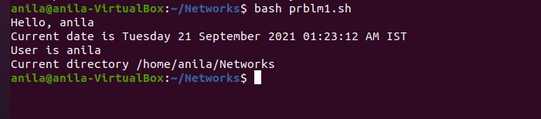

1. How to print the login names of all users on a system?

cat etc/passwd

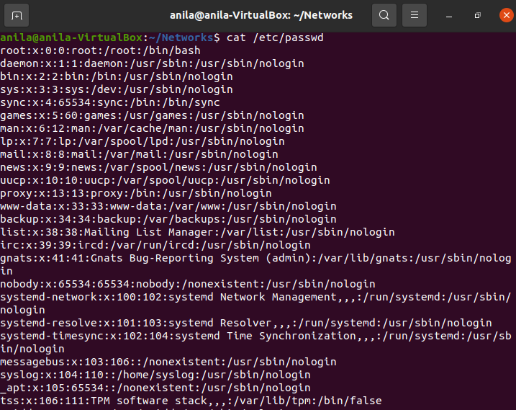

1. How can we pass arguments to a script in Linux? And how to access these arguments from within the script?

We can write a bash script that can accept arguments from the command line in the following manner.

$ ./scriptName "arg1" "arg2"..."argn" #!/bin/bash

# sh parameters .sh 50,51,52 echo "First parameter is 50" echo "Second parameter is 51" echo "Third parameter is 52" exit 0

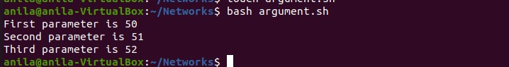

1. How to set an array in Linux?
   1. **Indirect Declaration**

In Indirect declaration, We assigned a value in a particular index of Array Variable. No need to first declare.

ARRAY NAME[INDEXNR]=value

* 1. **Explicit Declaration**

In Explicit Declaration, First We declare an array then assign the values.

declare -a ARRAYNAME

* 1. **Compound Assignment**

In Compound Assignment, We declare an array with a bunch of values. We can add other values later too.

ARRAYNAME=(value1 value2 valueN)

1. **How to check if a directory exists?**

**if [** -d "/path/to/dir" **] then**

**echo** "Directory /path/to/dir exists."

else

**echo** "Error: Directory /path/to/dir does not exists."

fi

1. **What is the difference between $* and $@?**

Ans: $@ treats each quoted arguments as separate arguments but $* considers the entire set of positional parameters as a single string.

1. Use the sed command to replace the content of the file?

Ans: sed -i 's/old-text/new-text/g' input.txt

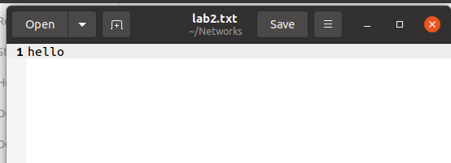



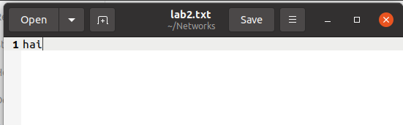

1. Write a script to compare numbers?

#!/bin/bash

# Script to do numeric comparisons var1=10

var2=20

if [ $var2 -gt $var1 ] then

echo "$var2 is greater than $var1"

fi

# Second comparison If [ $var1 -gt 30]then

echo "$var is greater than 30" else

echo "$var1 is less than 30"

fi



1. Write a shell script to check to see if the file “file_path” exists.

If it does exist, display “file_path passwords are enabled.” Next, check to see if you can write to the file. If you can, display “You have permissions to edit “file_path.””If you cannot, display “You do NOT have permissions to edit“file_path””**?**

#!/bin/bash FILE=””

if [ -e “$FILE” ] then

echo “$FILE passwords are enabled”

fi

if [ -x “$FILE” ] then

echo “You have permission to execute $FILE” else echo “You do Not have permissions to execute $FILE”

fi

1. How to print all array indexes?

echo ${ARRAYNAME[*]} #! /bin/bash

# To declare static Array arr=(green pink green yellow red) # To print all elements of array

echo ${arr[@]}

echo ${arr[*]}

echo ${arr[@]:0}

echo ${arr[*]:0}



1. Write a shell script to display the last updated file or the newest file in a directory?

#!/bin/bash

ls -lrt | grep ^- | awk 'END{print $NF}'

1. Write a shell script that adds an extension “.new” to all the files in Directory?

running the test script.

#!/bin/bash dir=$1

for file in `ls $1/*` do

mv $file $file.new done

1. Write a shell script to print a number in reverse order. It should support the following requirements.

#!/bin/bash if [ $# -ne 1 ] then

echo "Provide the correct input in the above format." echo "Usage: $0 number"

echo " this script will reverse the given number." echo " For eg. $0 1234, will print 4321"

exit 1

fi

n=$1 rev=0 sd=0

while [ $n -gt 0 ] do

sd=`expr $n % 10` rev=`expr $rev \* 10 + $sd` n=`expr $n / 10`

done

echo "Reverse number is $rev"

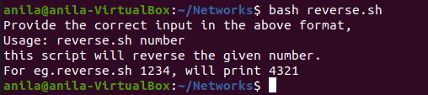

1. Write a shell script delete a file which has special characters in its file name?

In Linux or Unix-like systems, you may come across file names including the following special characters, white spaces, backslashes and more.

-

--

;

&

$

?

*

Bash shell considers most of the above special characters as commands. Thus, the “rm” command may not be able to delete such files. The simplest way to delete files having special characters in its name is by using the inode number

1. Write a shell script to find out the unique words in a file and also count the occurrence of each of these words. We can say that the file under consideration contains many lines, and each line has multiple words

$ cat animal.txt tiger bear

elephant tiger bear bear

Following test script/command will count the unique words.

$ awk '{for(i=1;i<=NF;i++)a[$i]++;}END{for(i in a){print i, a[i];}}' animal.txt

1. Write a script to print the first 10 elements of the Fibonacci series.

# Program for Fibonacci # Series

# Static input fo N N=6

# First Number of the # Fibonacci Series a=0

# Second Number of the # Fibonacci Series

b=1

echo "The Fibonacci series is : " for (( i=0; i<N; i++ ))

do

echo -n "$a " fn=$((a + b)) a=$b

b=$fn done

# End of for loop

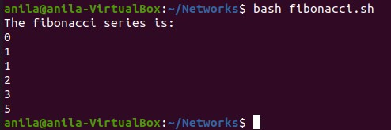

17 .Write a shell script to get the total count of the word “Linux” in all the “.txt” files and also across files present in subdirectories.

The following is the test script/command which recursively searches for the “.txt” files and returns the total occurrences of a word <Linux>.

$ find . -name *.txt -exec grep -c Linux '{}' \; | awk '{x+=$0;}END{print x}'

1. Write a shell script to validate password strength. Here are a few assumptions for the password string.
   * Length – minimum of 8 characters.
   * Contain both the alphabet and number.
   * Include both the small and capital case letters.

If the password doesn’t comply with any of the above conditions, then the script should report it as a <Weak Password>

**Ans.**

Password Validation Script echo "Enter your password" read password len="${#password}"

if test $len -ge 8 ; then

echo "$password" | grep -q [0-9] if test $? -eq 0 ; then

echo "$password" | grep -q [A-Z]

if test $? -eq 0 ; then

echo "$password" | grep -q [a-z] if test $? -eq 0 ; then

echo "Strong Password" else

echo "Weak Password -> Should include a lower case letter."

fi

else

echo "Weak Password -> Should include a capital case letter."

fi

else

echo "Weak Password -> Should use numbers in your password." fi

else

echo "Weak Password -> Password length should have at least 8 characters."

fi

### CYCLE- 4

Date: 13-08-2021

**EXPERIMENT- 15 INSTALLATION OF LAMP STACK**

Introduction

A “LAMP” stack is a group of open-source software that is typically installed together to enable a server to host dynamic websites and web apps. This term is actually an acronym which represents the Linux operating system, with the Apache web server. The site data is stored in a MySQL database, and dynamic content is processed by PHP

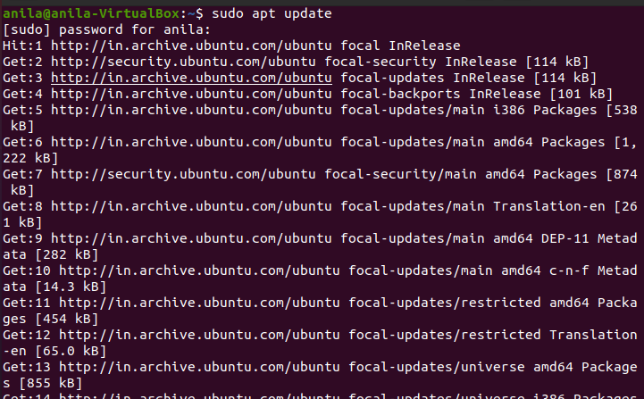Step 1 — Installing Apache and Updating the Firewall sudo apt update

sudo apt install apache2

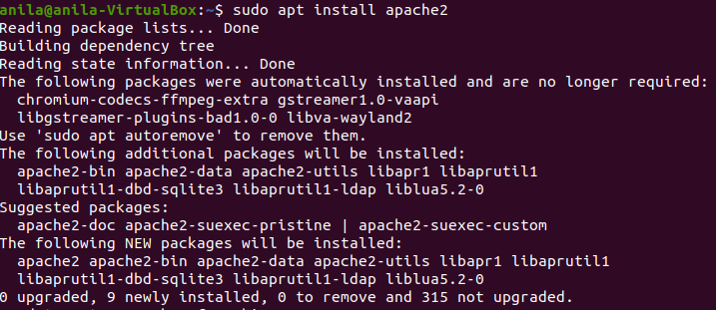

sudo ufw app list

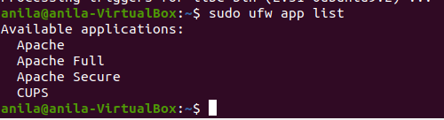

sudo ufw app info "Apache Full"

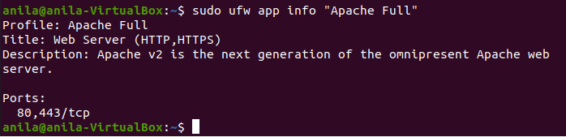

You will see the default Ubuntu 18.04 Apache web page, which is there for informational and testing purposes. It should look something like this:

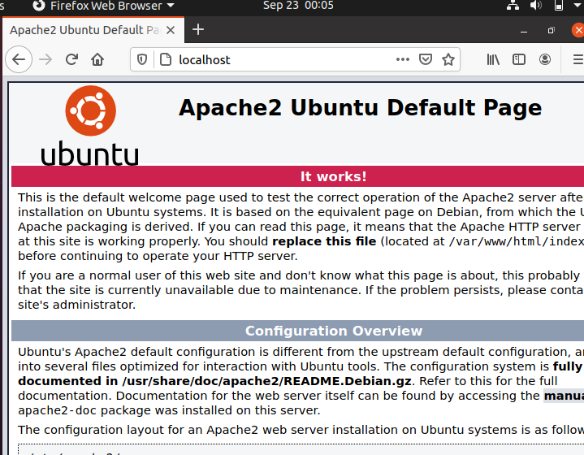

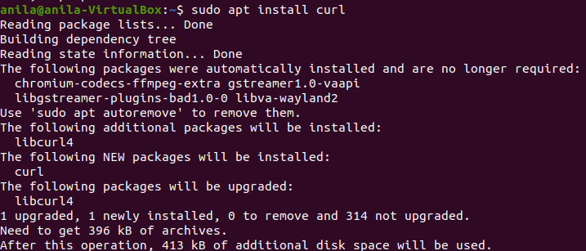

Step 2 — Installing MySQL sudo apt install mysql-server

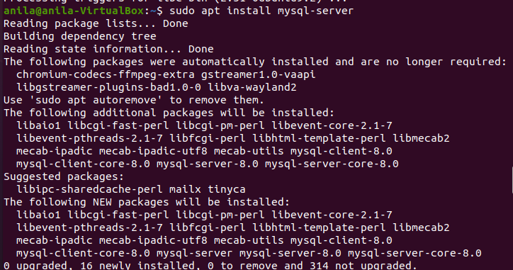

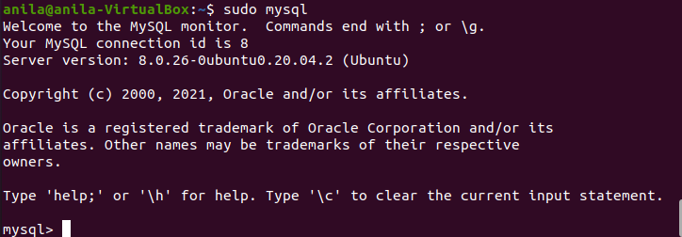sudo mysql_secure_installation sudo mysql

Step 3 — Installing PHP

sudo apt install php libapache2-mod-php php-mysql

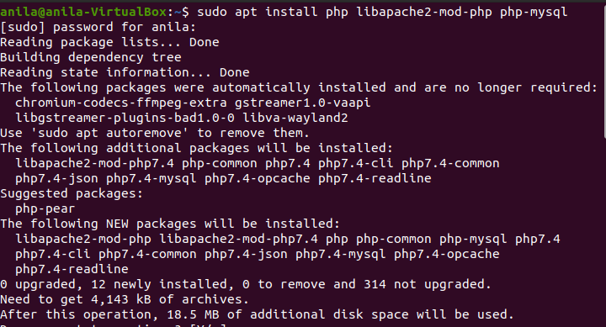

Step 4 — Testing PHP Processing on your Web Server

In order to test that your system is properly configured for PHP, create a PHP script called info.php. In order for Apache to find this file and serve it correctly, it must be saved to your web root directory.

Create the file at the web root you created in the previous step by running:

$ sudo nano /var/www/your_domain/info.php

This will open a blank file. Add the following text, which is valid PHP code, inside the file:

<?php phpinfo();

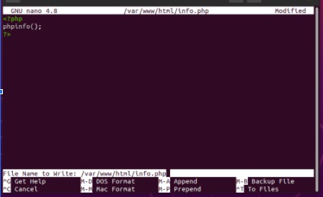

When you are finished, save and close the file. Now you can test whether your web server is able to correctly display content generated by this PHP script. To try this out, visit this page in your web browser. You’ll need your server’s public IP address or domain name again.

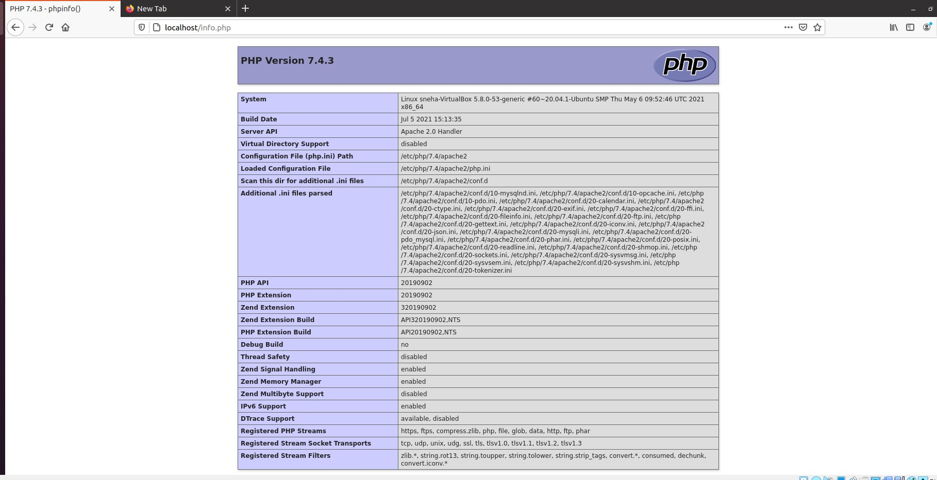The address you will want to visit is: http://your_domain/info.php

Date: 01-09-2021

##### EXPERIMENT- 16

**INSTALLATION OF LARAVEL**

Laravel is an open-source PHP framework, which is robust and easy to understand. It follows a model-view-controller design pattern. Laravel reuses the existing components of different frameworks which helps in creating a web application. The web application thus designed is more structured and pragmatic.

Laravel offers a rich set of functionalities which incorporates the basic features of PHP frameworks like CodeIgniter, Yii and other programming languages like Ruby on Rails. Laravel has a very rich set of features which will boost the speed of web development.

If you are familiar with Core PHP and Advanced PHP, Laravel will make your task easier. It saves a lot time if you are planning to develop a website from scratch. Moreover, a website built in Laravel is secure and prevents several web attacks.

Advantages of Laravel

Laravel offers you the following advantages, when you are designing a web application based on it −

* + The web application becomes more scalable, owing to the Laravel framework.
  + Considerable time is saved in designing the web application, since Laravel reuses the components from other framework in developing web application.
  + It includes namespaces and interfaces, thus helps to organize and manage resources.

Composer

Composer is a tool which includes all the dependencies and libraries. It allows a user to create a project with respect to the mentioned framework (for example, those used in Laravel installation). Third party libraries can be installed easily with help of composer.

All the dependencies are noted in composer.json file which is placed in the source folder.

Artisan

Command line interface used in Laravel is called Artisan. It includes a set of commands which assists in building a web application. These commands are incorporated from Symphony framework, resulting in add-on features in Laravel 5.1 (latest version of Laravel).

#### Features of Laravel

Laravel offers the following key features which makes it an ideal choice for designing web applications −

Modularity

Laravel provides 20 built in libraries and modules which helps in enhancement of the application. Every module is integrated with Composer dependency manager which eases updates.

Testability

Laravel includes features and helpers which helps in testing through various test cases. This feature helps in maintaining the code as per the requirements.

Routing

Laravel provides a flexible approach to the user to define routes in the web application. Routing helps to scale the application in a better way and increases its performance.

**INSTALLATION:**

For managing dependencies, Laravel uses composer. Make sure you have a Composer installed on your system before you install Laravel. In this chapter, you will see the installation process of Laravel.

You will have to follow the steps given below for installing Laravel onto your system − Step 1 − Visit the following URL and download composer to install it on your system. <https://getcomposer.org/download/>

Step 2 − After the Composer is installed, check the installation by typing the Composer command in the command prompt as shown in the following screenshot.

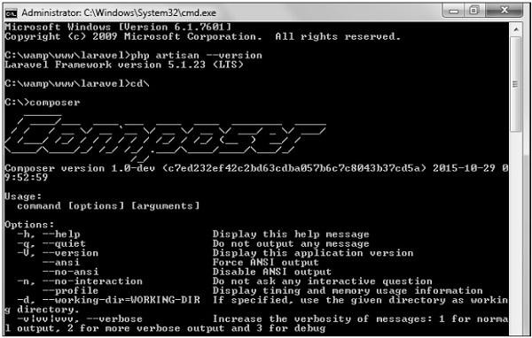

Step 3 − Create a new directory anywhere in your system for your new Laravel project. After that, move to path where you have created the new directory and type the following command there to install Laravel.

composer create-project laravel/laravel –-prefer-dist

Now, we will focus on installation of version 5.7. In Laravel version 5.7, you can install the complete framework by typing the following command −

composer create-project laravel/laravel test dev-develop

The output of the command is as shown below −

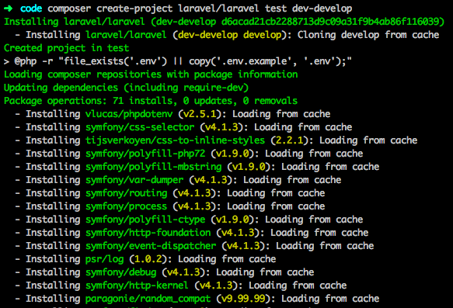

The Laravel framework can be directly installed with develop branch which includes the latest framework.

Step 4 − The above command will install Laravel in the current directory. Start the Laravel service by executing the following command.

php artisan serve

Step 5 − After executing the above command, you will see a screen as shown below −

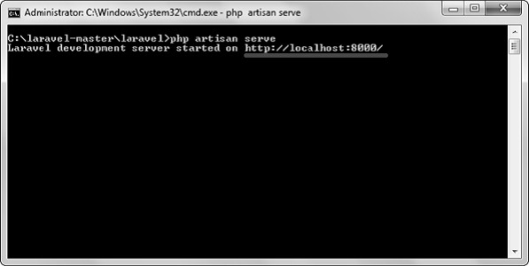

Step 6 − Copy the URL underlined in gray in the above screenshot and open that URL in the browser. If you see the following screen, it implies Laravel has been installed successfully.

### CYCLE- 5

**Date: 03-09-2021**

**EXPERIMENT- 17 INTRODUCTION TO COMMAND LINE TOOL FOR**

##### NETWORKING

Network Commands

The operating system consists of various built-in, command-line networking utilities that are used for network troubleshooting.

1. Ping
2. Hostname
3. Netstat
4. If Config
5. Nslookup
6. Traceroute
7. Route
   1. **PING** (PACKET INTERNET GROPER)

* Most widely used utility tool to troubleshoot
* It sends packets of information to the user-defined source. If the packets are received , the destination device sends packets back.
* Ping can be used for two purposes:
  + 1. Network connection can be established
    2. Speed of the connection
* Ping is used to test a network host's capacity to interact with another host. Just enter the command Ping, followed by the target host’s name or IP address.



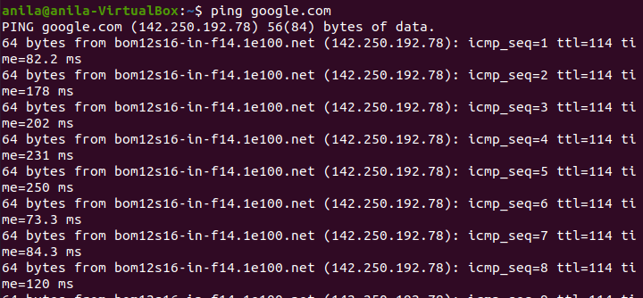

* 1. HOSTNAME

Hostname :displays the machine hostname

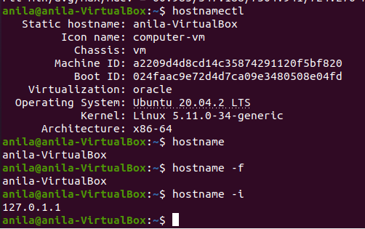Hostname –f :displays the fully qualified host and domain name Hostname –I :displays the ip address for the current machine

* 1. NETSTAT

Netstat command displays various network related information such as network connections, routing tables, interface statistics, multicast memberships etc.

netstat -a : To show both listening and non-listening sockets netstat -at : To list all tcp ports.

netstat -au : To list all udp ports.

netstat -l : To list only the listening ports. netstat -lt : To list only the listening tcp ports netstat -lu : To list only the listening udp ports.

netstat -lx : To list only the listening UNIX ports. netstat -s : To list the statistics for all ports

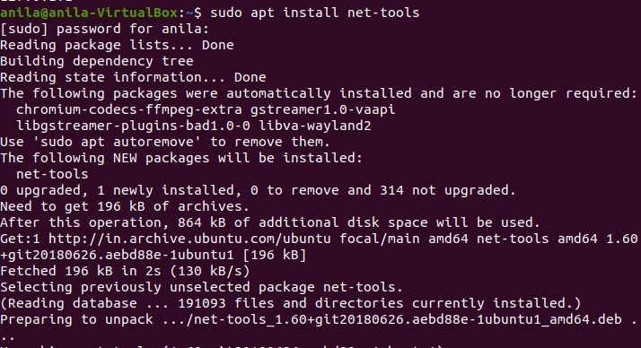

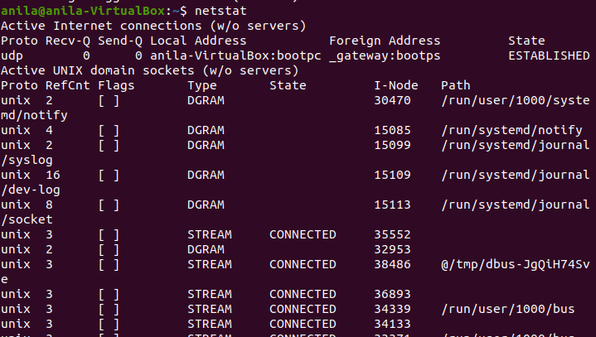

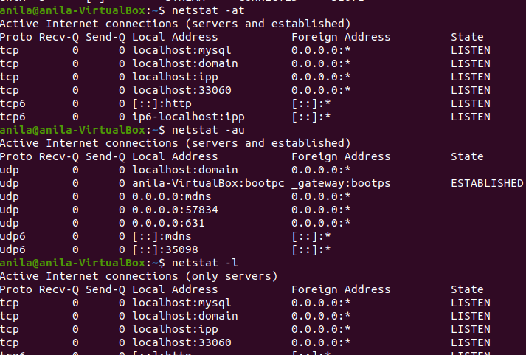

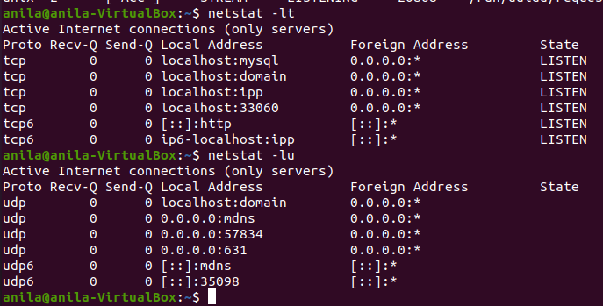

* 1. IF CONFIG

The if config commands is used for displaying current network configuration information , setting up an ip address , netmask or broadcast address to an network interface , creating an alias for network interface , setting up hardware address and enable or disable network interface

* ifconfig –a :This option is used to display all the interfaces available, even if they are down.
* ifconfig -s : Display a short list, instead of details
* ifconfig interface up :This option is used to activate the driver for the given interface
* ifconfig interface down :This option is used to deactivate the driver for the given interface.

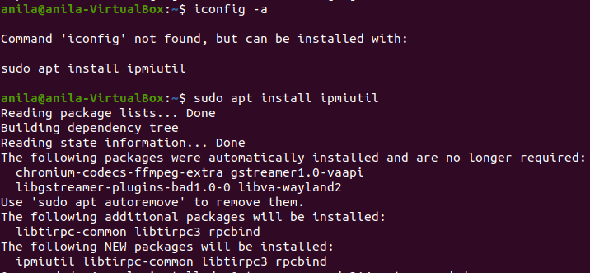

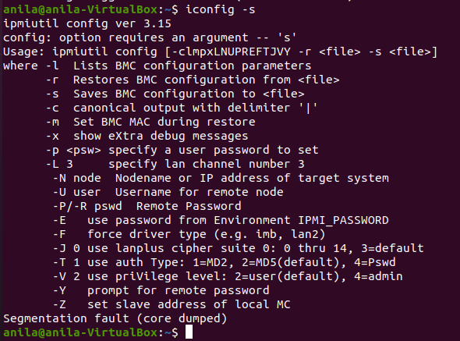

* 1. NSLOOKUP

Nslookup (stands for “Name Server Lookup”) is a useful command for getting information from DNS server. It is a network administration tool for querying the Domain Name System (DNS) to obtain domain name or IP address mapping or any other specific DNS record. It is also used to troubleshoot DNS related problems.

nslookup google.com :

nslookup followed by the domain name will display the “A Record” (IP Address) of the domain. Use this command to find the address record for a domain. It queries to domain name servers and get the details.

nslookup 192.168.0.10 : Reverse DNS lookup

we can also do the reverse DNS look-up by providing the IP Address as argument to nslookup

|  |  |
| --- | --- |
| **command** | **Used for** |
| **nslookup -type=any google.com** | Lookup for any record |
| **nslookup -type=soa redhat.com** | Lookup for an soa record(start of authority) |
| **nslookup -type=ns google.com** | Lookup for an ns record(Name Server) |
| **nslookup -type=mx google.com** | Lookup for an mx record(Mail Exchange) |
| **nslookup -type=txt google.com** | Lookup for an txt record |

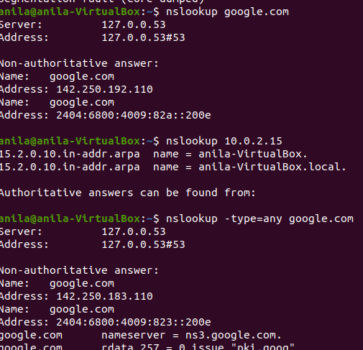

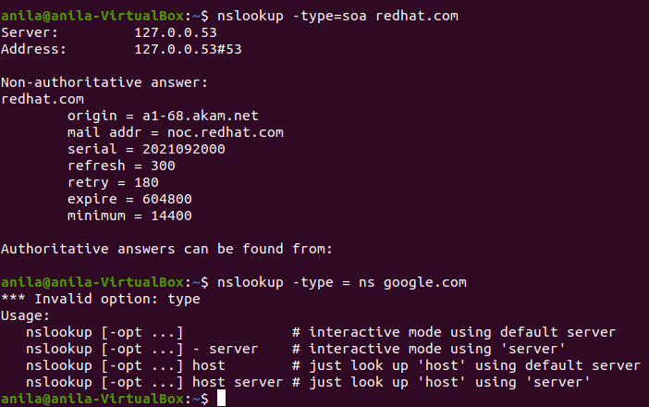

* 1. TRACEROUTE

traceroute command prints the route that a packet takes to reach the host. This command is useful when we want to know about the route and about all the hops that a packet takes

|  |  |
| --- | --- |
| **command** | **Used for** |
| $ traceroute -g 192.168.43.45 google.com | Route the packet through gate |
| $traceroute -m 5 google.com | Set the max number of hops for the packet to reach the destination.Default value is 30. |
| $traceroute -n google.com | Do not resolve IP addresses to their domain names |
| $traceroute -p 20292 google.com | Set the destination port to use. Default is 33434 |

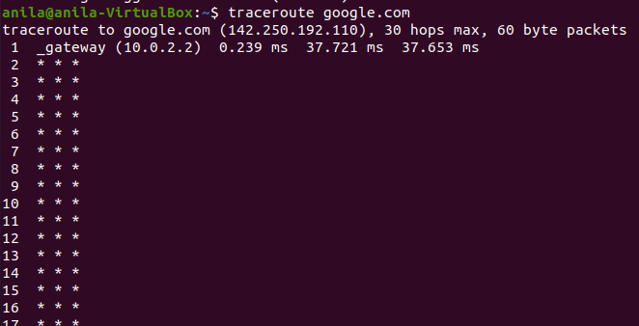

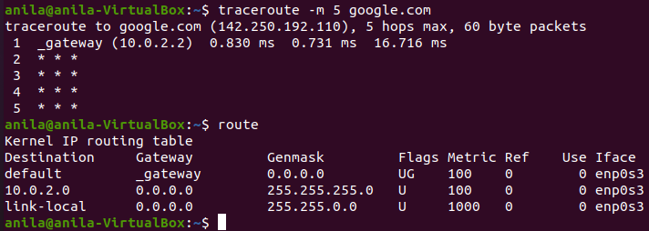

7.ROUTE

route command in Linux is used when you want to work with the IP/kernel routing table. It is mainly used to set up static routes to specific hosts or networks via an interface. It is used for showing or update the IP/kernel routing table.

install net-tools by $sudo apt-get install net-tools

|  |  |
| --- | --- |
|  |  |
| $route | To display the IP/kernel routing table |
| $route -n | To display routing table in full numeric form |
| $sudo route add default gw 169.254.0.0 | To add a default gateway. |
| $route -Cn | To list kernel’s routing cache information. |
| $sudo route add -host 192.168.1.51 reject | **.** To reject routing to a particular host or network |

|  |  |
| --- | --- |
| $ip route | To get details of the kernel/IP routing table using ip command |
| $route del default | To delete the default gateway. |
| $ip route show table local | To get the details of the local table with destination addresses assigned to the localhost. |

##### EXPERIMENT-18

Date:03-09-2021

##### FAMILIARISATION OF STATIC AND DYNAMIC IP

STATIC AND DYNAMIC IP STATIC IP

A fixed IP address is called static IP address , i.e. it never changes.

It is required to set up an Ubuntu static IP address in order to access a device remotely and without losing a connection over the network.

It is used to connect to an IP camera, home file server, game server, and many other devices.

A static IP address is necessary only for servers and not for personal PCs

**STEPS FOR SETTING STATIC IP**

Click on the top right network icon and select settings of the network interface you wish to configure to use a static IP address on Ubuntu.

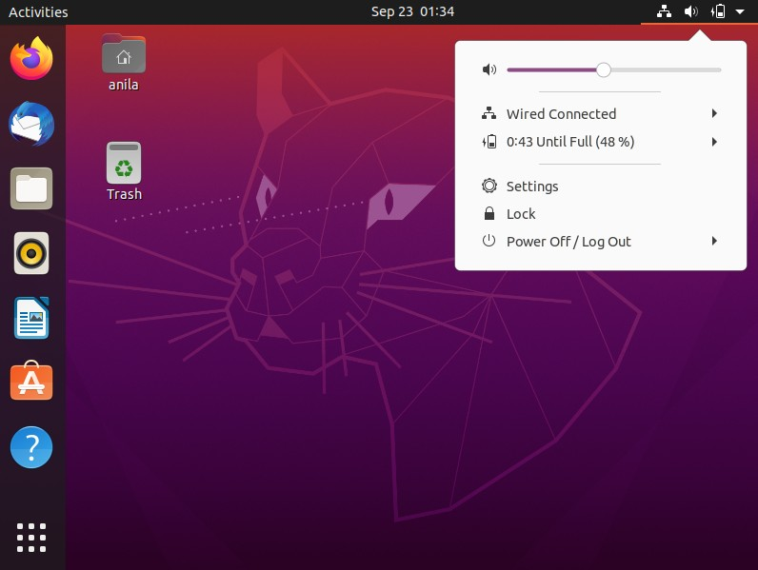

Click on the settings icon to start IP address configuration

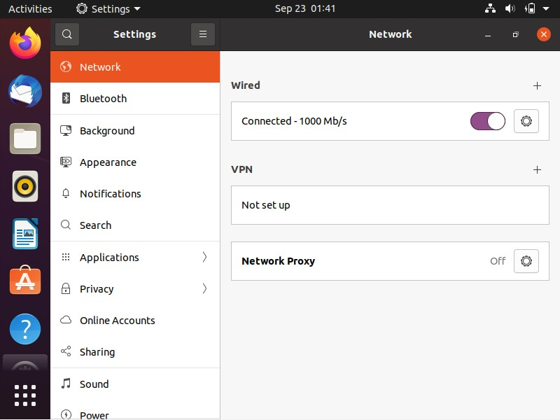

Select IPv4 tab

Select manual and enter your desired IP address, netmask, gateway and DNS settings. Once ready click Apply button.

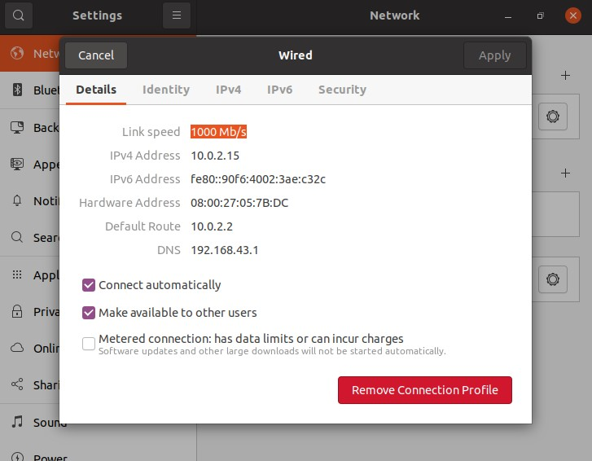

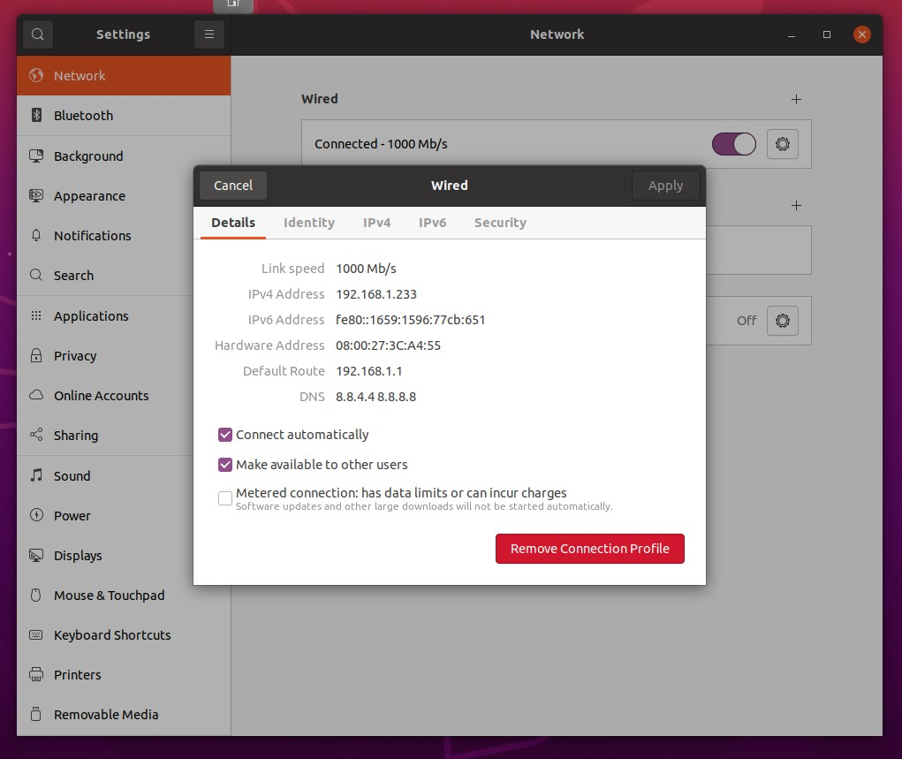

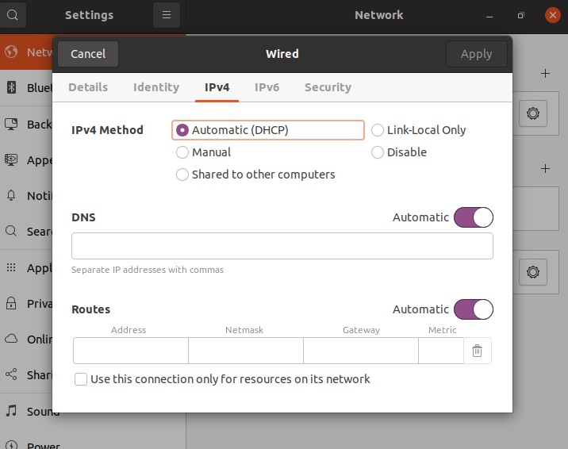

Turn OFF and ON switch to apply your new network static IP configuration settings.

Click on the network settings icon once again to confirm your new static IP address settings.

DYNAMIC IP

A dynamic IP address as its name suggests is a temporary IP address assigned by a DHCP server for every new network.

A dynamic IP address is used due to the shortage of IP addresses on IPV4. A single dynamic IP address can be used between many devices Configuring dynamic ip addresses

Step1: type the command in the terminal

sudo nano /etc/netplan/01-network-manager-all.yaml

step2:Now find the name of the network interface you want to configure and insert the following lines:

dhcp4: yes dhcp6: yes

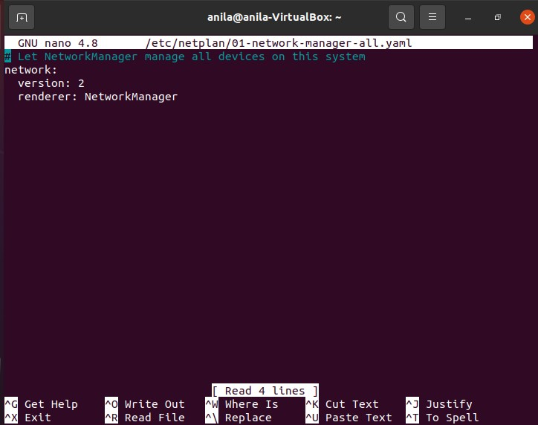

Step3:Apply the changes with sudo netplan apply command

##### EXPERIMENT-19

Date:05-09-2021

##### CONCEPT OF SUBNETS AND CIDR ADDRESS SCHEME

Subnets:

The process of dividing a network into smaller network sections is called subnetting. This can be useful for many different purposes and helps isolate groups of hosts from each other to deal with them more easily. By default, each network has only one subnet, which contains all of the host addresses defined within. A netmask is basically a specification of the amount of address bits that are used for the network portion. A subnet mask is another netmask within used to further divide the network.

Each bit of the address that is considered significant for describing the network should be represented as a “1” in the netmask. For instance, the address we discussed above, 192.168.0.15 can be expressed like this, in binary:

1100 0000 - 1010 1000 - 0000 0000 - 0000 1111

As we described above, the network portion for class C addresses is the first 3 octets, or the first 24 bits. Since these are the significant bits that we want to preserve, the netmask would be:

1111 1111 - 1111 1111 - 1111 1111 - 0000 0000

This can be written in the normal IPv4 format as 255.255.255.0. Any bit that is a “0” in the binary representation of the netmask is considered part of the host portion of the address and can be variable. The bits that are “1” are static, however, for the network or subnetwork that is being discussed. We determine the network portion of the address by applying a bitwise AND operation to between the address and the netmask. A bitwise AND operation will save the networking portion of the address and discard the host portion. The result of this on our above

example that represents our network is:

1100 0000 - 1010 1000 - 0000 0000 - 0000 0000

This can be expressed as 192.168.0.0. The host specification is then the difference between these original value and the host portion. In our case, the host is 0000 1111 or 15. The idea of subnetting is to take a portion of the host space of an address, and use it as an additional networking specification to divide the address space again. For instance, a netmask of 255.255.255.0 as we saw above leaves us with 254 hosts in the network (you cannot end in 0 or 255 because these are reserved).

So, continuing with our example, the networking portion is: 1100 0000 - 1010

1000 - 0000 0000

The host portion is: 0000 1111

We can use the first bit of our host to designate a subnetwork. We can do this by adjusting the subnet mask from this:

1111 1111 - 1111 1111 - 1111 1111 - 0000 0000

To this:

1111 1111 - 1111 1111 - 1111 1111 - 1000 0000

In traditional IPv4 notation, this would be expressed as 192.168.0.128. What we have done here is to designate the first bit of the last octet as significant in addressing the network. This effectively produces two subnetworks. The first subnetwork is from 192.168.0.1 to 192.168.0.127. The second subnetwork contains the hosts 192.168.0.129 to 192.168.0.255.

CIDR Notation:

A system called Classless Inter-Domain Routing, or CIDR, was developed as an

alternative to traditional subnetting. For example, we could express the idea that the IP address 192.168.0.15 is associated with the netmask 255.255.255.0 by using the CIDR notation of 192.168.0.15/24. This means that the first 24 bits of the IP address given are considered significant for the network routing.

This allows us some interesting possibilities. We can use these to reference “supernets”. In this case, we mean a more inclusive address range that is not possible with a traditional subnet mask. For instance, in a class C network, like above, we could not combine the addresses from the networks 192.168.0.0 and 192.168.1.0 because the netmask for class C addresses is 255.255.255.0. However, using CIDR notation, we can combine these blocks by referencing this chunk as 192.168.0.0/23. This specifies that there are 23 bits used for the network portion that we are referring to. So the first network (192.168.0.0) could be represented like this in binary:

1100 0000 - 1010 1000 - 0000 0000 - 0000 0000

While the second network (192.168.1.0) would be like this: 1100 0000 - 1010 1000 - 0000 0001 - 0000 0000

The CIDR address we specified indicates that the first 23 bits are used for the network block we are referencing. This is equivalent to a netmask of 255.255.254.0, or:

1111 1111 - 1111 1111 - 1111 1110 - 0000 0000

As you can see, with this block the 24th bit can be either 0 or 1 and it will still match, because the network block only cares about the first 23 digits. CIDR allows us more control over addressing continuous blocks of IP addresses. This is much more useful than the subnetting we talked about originally.

Date:05-09-2021

##### EXPERIMENT-20 CONCEPT OF SUBNET MASK

The subnet mask is used by the TCP/IP protocol to determine whether a host is on the local subnet or on a remote network. In TCP/IP, the parts of the IP address that are used as the network and host addresses aren't fixed. Unless you have more information, the network and host addresses above can't be determined. This information is supplied in another 32-bit number called a subnet mask. The subnet mask is 255.255.255.0 in this example. It isn't obvious what this number means unless you know 255 in binary notation equals 11111111. So, the subnet mask is 11111111.11111111.11111111.00000000.

Lining up the IP address and the subnet mask together, the network, and host portions of the address can be separated:

11000000.10101000.01111011.10000100 - IP address (192.168.123.132)

11111111.11111111.11111111.00000000 - Subnet mask (255.255.255.0)

The first 24 bits (the number of ones in the subnet mask) are identified as the network address. The last 8 bits (the number of remaining zeros in the subnet mask) are identified as the host address. It gives you the following addresses:

11000000.10101000.01111011.00000000 - Network address (192.168.123.0)

00000000.00000000.00000000.10000100 - Host address (000.000.000.132)

So now you know, for this example using a 255.255.255.0 subnet mask, that the network ID is 192.168.123.0, and the host address is 0.0.0.132. When a packet arrives on the 192.168.123.0 subnet (from the local subnet or a remote network), and it has a destination address of 192.168.123.132, your computer will receive it from the network and process it.Almost all decimal subnet masks convert to binary numbers that are all ones on the left and all zeros on the right.

Some other common subnet masks are:

Decimal Binary 255.255.255.192 1111111.11111111.1111111.11000000 255.255.255.224

1111111.11111111.1111111.11100000

Internet RFC 1878 (available from InterNIC-Public Information Regarding Internet Domain Name Registration Services) describes the valid subnets and subnet masks that can be used on TCP/IP networks

Date: 07-09-2021

##### EXPERIMENT- 21 SETTING UP A FIREWALL FOR LAN

ufw-uncomplicated firewall-

The default firewall configuration tool for Ubuntu is ufw. Developed to ease iptables firewall configuration.

ufw provides a user-friendly way to create an IPv4 or IPv6 host-based firewall. ufw by default is initially disabled.

ufw is not intended to provide complete firewall functionality via its command interface, but instead provides an easy way to add or remove simple rules.

It is currently mainly used for host-based firewalls.”

To Enable ufw

Step1:check current firewall status sudo ufw status

Step2:to enable firewall sudo ufw enable

Step3:to check status

sudo ufw status

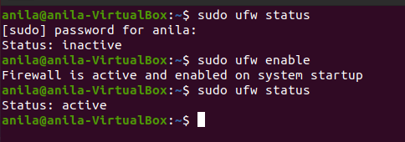

To disable ufw

Step1:To disable firewall sudo ufw disable

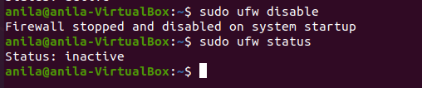Step2:to check status sudo ufw status

WIRESHARK

##### EXPERIMENT- 22 WIRESHARK AND TCPDUMP

Date: 08-09-2021

* Network packet protocol analyzer
* A network packet analyzer will try to capture network packets and try to display that packet data as detailed as possible.
* One of the best open source packet analyzers available today for UNIX and Windows

WHERE IT USE ?

* Network administrators use it to troubleshoot network problems
* Network security engineers use it to examine security problems
* Developers use it to debug protocol implementations
* Testers use it to detect defects
* People use it to learn network protocol internals

##### STEPS TO INSTALL WIRESHARK

* Step1: Go to [www.wireshark.org](http://www.wireshark.org/) ->download 64bit package.
* Step 2 : run application and click on noted

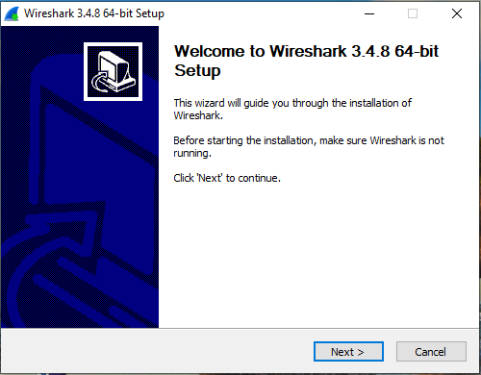

* Step 3 :select components and click next

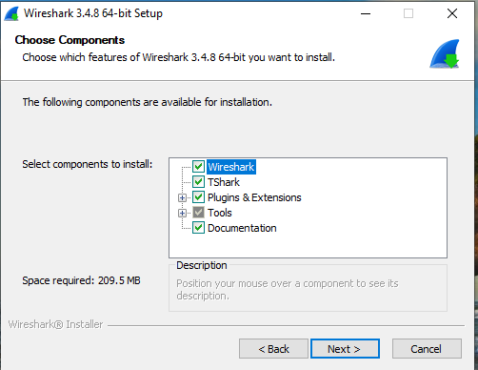

* Step 4: choose default destination location

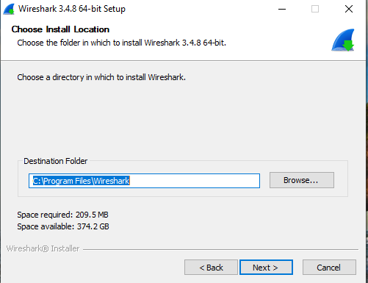

* Step 5: installation start running

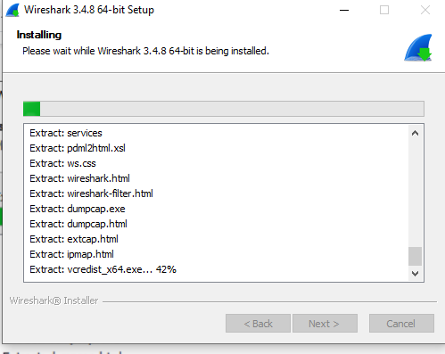

* Step 6 : click on I agree
* Step 7 : complete installation part and click finish

**HOMESCREEN**

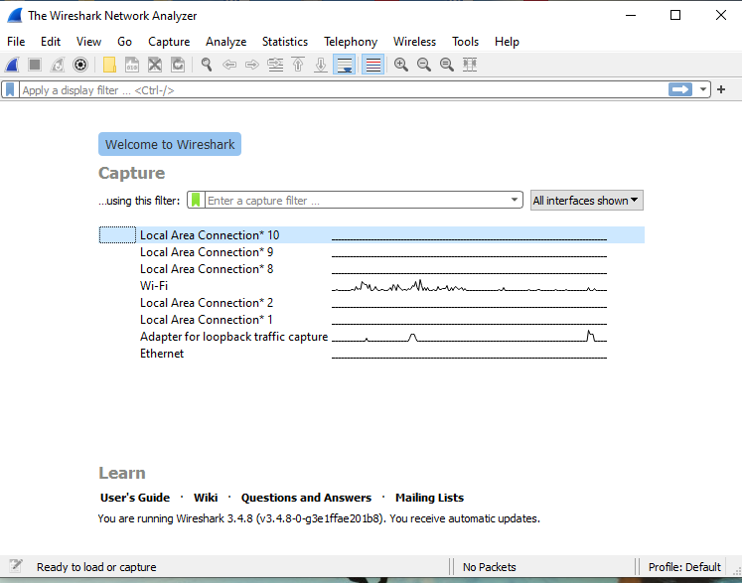

**HOW IT CAPTURE PACKETS?**

* Wireshark captures packets and lets you examine their contents
* Select any interface to capture its packet**.**
* No. shows the number of captured packet or index number.
* Time shows the time of capture
* Source shows the source ip of the packet or the packet is originally generated from which source ip.
* Destination shows the destination ip where the packet is going.
* Protocol shows which kind of protocol communication is held between the source and destination.
* Info shows the data payload in the packet

**FEATURES OF WIRESHARK**

* Available for UNIX and Windows.
* Capture live packet data from a network interface.
* Import packets from text files containing hex dumps of packet data.
* Display packets with very detailed protocol information.
* Save packet data captured.
* Export some or all packets in a number of capture file formats.
* Filter packets on many criteria.
* Search for packets on many criteria.
* Colorize packet display based on filters.
* Create various statistics.

## TCPDUMP

* It is an ip utility tool used for real-time packet sniffing(Network).
* Command line program comes in built in a Unix based system.
* Programs like ethereal(Wireshark) provide an alternative to Tcpdump in GUI environment

STEPS TO INSTALL TCPDUMP

* Install tcpdump by entering the following commands in the terminal: sudo apt update

sudo apt install tcpdump

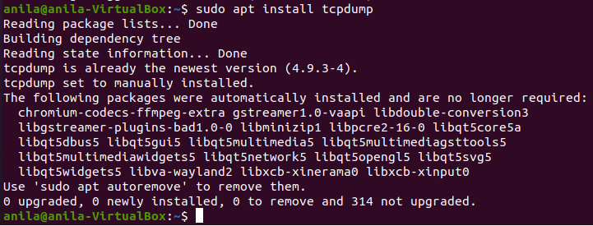

tcpdump Command Examples

1. Display Available Interfaces # tcpdump –D
2. Capture Packets from Specific Interface # tcpdump -i any
   * The command screen will scroll up until you interrupt and when we execute the tcpdump command it will captures from all the interfaces, however with

-i switch only capture from the desired interface

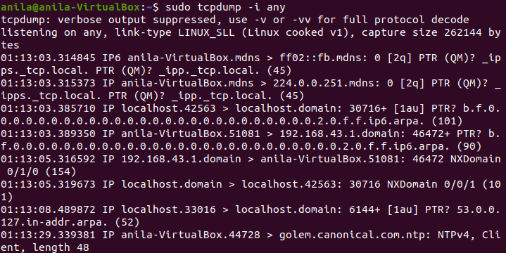

1. Print Captured Packets in ASCII
   * The below tcpdump command with the option -A displays the package in ASCII format. It is a character-encoding scheme format.
   * # tcpdump -A -i any

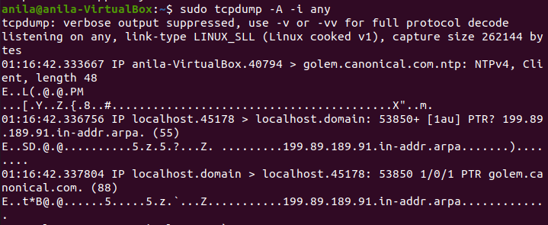

1. Capture Only N Number of Packets
   * When you run the tcpdump command it will capture all the packets for the specified interface, until you hit the cancel button. But using -c option, you can capture a specified number of packets.
   * # tcpdump -c 5 -i any

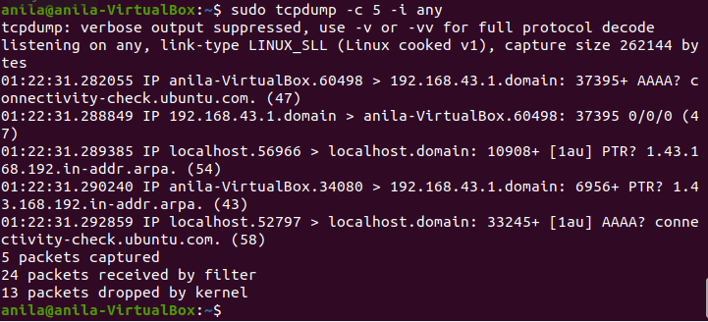

1. Display Captured Packets in HEX and ASCII
   * The following command with option -XX capture the data of each packet, including its link level header in HEX and ASCII format.
   * # tcpdump -XX -i any

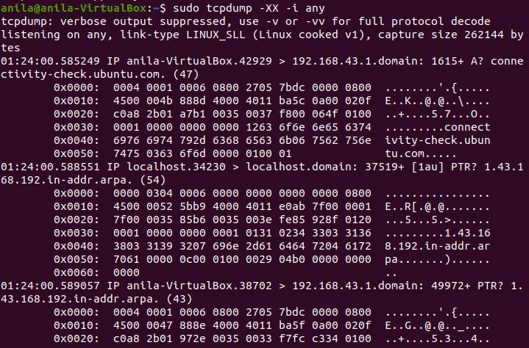

1. Capture and Save Packets in a File
   * As we said, that tcpdump has a feature to capture and save the file in a .Pcap format, to do this just execute the command with -w option.
   * # tcpdump -w 0001.Pcap -i any

**Testing network services with Netcat [nc]**

Use the netcat command, nc, to access the service. If you don’t have nc installed, type the following command on the command line

Step1: $sudo apt-get install netcat

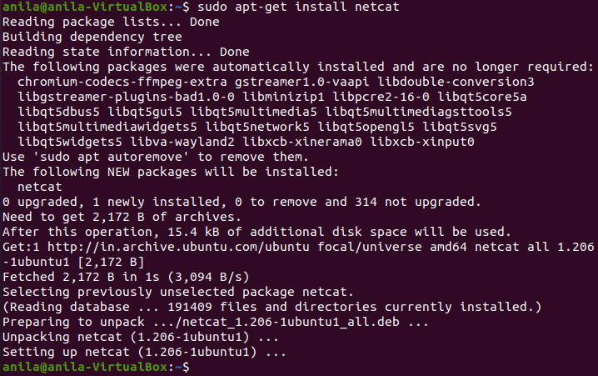

Step 2: After the installation is done type ‘nc -h’

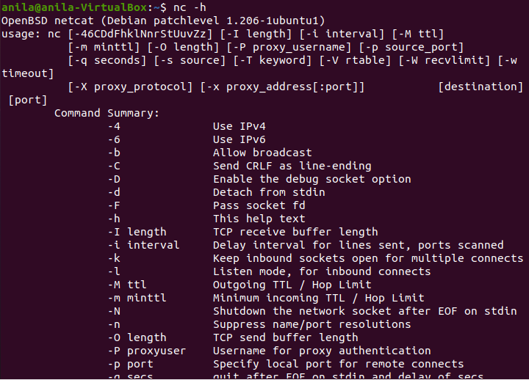

Step3:Set up the server using netcat in listening mode.

We will use port 12345 and will specify the port number with -p option.

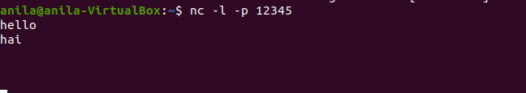

Step 4:Creating the server with netcat

* + The command ‘nc hostname port’ puts netcat in client mode and connects to the specified hostname on the specified port. Open a new terminal window and type ‘nc localhost 12345’

Step 5 : Now that we are connected to the server we can start chatting

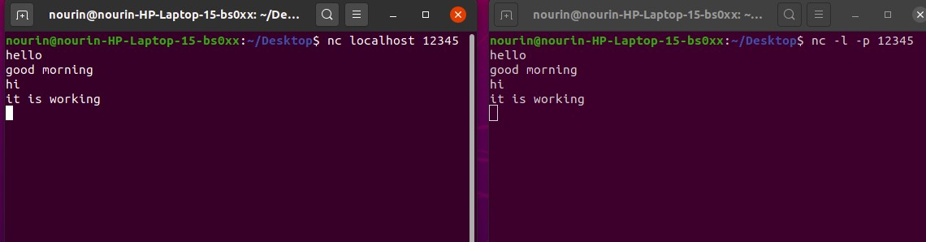

Date: 08-09-21

##### EXPERIMENT- 23

**ANALYSE PACKETS USING WIRESHARK WIRESHARK LAB ASSIGNMENT**

###### List 3 different protocols that appear in the protocol column in the unfiltered packet-listing window. Support your answer with an appropriate screenshot from your computer.

Ans: TCP, UDP, DNS, TLSV1.2, etc..

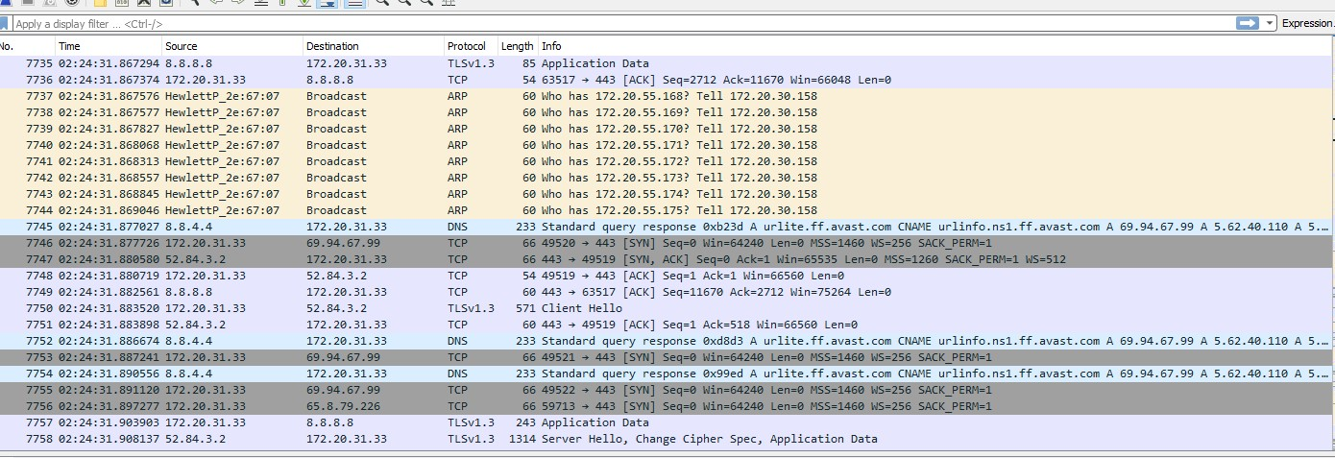

###### How long did it take from when the HTTP GET message was sent until the HTTP OK reply was received? (By default, the value of the Time column in the packet-listing window is the amount of time, in seconds, since Wireshark tracing began. To display the Time field in time-of-day format, select the Wireshark View pull down menu, then select Time Display Format, then select Time-of-day.)

Ans: If we look at the frame section of the GET request we see that the time the packet arrived is **02:09:02.092367**

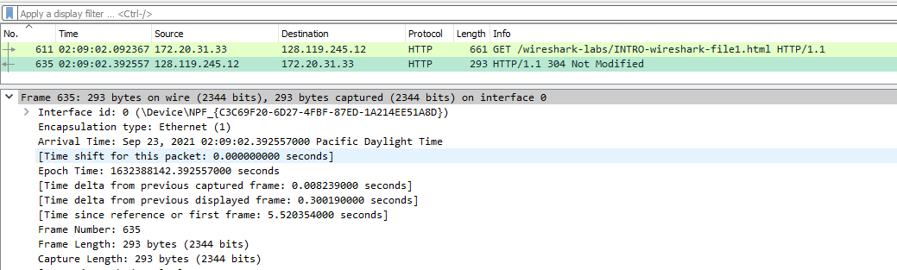

The same section for the HTTP OK shows an arrival time of

###### 02:09:02.392557

The difference of these 2 times gives :

###### 0.392557-0.092367=0.300190

1. **What is the Internet address of the** [**gaia.cs.umass.edu**](http://gaia.cs.umass.edu/)**? What is the Internet address of your computer? Support your answer with an appropriate screenshot from your computer.**

If we look at the IP section of the GET request, the source and destination are shown.

The source is the local machine’s address and the destination is the web server’s public

My computer’s address = **172.20.10.2**

IP address **128.119.245.12 (**gaia.cs.umass.edu)



###### Print the two HTTP messages (GET and OK) referred to in question 2 above. To do so, select Print from the Wireshark File command menu, and select the “Selected Packet Only” and “Print as displayed” radial buttons, and then click OK

**Ans:** Screenshot of HTTP GET message

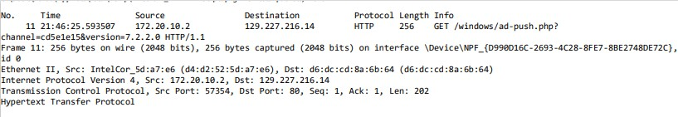

Screenshot of HTTP OK message+

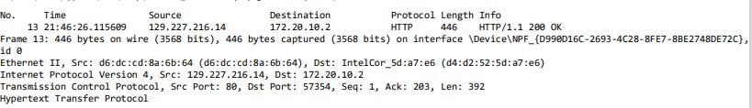

###### How many HTTP GET request messages did your browser send? Which packet number in the trace contains the GET message for the Bill of Rights?

**Which packet number in the trace contains the status code and phrase associated with the response to the HTTP GET request? What is the status code and phrase in the response?**

# Ans:

* + My browser only sent 1 HTTP GET request to the server. The Packet that contained the GET message was packet number 4730
  + The packet that contains the status code and phrase which the server sent in response to the GET message was packet number 4733
  + The code and phrase in the response was 304 Not Modified

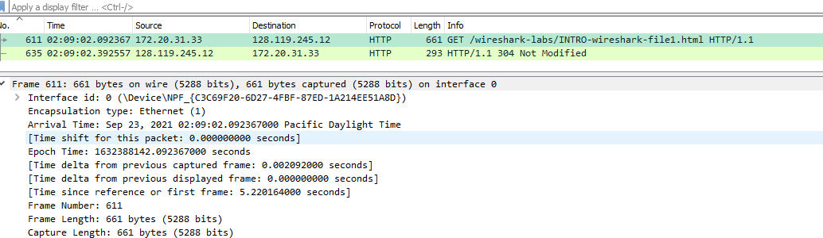

1. **How many data-containing TCP segments were needed to carry the single HTTP response and the text of the Bill of Rights?**

**Is there any HTTP header information in the transmitted data associated with TCP segmentation? For this question you may want to think about at what layer each protocol operates, and how the protocols at the different layers interoperate.**

**Ans:** The data was sent in 1 TCP segments to the browser

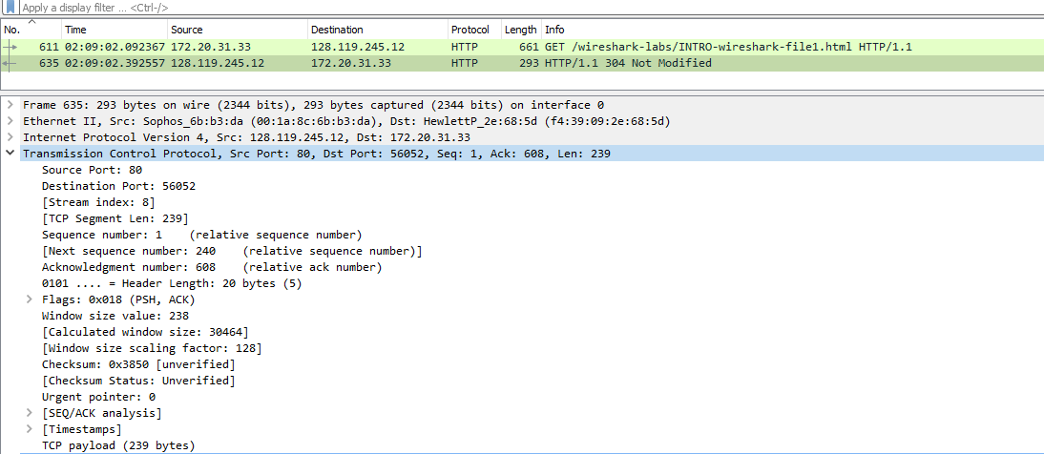

Date: 15-09-2021

**CYCLE- 6**

##### EXPERIMENT- 24 FAMILIARISATION TO HYPERVISORS AND VIRTUAL

**MACHINES**

**Virtual machine**

* A virtual machine is a virtual representation, or emulation, of a physical computer. They are often referred to as a guest while the physical machine they run on is referred to as the host.
* [Virtualization](https://www.ibm.com/cloud/learn/virtualization-a-complete-guide) makes it possible to create multiple virtual machines, each with their own operating system (OS) and applications, on a single physical machine. A VM cannot interact directly with a physical computer. Instead, it needs a lightweight software layer called a [hypervisor](https://www.ibm.com/cloud/learn/hypervisors) to coordinate between it and the underlying physical hardware.

# Hypervisor

* Hypervisor is a software program that manages multiple operating systems (or multiple instances of the same operating system) on a single computer system.
* The hypervisor manages the system's processor, memory, and other resources to allocate what each operating system requires.
* Hypervisors are designed for a particular processor architecture and may also be called

virtualization managers.

Hypervisor Types

* + Type 1: native (bare-metal) hypervisors

The Hypervisor runs directly on the host's hardware to control the hardware and to manage guest operating systems.

E.g., Xen, VMWare ESXi, Microsoft Hyper-V

* + Type 2: hosted hypervisors

These hypervisors run on a conventional operating system just as other computer programs do.Eg. VMWare Workstation, VirtualBox

Benefits of hypervisor

* Speed
* Efficiency
* Flexibility
* Portability

**Popular Hypervisors**

* Xen
* KVM(Kernel Based VM)
* SAN
* NAS

Date:15-09-2021

**EXPERIMENT-25**

**FAMILIARISATION TO XEN OR KVM**

Xen

Xen is an open-source **paravirtualization** technology that provides a platform for running multiple operating systems in parallel on one physical hardware resource.

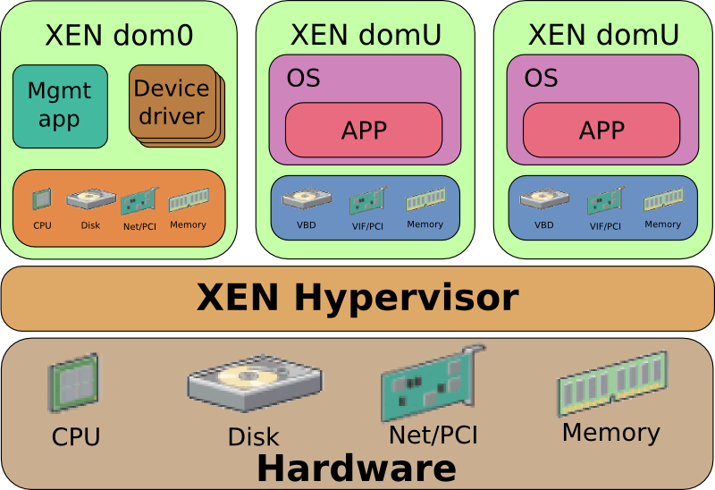

**Kernel-based Virtual Machine (KVM)**

* + Kernel-based Virtual Machine (KVM) is an **open source virtualization** technology built into Linux. Specifically, KVM lets you turn Linux into a **hypervisor** that allows a host machine to run multiple, isolated virtual environments called guests or virtual machines (VMs).
  + KVM converts Linux into a type-1 (bare-metal) hypervisor. All hypervisors need some operating system-level components—such as a memory manager, process scheduler,

input/output (I/O) stack, device drivers, security manager, a network stack, and more—to run VMs.

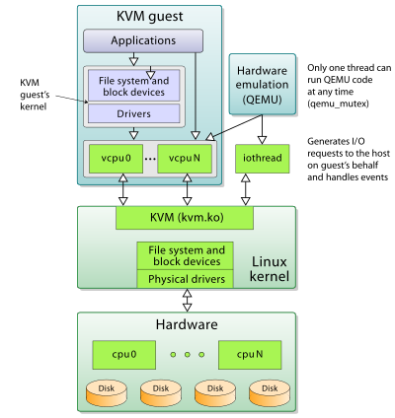

### DOCKER

* + Docker is an open platform for developing, shipping, and running applications.
  + Docker enables you to separate your applications from your infrastructure so you can deliver software quickly.
  + With Docker, you can manage your infrastructure in the same ways you manage your applications.
  + By taking advantage of Docker’s methodologies for shipping, testing, and deploying code quickly, you can significantly reduce the delay between writing code and running it in production.

What is a container?

* + Docker provides the ability to package and run an application in a loosely isolated environment called a container. The isolation and security allow you to run many

containers simultaneously on a given host. Containers are lightweight and contain everything needed to run the application, so you do not need to rely on what is currently installed on the host. You can easily share containers while you work, and be sure that everyone you share with gets the same container that works in the same way.

What is a Docker image?

* + A Docker image is a file used to execute code in a Docker container. Docker images act as a set of instructions to build a Docker container, like a template. Docker images also act as the starting point when using Docker. An image is comparable to a snapshot in virtual machine (VM) environments.

## Docker installation

* + $ sudo apt install docker.io

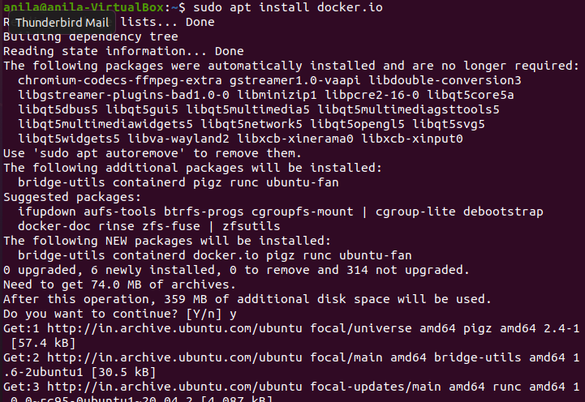

* **Version check**

$ docker --version



###### Check whether it is running or not

$ sudo systemctl status docker

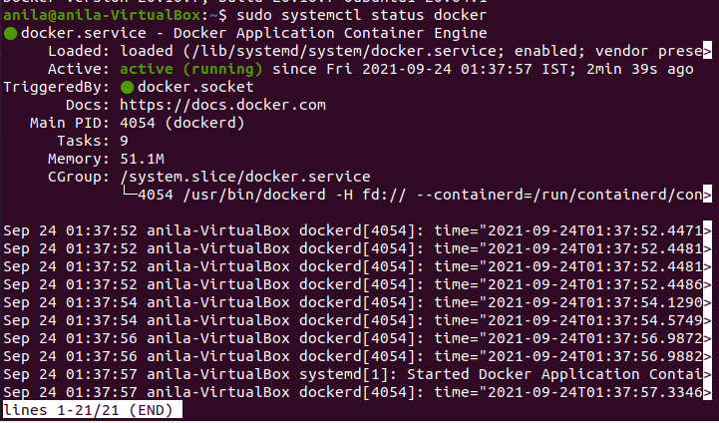

###### If not active

$ sudo systemctl enable –now docker

###### List all the images you have locally

$ sudo docker images



###### Pull an image from the Docker registry

$ sudo docker pull <image_name>:<tag>

###### Run a docker

$ sudo docker run <image_name>:<tag>

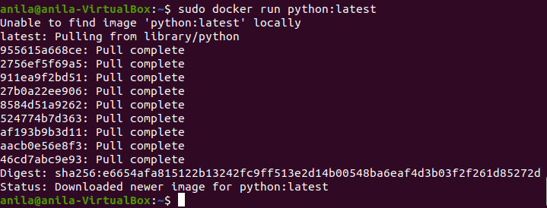

###### List all the running containers

$ sudo docker ps -a

Date:19-09-2021

**EXPERIMENT- 26**

**INSTALLING SOFTWARE FROM SOURCE CODE**

* Source code software must be compiled and installed.
* Usually comes in a compressed archive, called a tarball with .tar or .tar.gz ending.
* Archive includes source, configure script, makefile, and install scripts.

**Package Mangers**

* + Automate the installation, removal, and management of the software applications.
  + Only track software installed using the package manger.
  + Similar to Add/Remove programs control panel in MS Windows

**Configure Script:**

Inspects system for requirements and configures the “makefile” .

**Make:**

* + Automates the compilation of programming source code for the target system.
  + “makefile” define the necessary steps to build the application.
  + They are far from perfect
  + There is no central database to track applications installed with make.
  + Removal of applications may or may not be supported by the make file.
  + “makefile” contains installation parameters, variables, and setup instructions.
  + “make” and “make install” commands are run to compile and install software.
  + There is no central database to track applications installed with make.
  + Removal of applications may or may not be supported by the make file.
  + makefile” contains installation parameters, variables, and setup instructions.
  + “make” and “make install” commands are run to compile and install software.

Make Command:

* + Source code distributed as “gzipped tarballs”.
  + After unpacking the code you must check the README file for specific install instructions.

$ configure

$ make

$ make install

**Installation Steps:**

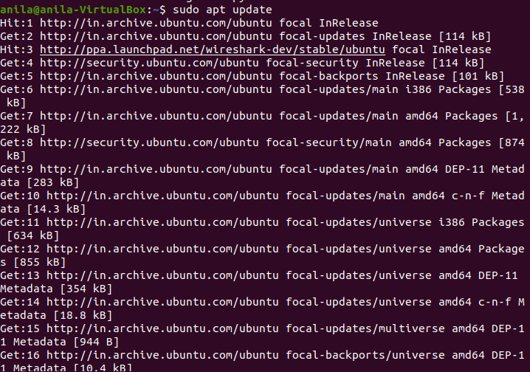**Step 1**: Open the Linux terminal and enter sudo apt update

**Step 2**: Enter

sudo apt install build-essential

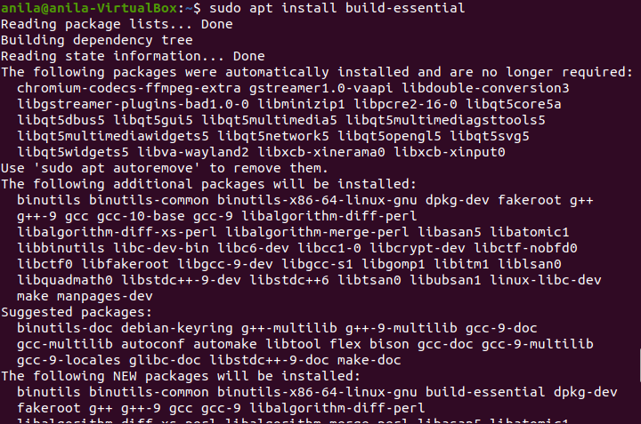

**Step 3**: Enter

cd /usr/local/src/



**Step 4**: Enter

sudo wget [*http://www.noip.com/client/linux/noip-duc-linux.tar.gz*](http://www.noip.com/client/linux/noip-duc-linux.tar.gz)

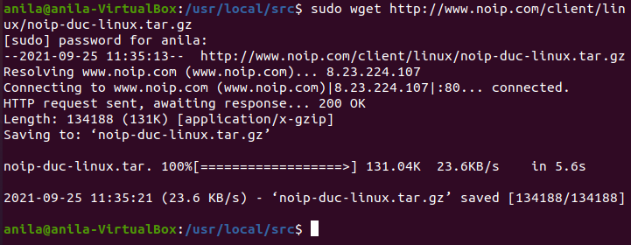

**Step 5**: Enter

sudo tar xf noip-duc-linux.tar.gz and cd noip-2.1.9-1/

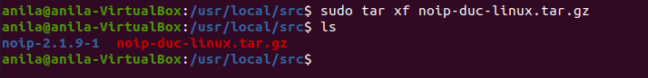

**Step 6**: Enter

sudo make install

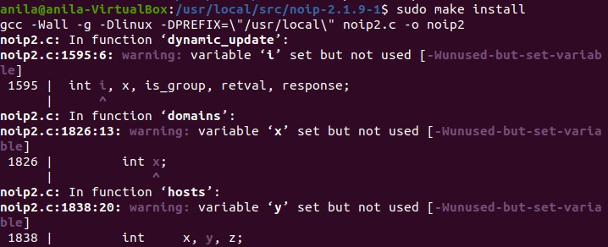

##### Date: 19-09-2021

**EXPERIMENT- 27**

##### DEPLOY LINUX VM USING ANSIBLE PLAYBOOK

**Ansible**

* + Ansible is simple open source IT engine which automates application deployment, intra service

orchestration, cloud provisioning and many other IT tools.

* + Ansible is easy to deploy because it does not use any agents or custom security infrastructure.
  + Ansible uses playbook to describe automation jobs, and playbook uses very simple language

i.e. YAML (It’s a human-readable data serialization language & is commonly used for configuration files, but could be used in many applications where data is being stored)which is very easy for humans to understand, read and write. Hence the advantage is that even the IT infrastructure support guys can read and understand the playbook and debug if needed (YAML –

It is in human readable form).

* + Ansible is designed for multi-tier deployment. Ansible does not manage one system at time, it models IT infrastructure by describing all of your systems are interrelated. Ansible is completely agentless which means Ansible works by connecting your nodes through ssh(by default). But if you want other method for connection like Kerberos, Ansible gives that option to you.

###### How do Ansible playbooks work?

* + Ansible works by connecting to your nodes and pushing out small programs, called "Ansible modules" to them. Ansible then executes these modules (over SSH by default), and removes them when finished. Your library of modules can reside on any machine, and there are no servers, daemons, or databases required.

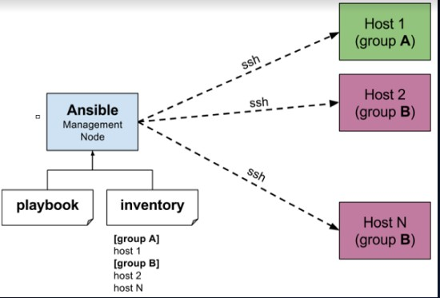

###### Installation Process

* + Ansible can be run from any machine with Python 2 (versions 2.6 or 2.7) or Python 3 (versions 3.5 and higher) installed.
  + Ansible can be installed on control machine which have above mentioned requirements in different ways. You can install the latest release through Apt, yum, pkg, pip, OpenCSW, pacman,etc

**Installation through Apt on Ubuntu Machine**

* + For installing Ansible you have to configure PPA on your machine. For this, you have to run the following line of code:

**sudo apt-add-repository ppa:ansible/ansible**

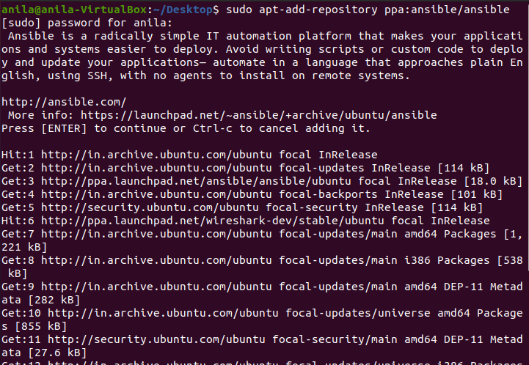

**sudo apt update**

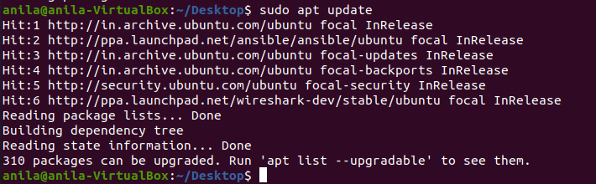

**sudo apt install ansible**

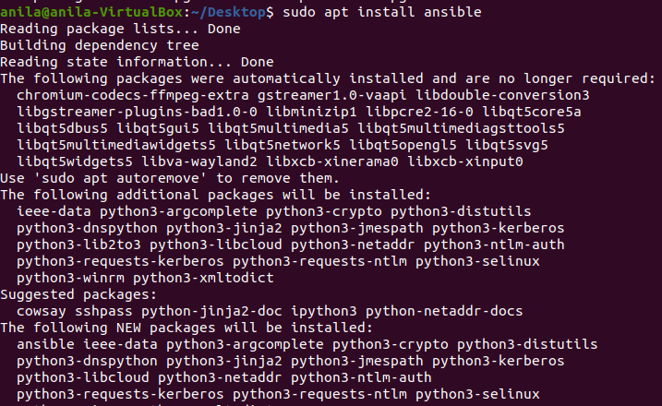

Setting up Inventory File ansible-inventory --list -y

###### Testing Connection

* + After setting up the inventory file to include your servers, it’s time to check if Ansible is able to connect to these servers and run commands via SSH.
  + You can use the -u argument to specify the remote system user. When not provided, Ansible will try to connect as your current system user on the control node.
  + ansible all -m ping -u root

###### PaaS (Platform-as-a-Service)

* + Platform-as-a-service (PaaS) is a model of cloud service delivery where a third-party cloud service provider delivers some hardware and software tools, often those needed for application hosting or development, to customers over the internet. The key benefit of the PaaS model is that it enables users to access hardware and software that can be used to develop and run applications without having to purchase, install and maintain the infrastructure.
  + Microsoft Azure, formerly known as Windows Azure, is Microsoft's public cloud computing platform. It provides a range of cloud services, including compute, analytics, storage and networking. Users can pick and choose from these services to develop and scale new applications, or run existing applications in the public cloud.

###### What is Microsoft Azure used for?

* + Microsoft Azure consists of numerous service offerings, its use cases are extremely diverse. Running virtual machines or containers in the cloud is one of the most popular uses for Microsoft Azure. These compute resources can host infrastructure components, such as domain name system (DNS) servers; Windows Server services -- such as Internet Information Services (IIS); or third-party applications. Microsoft also supports the use of third-party operating systems, such as Linux.

AZURE SERVICES

* **Compute.** These services enable a user to deploy and manage VMs, containers and [batch jobs](https://searchdatacenter.techtarget.com/definition/batch), as well as support remote application access. Compute resources created within the Azure cloud can be configured with either public [IP](https://whatis.techtarget.com/definition/IP-address) [addresses](https://whatis.techtarget.com/definition/IP-address) or private IP addresses, depending on whether the resource needs to be accessible to the outside world.
* **Mobile.** These products help developers build cloud applications for mobile devices, providing notification services, support for back-end tasks, tools for building application program interfaces ([APIs](https://searchapparchitecture.techtarget.com/definition/application-program-interface-API)) and the ability to couple [geospatial](https://whatis.techtarget.com/definition/geospatial-analysis) context with data.
* **Web.** These services support the development and deployment of web applications. They also offer features for search, content delivery, [API](https://searchapparchitecture.techtarget.com/definition/API-management) [management](https://searchapparchitecture.techtarget.com/definition/API-management), notification and reporting.
* **Storage.** This category of services provides scalable cloud storage for structured and unstructured data. It also supports big data projects, [persistent storage](https://searchstorage.techtarget.com/definition/Persistent-storage) and archival storage.
* **Analytics.** These services provide distributed analytics and storage, as well as features for real-time analytics, big data analytics, data lakes, machine learning ([ML](https://searchenterpriseai.techtarget.com/definition/machine-learning-ML)), business intelligence ([BI](https://searchbusinessanalytics.techtarget.com/definition/business-intelligence-BI)), internet of things ([IoT](https://internetofthingsagenda.techtarget.com/definition/Internet-of-Things-IoT)) data streams and data warehousing.
* **Networking.** This group includes [virtual networks](https://searchservervirtualization.techtarget.com/definition/network-virtualization), dedicated connections and [gateways](https://internetofthingsagenda.techtarget.com/definition/gateway), as well as services for traffic management and diagnostics, load balancing, DNS hosting and network protection against distributed denial-of-service ([DDoS](https://searchsecurity.techtarget.com/definition/distributed-denial-of-service-attack)) attacks.
* **Media and content delivery network (CDN).** These [CDN](https://techtarget.com/searchnetworking/definition/CDN-content-delivery-network) services include on-demand streaming, digital rights protection, encoding and media playback and indexing.
* **Integration.** These are services for server backup, site recovery and connecting private and public clouds.
* **Identity.** These offerings ensure only authorized users can access Azure services and help protect encryption keys and other sensitive information in the cloud. Services include support for [Azure Active Directory](https://searchwindowsserver.techtarget.com/definition/Microsoft-Windows-Azure-Active-Directory-Windows-Azure-AD) and multifactor authentication ([MFA](https://searchsecurity.techtarget.com/definition/multifactor-authentication-MFA)).
* **Internet of things.** These services help users capture, monitor and analyze IoT

data from [sensors](https://whatis.techtarget.com/definition/sensor) and other devices. Services include notifications, analytics, monitoring and support for coding and execution.

* **DevOps.** This group provides project and collaboration tools, such as [Azure](https://searchwindowsserver.techtarget.com/definition/Visual-Studio-Team-System)

[DevOps](https://searchwindowsserver.techtarget.com/definition/Visual-Studio-Team-System) -- formerly Visual Studio Team Services -- that facilitate [DevOps](https://searchitoperations.techtarget.com/definition/DevOps) software development processes. It also offers features for application diagnostics, DevOps tool integrations and test labs for build tests and experimentation.

* **Development.** These services help application developers share code, test

applications and track potential issues. Azure supports a range of application programming languages, including JavaScript, Python, .NET and Node.js. Tools in this category also include support for Azure DevOps, software development kits ([SDKs](https://whatis.techtarget.com/definition/software-developers-kit-SDK)) and [blockchain](https://searchcio.techtarget.com/definition/blockchain).

* **Security.** These products provide capabilities to identify and respond to cloud security threats, as well as manage encryption keys and other sensitive assets.
* **Artificial intelligence (AI) and machine learning.** This is a wide range of

services that a developer can use to infuse [artificial intelligence](https://searchenterpriseai.techtarget.com/definition/AI-Artificial-Intelligence), machine learning and [cognitive computing](https://searchenterpriseai.techtarget.com/definition/cognitive-computing) capabilities into applications and data sets.

* **Containers.** These services help an enterprise create, register, orchestrate and

manage huge volumes of containers in the Azure cloud, using common platforms such as [Docker](https://searchitoperations.techtarget.com/definition/Docker) and [Kubernetes](https://searchitoperations.techtarget.com/definition/Google-Kubernetes).

* **Databases.** This category includes Database as a Service ([DBaaS](https://searchdatamanagement.techtarget.com/definition/database-as-a-service-DBaaS)) offerings for

SQL and NoSQL, as well as other database instances -- such as Azure Cosmos DB and Azure Database for PostgreSQL. It also includes [Azure SQL Data](https://searchsqlserver.techtarget.com/definition/Azure-SQL-Data-Warehouse) [Warehouse](https://searchsqlserver.techtarget.com/definition/Azure-SQL-Data-Warehouse) support, [caching](https://whatis.techtarget.com/definition/caching) and hybrid database integration and migration features. Azure SQL is the platform's flagship database service. It is a relational database that provides SQL functionality without the need for deploying a SQL server.

* **Migration.** This suite of tools helps an organization estimate workload Migration

costs and perform the actual migration of workloads from local data centers to the Azure cloud.

* **Management and governance.** These services provide a range of backup,

recovery, [compliance](https://searchdatamanagement.techtarget.com/definition/compliance), automation, scheduling and monitoring tools that can help a cloud administrator manage an Azure deployment.

* **Mixed reality.** These services are designed to help developers create content for the [Windows Mixed Reality](https://whatis.techtarget.com/definition/Windows-Mixed-Reality) environment.
* **Blockchain.** The Azure Blockchain Service allows you to join a blockchain consortium or to create your own.

###### HOME PAGE OF AZURE

**VM DEPLOYEMENT WITHOUT ANSIBLE**

1. Head to a virtual machine from the Azure homescreen.
2. Click on **create->virtual machine.**

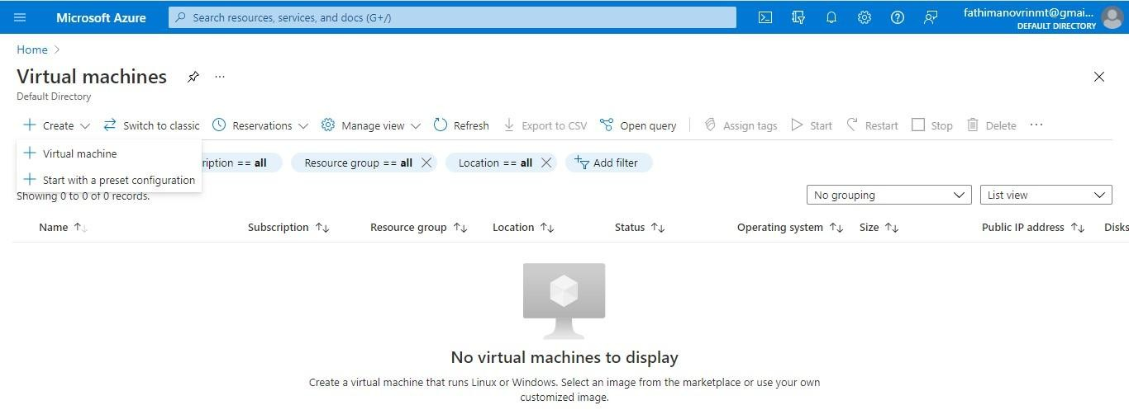

1. Fill the details that you need to create a virtual machine and hit **Review+create**.

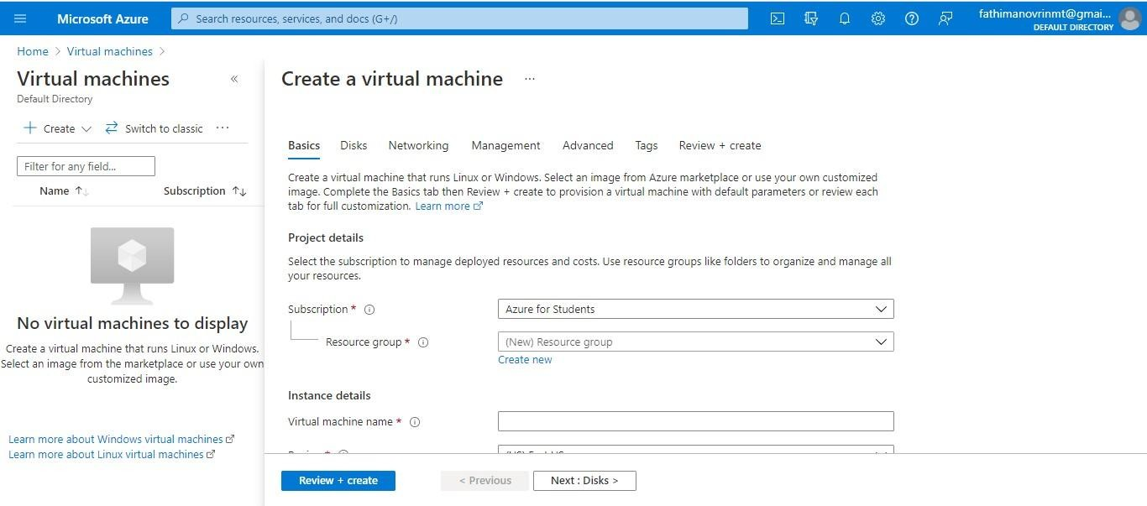

**USING ANSIBLE**

To Configure LINUX VM Using Ansible Playbook ,

* + First we need an azure account, to get a free account:

-> <https://azure.microsoft.com/en-in/free/>

* Create a resource group
* Create a virtual network
* Create a public IP address
* Create a network security group
* Create a virtual network interface card
* Create a virtual machine

Open The Azure Shell, we can directly run Ansible in Azure Cloud Shell, where Ansible is **pre-installed**.

In case not installed,

#Update all packages that have available updates.

**sudo yum update –y**

# Install Python 3 and pip.

sudo yum install -y python3-pip

# Upgrade pip3.

sudo pip3 install --upgrade pip

# Install Ansible. pip3 install "ansible==2.9.17“

# Install Ansible azure_rm module for interacting with Azure.

pip3 install ansible[azure]

To check the ansible version installed,

**ansible --version**

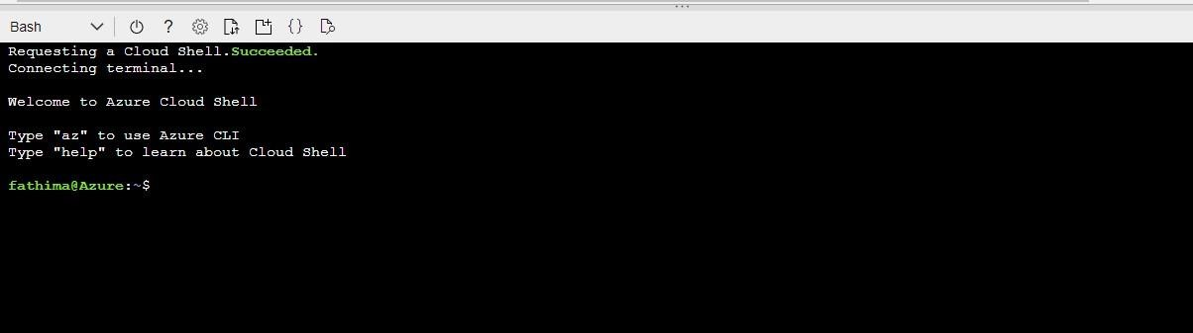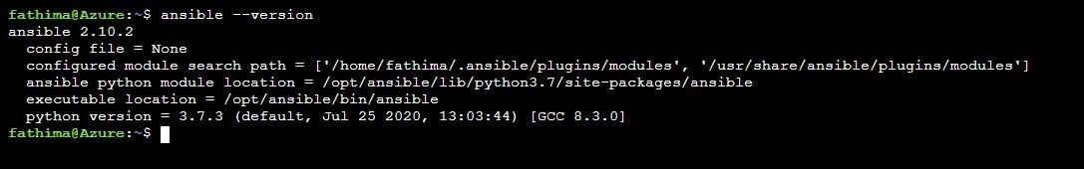

###### Creating a Linux vm(using ansible)

**CREATING A RESOURCE GROUP**

* name: Create Linux VM hosts: localhost connection: local

tasks:

* name: Create resource group to hold VM azure_rm_resourcegroup:

name: ansible-test-rg-vm location: eastus

**CREATING A VIRTUAL NETWORK**

* name: Create virtual network azure_rm_virtualnetwork: resource_group: ansible-test-rg-vm name: myVnet

address_prefixes: "10.0.0.0/16"

* name: Add subnet azure_rm_subnet:

resource_group: ansible-test-rg-vm name: mySubnet

address_prefix: "10.0.1.0/24" virtual_network: myVnet

CREATING A PUBLIC IP

* name: Create public IP address azure_rm_publicipaddress: resource_group: ansible-test-rg-vm allocation_method: Static

name: myPublicIP

register: output_ip_address

* name: Dump public IP for VM which will be created debug:

msg: "The public IP is {{ output_ip_address.state.ip_address }}."

CREATING A NETWORK SECURITY GROUP

* name: Create Network Security Group that allows SSH azure_rm_securitygroup:

resource_group: ansible-test-rg-vm name: myNetworkSecurityGroup rules:

* name: SSH protocol: Tcp

destination_port_range: 22 access: Allow

priority: 1001 direction: Inbound

CREATING A VIRTUAL NIC

* name: Create virtual network interface card azure_rm_networkinterface: resource_group: ansible-test-rg-vm

name: myNIC virtual_network: myVnet subnet: mySubnet

public_ip_name: myPublicIP security_group: myNetworkSecurityGroup

CREATING A VM

* name: Create VM azure_rm_virtualmachine:

resource_group: ansible-test-rg-vm name: Linuxvm

vm_size: Standard_DS1_v2 admin_username: azureuser admin_password: Pa55w.rd1234 ssh_password_enabled: true network_interfaces: myNIC image:

offer: CentOS publisher: OpenLogic sku: '7.5'

version: latest

**TO RUN THIS CODE,**

* + Open an azure shell and type :

**->code ansible-filename.yml**.(It creates an ansible playbook where we enter the code above and save it)

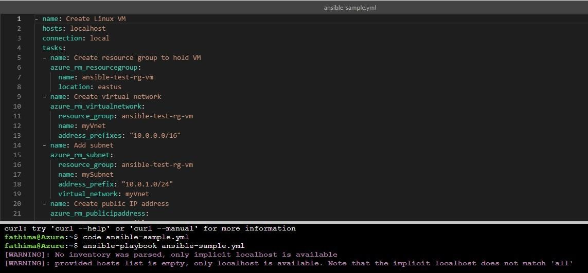

* + To run the above playbook created, use command:

->ansible-playbook ansible-filename.yml

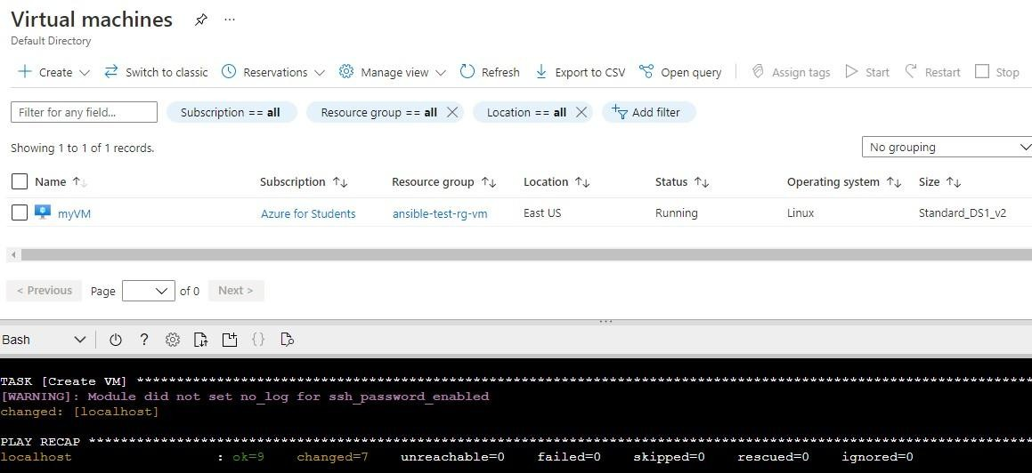

**THE VM CREATED WILL BE LIKE:**

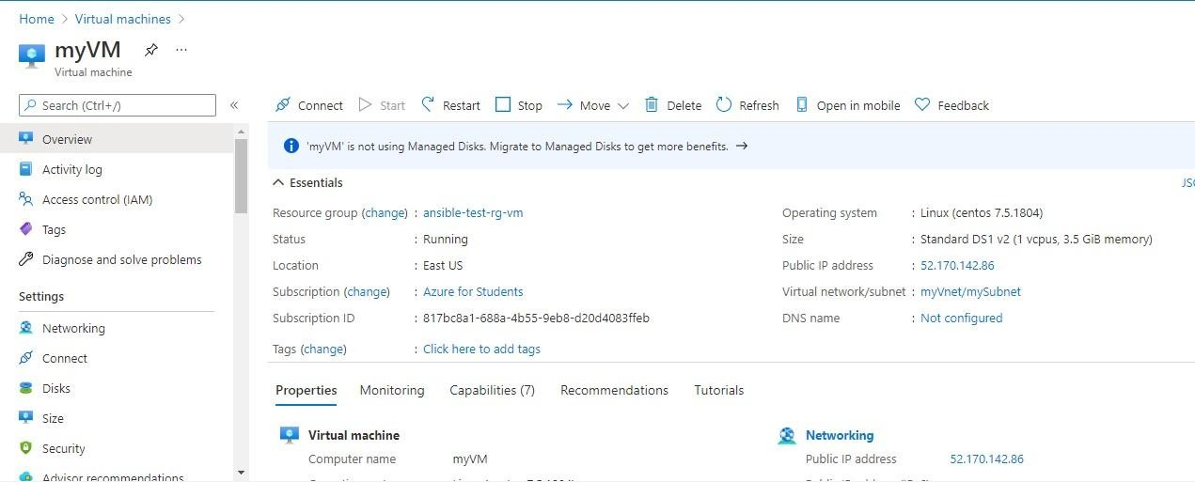

* + To access the VM created ,open a shell and type:

ssh username@ public ip address of vm

